OER Accessibility Series: PowerPoint Design
There are lots of little particulars when designing PowerPoints for accessibility, and the easiest and most user-friendly way to comply with them is to stick to the templates provided by Microsoft and use the features built into PowerPoint. As you go through this guide, you may ask yourself why it matters that you use the built-in functions, if the screen reader will read the text anyway? Well, you’re right that that the text will be read. However, the formatting won’t be, and the text is likely to be read in the wrong order unless it is designed properly. Things like slide titles, lists, and tables are only visible to the screen reader and read correctly by it if they are used and designed correctly. This guide will cover slide layout in Microsoft PowerPoint.
Don’t forget to review the Document Design, Alternative Text, and Captioning and Transcripts guides for additional accessibility compliance considerations.
Slide titles are essential to accessible PowerPoints because it tells the screen reader when to tell the student that they are starting a new slide and what that slide is about. Imagine listening to an audiobook, and instead of the reader pausing when they read the next chapter title, they just went straight from the end of the previous chapter to the chapter title to the chapter text, all in one breath. Well, that’s what it is like when a person using a screen reader doesn’t have title structure in the PowerPoints they need to read.
Luckily, titles are defined on pre-defined layouts of MS PowerPoint. Note: That doesn’t mean your slideshows have to be boring white slides with black text and nothing else. It simply means that you should start there and use the Layout function of PowerPoint to decide on what all you will have on the page and how it will be laid out.
Note: If your slideshow requires a more complex layout or structure than what PowerPoint provides as a default, consult your on-campus accessibility expert or contact Tiffani Reardon at tiffani.reardon@usg.edu.

Creating Accessible Layout Structure in MS PowerPoint
- Create a new slideshow in MS PowerPoint and fill in all of your content. Keep the basic layout for now—you’ll modify the style without losing accessibility later. As you create new slides, you can choose from a variety of default slide layouts. Click the arrow under “New Slide” on the home tab to see your options. Choose the layout that you need for each slide, but keep in mind that for accessibility reasons, you almost never want to use a Blank slide, and you should never delete the slide title box that each layout provides.
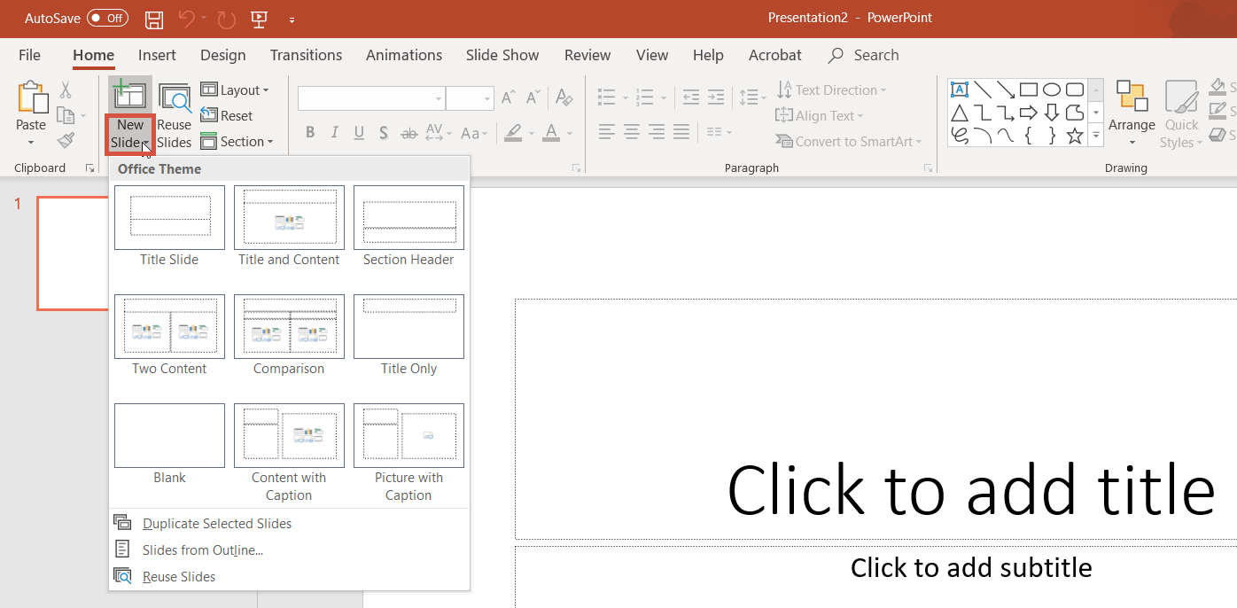

- Once you’ve got some content in the slideshow, you might be thinking it looks very boring. Your first instinct might be to delete boxes, move things around on the slide, add images on top of the layout, etc. Resist the urge to just plop things on the slide—there is a better way to make your slideshows more exciting without sacrificing accessibility. Click on the “Design” tab, then click “Design Ideas.”
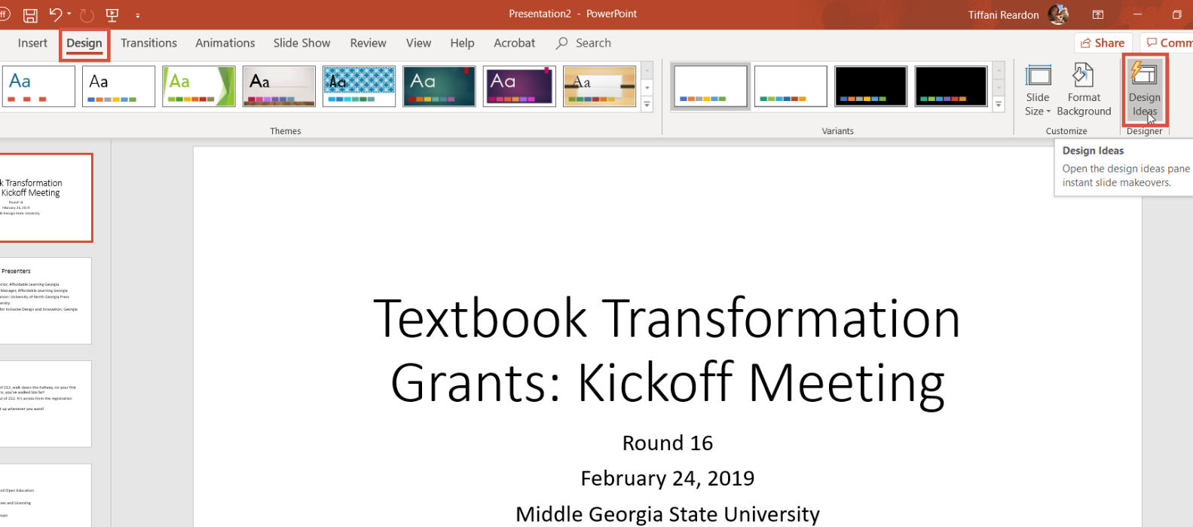

- MS PowerPoint has this cool new artificial intelligence feature that takes the text on your slide and helps you with design suggestions. Sometimes, it even pairs you with icons or images that work well with the theme! The really cool thing about this, though, is that it maintains the accessibility structure. So instead of moving your things around on the slide manually to create a presentation and then having to go back and re-do it for accessibility, use the “Design Ideas” feature!
