OER Accessibility Series: Document Design
There are lots of little particulars when designing documents for accessibility, and the easiest and most user-friendly way to comply with them is to design with Microsoft Word. As you go through this guide, you may ask yourself why it matters that you use the built-in functions, if the screen reader will read the text anyway? Well, you’re right that that the text will be read. However, the formatting won’t be unless it is designed properly. Things like headings, lists, and tables are only visible to the screen reader and read correctly by it if they are used and designed correctly. This guide will cover the essential functions of Microsoft Word for accessibility.
Don’t forget to review the Document Design, Alternative Text, and Captioning and Transcripts guides for additional accessibility compliance considerations.

Table of Contents
Creating Accessible Heading Structure in MS Word 2
Creating Accessible List Structure in MS Word 5
Creating Accessible Tables in MS Word 6
Creating Accessible Links in MS Word 8

Creating Accessible Heading Structure in MS Word
Heading structure is essential to accessible documents because it tells the screen reader when to tell the student that they are starting a new section of the document. Imagine listening to an audiobook, and instead of the reader pausing when they read the next chapter title, they just went straight from the end of the previous chapter to the chapter title to the chapter text, all in one breath. Well, that’s what it is like when a person using a screen reader doesn’t have heading structure in the documents they need to read.
The importance of heading structure goes beyond just first-level headings, however. Nested headings are equally as important because it helps the screen reader keep the page organized for the user. If there are multiple subheadings within an upper-level heading, the screen reader will tell the user what level it is so that they can keep up and stay organized.
- With your document open in MS Word, select the “Home” tab on the ribbon.
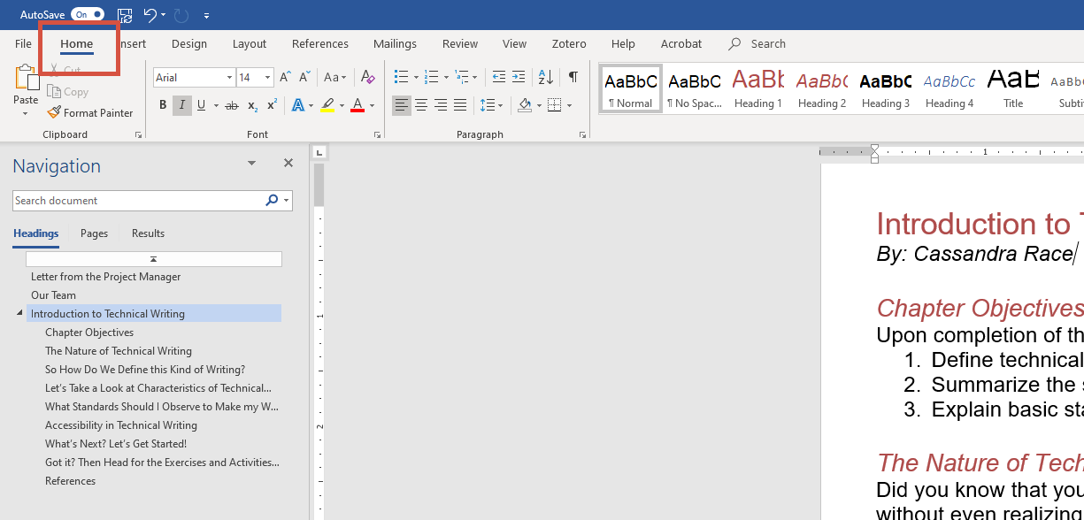

- At the center of the ribbon, you will see a list of font styles. In the bottom right corner of that section, click the expand button.
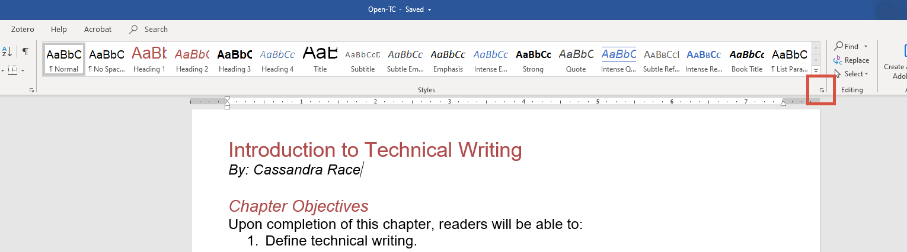

- The “Styles” panel will emerge from the right side of the screen. This panel contains all of the standard default styles plus any additional styles in your document. The default styles are the ones we want to use, but don’t worry! You can customize them to look the way you want. Start by highlighting the first heading in your document, then click “Heading 1.”
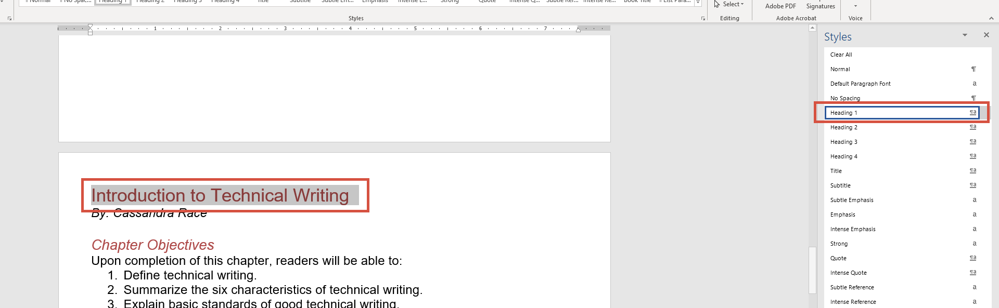

- You’ll notice that, unlike in our example images, the default for heading one is a larger Calibri font in the standard Microsoft blue color. To change that, right click “Heading 1,” and select “Modify.”
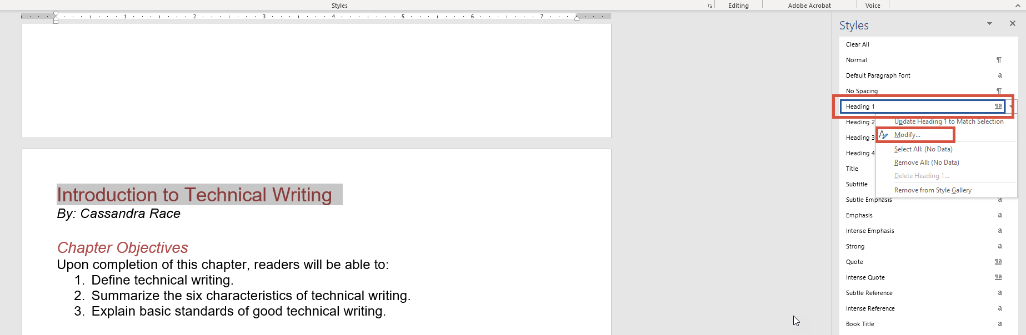

- From the window that pops up, you can customize your Heading 1 font style to be anything you want it to be—just keep readability and color contrast in mind.
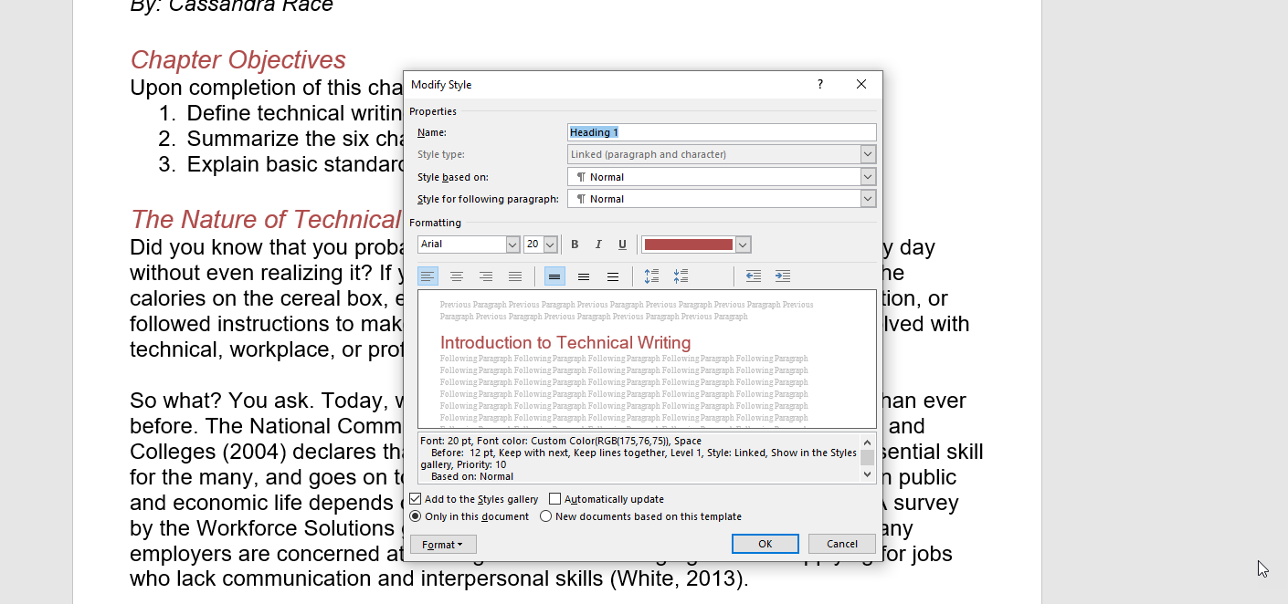

For nested headings (i.e. subheadings within headings), consider the heading number to be the heading level. So, first-level headings should be “Heading 1,” second-level subheadings (within Heading 1) should be “Heading 2,” third-level subheadings (within Heading 2) should be “Heading 3.” Most of the time, you will have one “Heading 1” per document, unless you are writing something large, like a textbook—in that case, you would have one “Heading 1” per chapter (the chapter title). Then from there, you may have any number of “Heading 2,” “Heading 3,” etc. Proper nesting and using the “Styles” feature are essential to document accessibility.

Creating Accessible List Structure in MS Word
List structure in MS Word is easy, and most of us do it the correct way anyway. To create accessible lists that will be ready as lists by a screen reader, just make sure you are using the list functions in Word and that you are using the correct type of list.
A bulleted list is for unordered lists—the order the items are in doesn’t matter. There is no hierarchy, and they are not steps. They could be read in any order and the meaning would not change.
A numbered or lettered list is for ordered lists—the order the items are in does matter. There is some kind of hierarchy or they are steps to a process. If they are read in the wrong order, the meaning would change.
Make sure that you are using the list feature when it’s appropriate to. While the grammatical structure of a list within a sentence may be correct, if the list is too long, it becomes hard to read and remember what the list is actually about.
For accessible lists, use the list function in MS Word, on the “Home” ribbon, in the “Paragraph” section.
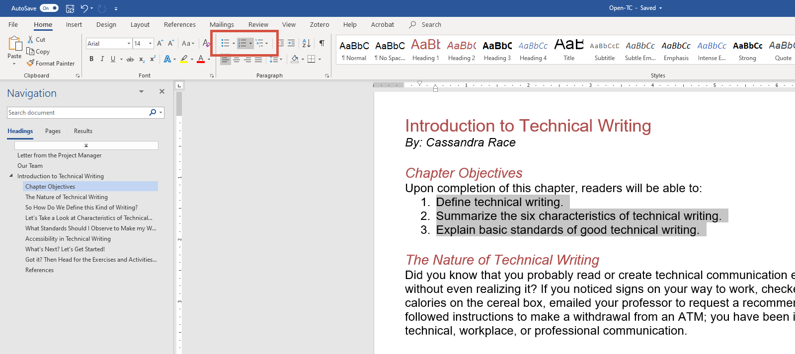

Creating Accessible Tables in MS Word
When creating tables in MS Word, you want to keep a few things in mind to make sure they are accessible.
Screen readers are very particular about how they read tables. For that reason, you should never use a table for anything other than for stuff that belongs in a table (meaning that you don’t want to use invisible tables for formatting, like many of us have done in the past).
Header rows are essential in tables, and you want them to repeat at the top of each page (for multi-page tables). And just as with headings and lists, using the styles provided by Word for tables is your best bet, but they can still be customized. Once you create your table, you can set these settings with just a few steps.
- Click on your header row, then right click and choose “Table Properties.”
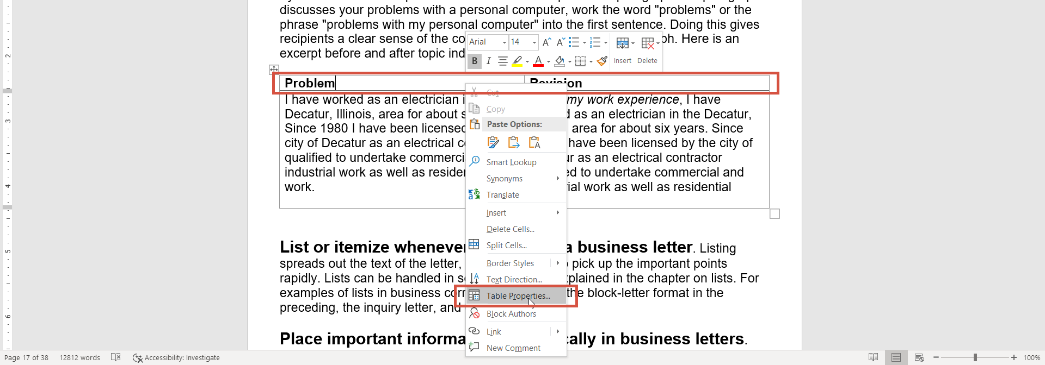

- On the “Row” tab, check the box to repeat as header row, and then click “OK.”
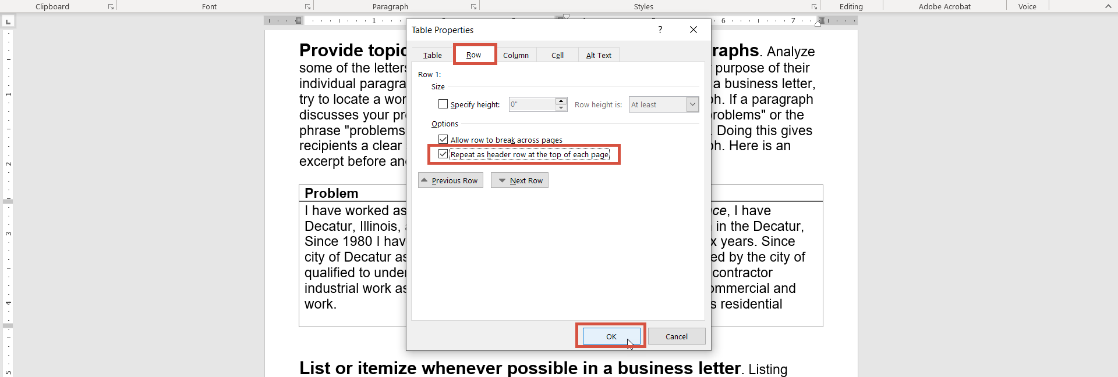

- Click the table, then click the “Design” tab under “Table Tools” on the ribbon.
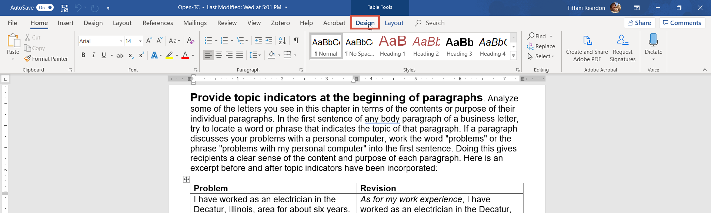

- On the left side of the ribbon, make sure that “Header Row” is checked, and if appropriate, check “First Column” (if you also have headers going down the table on the left side).
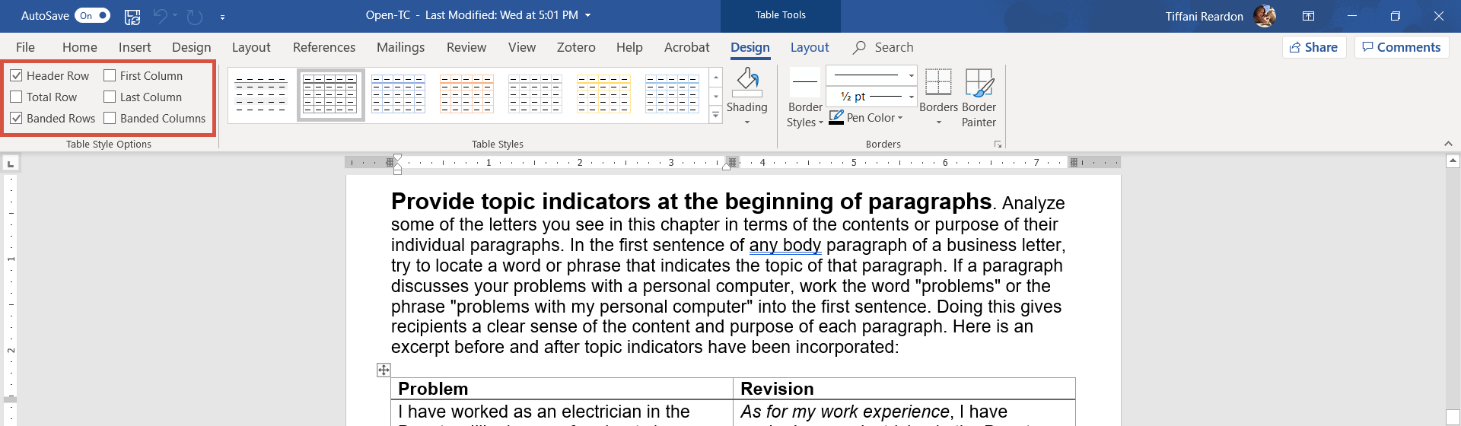

- You can play around with the table design from this tab as well, using the other features available. You can also play with the style of the table from the “Layout” tab under “Table Tools” on the ribbon.
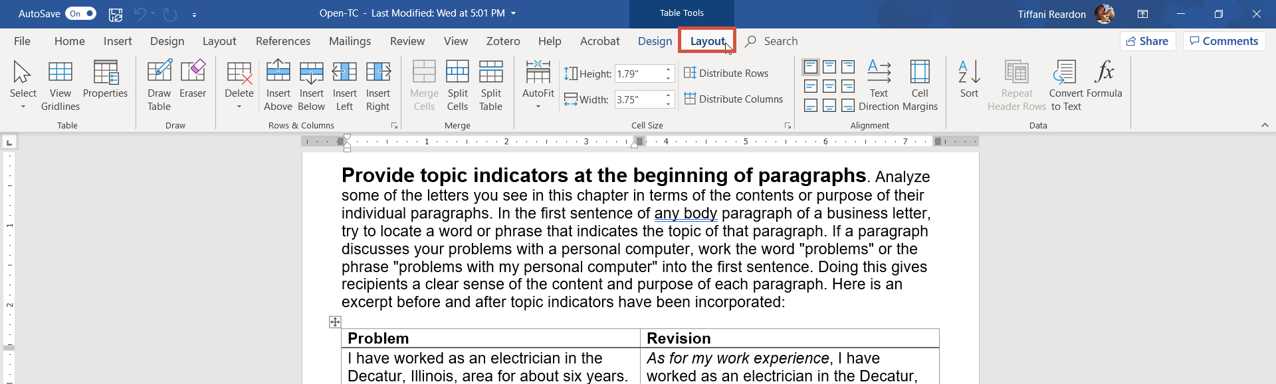

Creating Accessible Links in MS Word
We are often tempted to place the URL for a website into our documents as a link because it ensures that if our link doesn’t work, the user can copy and paste the URL into their browser and still find the page. It’s a smart back-up plan, but it’s often done without keeping accessibility in mind. When a screen reader reads a link, it reads the link text, followed by the URL. However, if there is no descriptive link text, it will only read that URL. I mean, we have all been taught never to click on a link that we don’t know where it goes, right?
To make our links accessible, they need to be descriptive—instead of reading as the URL, they should read as an explanation of where the link goes. For example:
Accessible: Affordable Learning Georgia
Not Accessible: https://www.affordablelearninggeorgia.org/
Of course, that doesn’t mean we can’t include the URL as well. There just needs to also be an accessible version of our links. Our suggestion is to use the accessible version as your primary link, and then provide the URL as an alternative. For example:
You can learn more about Textbook Transformation Grants on the Affordable Learning Georgia website. You can also access the website by copy/pasting the URL here: https://www.affordablelearninggeorgia.org/
It’s pretty easy to create accessible links:
- Type the description of the link, then highlight it. Click the “Insert” tab on the ribbon, then “Link.”
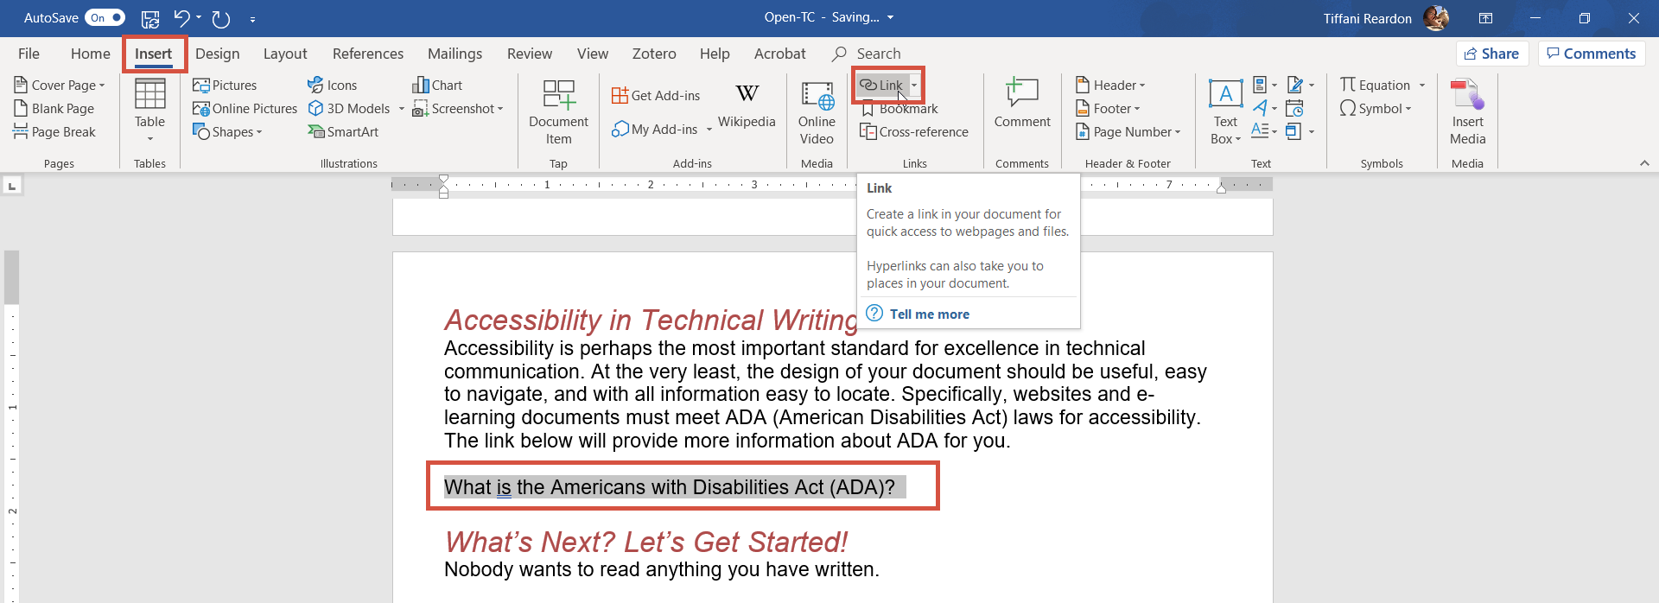

- Type or paste the URL into the box provided, and then click “OK.”
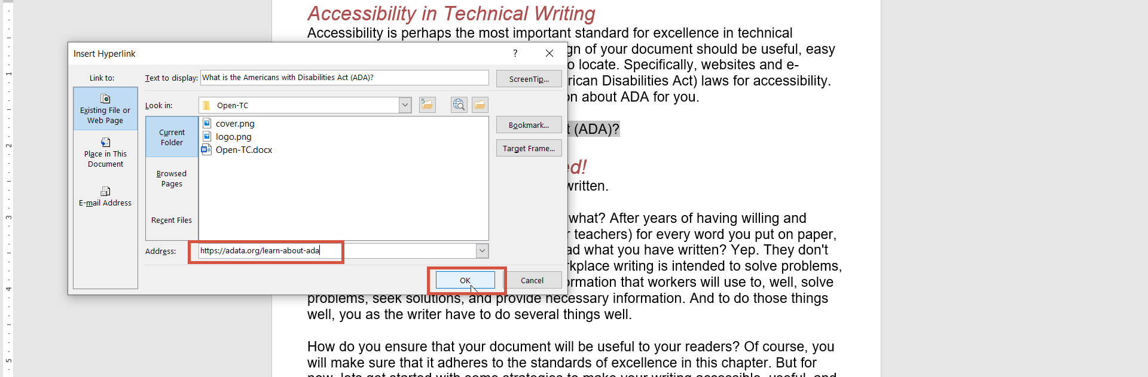

- Confirm that your link is functional by holding down the CTRL key and clicking the link.
