Affordable Learning Georgia Textbook Transformation Grants
Final Report for Mini-Grants

General Information
Date: August 12, 2018
Grant Round: Eleven
Grant Number: M30
Institution Name(s): University of North Georgia
Team Members (Name, Title, Department, Institutions if different, and email address for each):
Beata Hebda | Professor | Beata.hebda@ung.edu
Hashim Saber | Professor | Hashim.saber@ung.edu

Project Lead: Hashim Saber
Course Name(s) and Course Numbers: Introduction to Linear Algebra – Math 3650
Final Semester of Project: Summer 2018
If applicable to your project:
Average Number of Students Per Course Section:
Number of Course Sections Affected by Implementation of Revised Resources:
Total Number of Students Affected by Implementation of Revised Resources:

1. Project Narrative
Describe the course of your revision or ancillary creation project, including
- A summary of your project’s purpose, plan, and timeline.
Summary of Project’s Purpose:
Our goal was to revise the Linear Algebra materials (Class notes and online homework and assessment system using WeBWorK, a free online system) created in our previous grant # 264 -round 7. The main concern during the implementation process of the Linear Algebra segment of our grant #264 was the textbook that we used based on the theoretical concepts of Linear Algebra. Students who usually signed for this course end up majoring in Applied Sciences or Engineering Fields. In our mini-grant proposal, we proposed to use a Lyryx textbook product [Linear Algebra with Applications – Version 2018 Revision A - by W. Keith Nicholson] to overcome this concern. Throughout the implementation process, we found that another Lyryx product serves the same purpose, help achieve the main goal stated above, and it is more compatible with our syllabus. Accordingly, the Lyryx Open Textbook we decided to use in this mini-grant is “A First Course in Linear Algebra based on the original text by K. Kuttler”. We also used this alternative textbook to develop the teaching and homework materials to make them available to our faculty and any other faculty who seek open resources materials for a First Course in Linear Algebra. As stated in our proposal, we developed two different options to teach the course, namely zero-cost and low-cost approaches. They both share the fact that the e-textbook is available to students at no cost. The difference is in using the online homework and quiz/test delivery system as indicated in the Plan and Timeline below.

Plan and Timeline

Below we give our proposed timeline and implementation process
Proposed | Action Taken
March 2018 – April 2018. Review class notes material and develop class notes using the new proposed textbook. Class notes match the course objectives stated in the mathematics department syllabus. The Lyryx Open Textbook used for the class-notes is “A First Course in Linear Algebra based on the original text by K. Kuttler” | This item was completed, and 20 class-notes were developed based on the proposed Lyryx textbook
May 2018. Review all WeBWorK assessment materials and develop additional sets to match the sections in the new textbook. This part and the developed class notes will be the zero-cost option package. | We developed WeBWorK homework assignments that go together with the class-notes. Instructors who choose the zero-cost option will utilize these assignments. This is a zero-cost to students.
June 2018-July 2018. Develop new assessment materials using Lyryx system. This will include homework and quiz problems selected from the new textbook. This part and the developed class notes will comprise the low-cost option package. | We developed Lyryx assessment homework assignments that go together with the class-notes. This is a low-cost ($39.95) to students per semester.
August 2018. Submit the final report and make all class materials available to University of North Georgia faculty and other compasses faculty who opt to use Open resources in teaching their course.

In the Material Description Section, we give a table that summarizes the sections covered in the textbook together with the class-notes, the WeBWorK based, and Lyryx based assignments.

- The original works which were revised or added to, with links.
Original work on this project implemented under ALG Grant #264 Round 7. Related material of the original work is posted in the GALILEO Open Learning Materials repository under the following address: https://oer.galileo.usg.edu/mathematics-collections/31/

- A narrative description of how the project’s plan was carried out.
Class Notes: Class notes were collected from Lyryx products and organized and mapped to the objectives of the course offered at University of North Georgia. The sequence of the topics agrees with a typical First Course in Linear Algebra and can be easily used in other universities who offer similar course. Classroom notes were given so students can print them in 4 slides per page for convenience – all are given in the zipped file.
Online Homework System:
Zero-Cost Option: Together with the notes, we developed sets of WeBWorK (homework delivery system) assignments labeled according the Lyryx textbook sections covered in the course. These assignments organized according to certain sections covered in class.
Low-Cost Option: We used Lyryx assignment delivery system which costs students $39.95 per semester (log in instructions included in the appendix). we developed sets of Lyryx (homework delivery system) assignments labeled according the Lyryx textbook sections covered in the course. These assignments organized according to certain sections covered in class. This option might be more convenient to students who feel more comfortable working on assignments where most of the problems are selected from the textbook exercises.
- Lessons learned, including anything you would do differently next time.
Our team has experience in teaching linear algebra and other math courses for math major students and non-math major students. We believe that the Lyryx style textbooks are more attractive to students. Lyryx mathematics products are developed in Calculus I and Linear Algebra. We would like to team up with other faculty and Lyryx Learning Team to utilize the same style to develop materials in Calculus II, Differential Equations, and Statistics.
We also would like to analyze and compare data collected from both zero-cost and low-cost options to test a hypothesis that students are more inclined towards a low option approach. We also would like to compare students’ achievement in both options.

2. Materials Description
- Describe all the materials you have created or revised as part of this project. These descriptions may be used in the GALILEO Open Learning Materials repository in the official description field.
  - Lyryx and WeBWorK Assignments arranged to match the class-notes and departmental syllabus:
Lyryx Labs assignments  These assignments will be made accessible via a course code requested from either  hashim.saber@ung.edu  Or  beata.hebda@ung.edu | WebWork Labs Assignments  These assignments will be made accessible via a course code requested from either  hashim.saber@ung.edu  Or  beata.hebda@ung.edu
Lab#1-Sec(1.1, 1.2.1-1.2.3) | Lab1-Sec 1.1 1.2.1-1.2.3
Lab #2-Sec(1.2.3-1.2.4) | Lab2-Sec 1.2.4
Lab#3-Sec(1.2.5-1.2.7-TakeHome) | Lab3-Sec 1.2.5-1.2.7
Lab#4-Sec(2.1.1-2.1.2) | Lab4-Sec 2.1.1-2.1.2
Lab#5-Sec(2.1.3-2.1.6) | Lab5-Sec 2.1.3-2.1.6
Lab#6-Sec(2.1.7-2.1.9) | Lab6-Sec 2.1.7-2.1.9
Lab#7-Sec(2.2.1-2.2.4) | Lab7-Sec 2.2.1-2.2.4
Lab#8-Sec(3.1-3.2) | Lab8-Sec 3.1-3.2
Lab#9-Sec(9.1TakeHm&9.2) | Lab9-Sec 9.1-9.2
Lab#10-Sec(9.3-9.5) | Lab10-Sec 9.3-9.5
Lab#11-Sec(9.6, 5.1-5.2) | Lab11-Sec 9.6 5.1-5.2
Lab#12-Sec(9.7.1, 5.3-5.5) | Lab12-Sec 9.7.1 5.3-5.5
Lab#13-Sec(9.7.2, 5.6-5.8) | Lab13-Sec 9.7.2 5.6-5.8
Lab#14-Sec(7.1) | Lab14-Sec 7.1
Lab#15-Sec(7-2) | Lab15-Sec 7.2
Lab#16-Sec(7.3) | Lab16-Sec 7.3
Lab#17-Sec(4.11.1-4.11.2) | Lab17-Sec 4.11
Lab#18-Sec(4.1-4.6) | Lab18-Sec 4.1-4.6
Lab#19-Sec(4.7-4.9) | Lab19-Sec 4.7-4.9
Lab #20-Sec(4.10) | Lab20-Sec 4.10

  - Classroom Notes
Classroom Notes developed according to sections in Lyryx textbook. Below we will give a list of the Lyryx textbook sections’ lecture notes where the order chosen according to our UNG-Gainesville syllabus. The lecture notes together with selected supplementary lecture notes is can be found in a zipped file (Lecture and supplementary notes.zip) accompanied this report.
Supplementary Lecture Notes
Main Lecture Notes
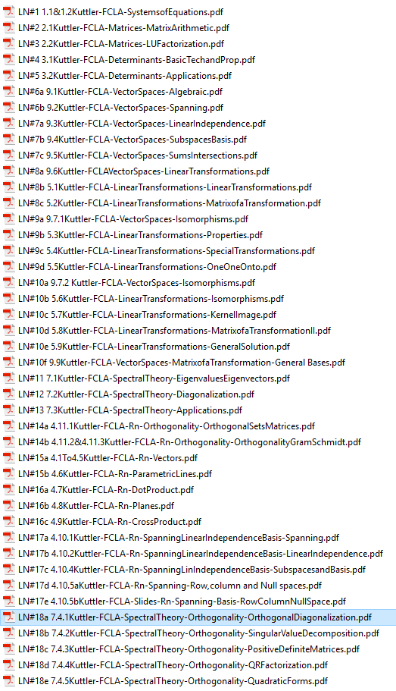
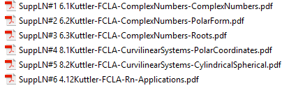

3. Materials Links
- If you are hosting your materials in places other than GALILEO Open Learning Materials, please provide these links in this section. Otherwise, leave blank.

4. Future Plans
- Describe any planned or actual papers, presentations, publications, or other professional activities that you expect to produce that reflect your work on this project.

Our plan is to present our product to other faculty in one of the weekly departmental colloquium sessions. We will also put together a poster of our product and present it in one of the conferences that focus on teaching and learning.

- Describe any plans to revise or add to these materials in the future.
Our team has experience in teaching linear algebra and other math courses for math major students and non-math major students. We believe that the Lyryx style textbooks are more attractive to students. Lyryx mathematics finished products are developed in Calculus I and Linear Algebra. We would like to team up with other faculty and Lyryx Learning Team to utilize the same style to develop materials in Calculus II, Differential Equations, and Statistics.
We would like to teach linear Algebra classes using both approaches and improve the materials based on the results of this teaching. We will be able to see how students react to lectures notes and assignments and revise them accordingly.
We would also like to analyze and compare data collected from both zero-cost and low-cost options to test a hypothesis that students are more inclined towards a low option approach vis a zero-option approach. In addition, we would like to compare students’ achievement in both options.

Appendix
- Information about purchasing a hardcopy of the Lyryx textbook:
If students would like to buy a hard copy of the textbook, the cost is $13.49 [https://www.amazon.com/dp/1542895529/ref=cm_sw_su_dp]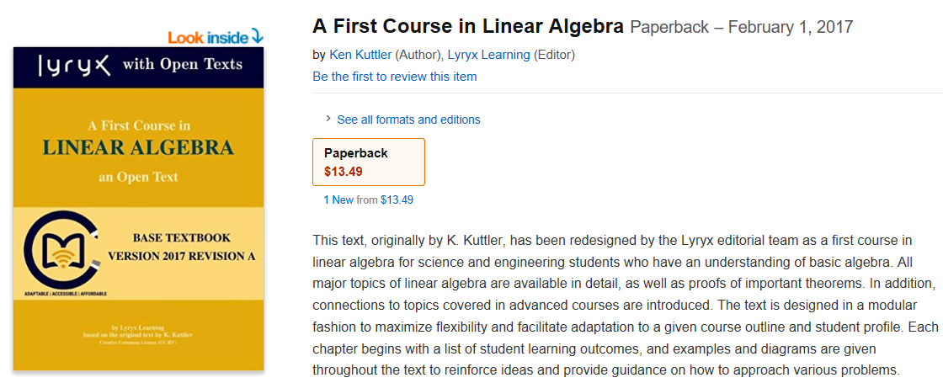
- Information about using the Lyryx Online Assessment tool:
The cost of the Lyryx Online assessment is $39.95 [https://login.lyryx.com/unprotected-servlets/StudentRegisterServlet?course=LILA1_2136]
