Affordable Materials Grants, Round 21:

Continuous Improvement Grants

(Spring 2022-Spring 2023)
  - Proposal Form and Narrative

Notes
- The proposal form and narrative .docx file is for offline drafting and for our review processes. Submitters must use the online Google Form for proposal submission, including uploading this document.
- The only way to submit the official proposal is through the Google Form. The link to the online application is on the Round 21 RFP Page.
- The italic text provided below is meant for clarifications and can be deleted.
The Round 21 Kickoff will include an asynchronous training module, required for all team members to complete, followed by the synchronous Kickoff Meeting on March 25, 2022 from 1pm-4pm. At least two team members from each awarded team (unless the award is for one individual) are required to attend the synchronous Kickoff Meeting.

Applicant and Team Information
The applicant is the proposed Project Lead for the grant project. The submitter is the person submitting the application (which may be a Grants Officer or Administrator). The submitter will often be the applicant—if so, just leave the submitter blank.
Requested information | Answer
Institution | Augusta University
Applicant name | Christina M. Heckman
Applicant email | checkman@augusta.edu
Applicant position/title | Professor of English
Submitter name | Sheree M. Wright
Submitter email | ogc@augusta.edu
Submitter position/title | Interim Executive Director, AURI, Senior Director, Pre-Award, Augusta University
Please provide the first/last names and email addresses of all team members within the proposed project. Include the applicant (Project Lead) in this list. Do not include prefixes or suffixes such as Ms., Dr., Ph.D., etc.
Team member | Name | Email address
Team member 1 | Christina M. Heckman | checkman@augusta.edu
Team member 2 | Jeff Mastromonico | jmastromonico@augusta.edu
Team member 3 | Lynsey Steinberg | lsteinberg@augusta.edu
Team member 4 | Melissa Johnson | mjohns69@augusta.edu
Team member 5
If you have any more team members to add, please enter their names and email addresses in the text box below.

Project Information
Requested information | Answer
Type of Project | - Revision of open educational resources (OER) used in existing courses
Requested Amount of Funding  $10,000 maximum total award per grant | $6,025.98
Course Titles and Course Numbers | ENGL 2111 World Literature I  HUMN 2010 Human Experience and Meaning
Final Semester of Project | - Spring 2023
Currently Existing Resource(s) to be Revised/Ancillaries Created  Please provide a title and web address (URL) to each of the currently existing resources that you are revising, creating new ancillary materials for, or replacing. If replacing, please include a title and web address (URL) to the new OER as well. | Compact Anthology of World Literature Parts 1, 2, and 3, edited by Laura Getty and Kyoungkye Kwon  https://ung.edu/university-press/books/compact-anthology-world-literature.php

Project Goals
In at least one paragraph, describe your project’s goals and what materials will be created or revised.
This project, World Lit Live, aims to provide an ancillary resource to the Compact Anthology of World Literature Parts 1, 2, and 3, edited by Laura Getty and Kyoungkye Kwon. World Lit Live provides not only a condensed student anthology of texts selected from Getty and Kwon’s edition but also a digital, interactive, and immersive experience that engages students and deepens their learning through the use of 3D technology, virtual reality, animation, gaming, and scaffolded, rigorous assessment of reading comprehension and cultural competence.
Students who use the resource funded by this grant, World Lit Live, will fulfill the following student learning outcomes. Students will be able to
- Interpret pre-modern global literatures by using World Lit Live, which integrates primary texts with immersive virtual reality scenarios, mini-games, and activities. By participating in these activities, students apply their knowledge in real time, review their readings, assess their own reading comprehension, and employ their cultural competence to solve problems.
- Recognize the significance of world literature as living story—that is, as narrative that pervades the real world, gives meaning to human life, and helps to structure reality.
- Use reading comprehension and critical skills to solve problems. These problems, accessed through puzzles, games, and other activities, will require that students imagine themselves in different worlds, see those worlds through others’ eyes, and learn from the peoples of the past by engaging with ancient texts, places, symbols, and ideas.
Students will collaborate in assessing the effectiveness of World Lit Live by providing feedback on how effectively the resource supports the fulfillment of the above outcomes. Through this assessment, students will be integrated into the learning process and the development of course materials.

Action Plan
Describe the tasks needed to complete the project in as much detail as possible. If this application has more than one team member, include the major roles for each person and which tasks this role is assigned. Estimate the amount of time (e.g. number of hours) each task will take. Include plans for open licensing and plans for making your materials accessible. Indicate if you are using other platforms in addition to the repository to host your created materials.
Currently, both ENGL 2111 World Literature I and Heckman’s sections of HUMN 2010 Human Experience and Meaning are taught using traditional anthologies and reading assignments (provided to students as pdfs) supplemented by films, art, and other materials. Assessments include quizzes (in-person and online), reading notes, and written papers. World Lit Live aims to provide a more interactive resource for these courses, a multimedia core experience that would integrate primary texts with activities to help students build their reading comprehension and cultural competence. Readings in the resource would also be accompanied by narration, accommodating students with visual impairments and diverse learning styles. Links to audio readings in the original languages of composition will also be incorporated whenever possible to help students recognize the linguistic diversity throughout the globe in both ancient and modern times.
Christina Heckman (Project Lead), Professor of English, will manage all content for World Lit Live, which will include six course units in all. She holds a Ph.D. in English and has been teaching literature and world humanities at the university level since 2002. She will edit the anthology integrated into World Lit Live, adapting selected texts from Getty and Kwon’s edition; designing scaffolded quizzes and activities to help students build reading comprehension skills; researching relevant ancient cultures and identifying places, objects, concepts, and cultural practices relevant to the students’ readings; and integrating that research into the resource to help students develop cultural competence. Hours: approximately 3-6 hours/week during fall 2021 as part of her contractual commitment, and 30-40 hours a week during June-July 2022. Heckman has a nine-month faculty appointment and therefore is not paid in the summer. The requested salary will include committed effort 0.21 (7% effort) during the summer months towards the development of World Lit Live. After the first two units have been developed, Heckman will also serve as primary designer and developer for the remaining units of World Lit Live, with support from the other team members.
Jeff Mastromonico, M.Ed., of Augusta University’s Center for Instructional Innovation, has twenty years of experience in teaching, multimedia development and design, video production, and learning game development. He holds a level 2 certification in Gamification. He will design original maps, art, and interactive mini-games based on the content Heckman provides for World Lit Live. After the first two units have been completed, Mastromonico will serve in a supportive role, assisting Heckman with the design and development of the remaining units. On average, he will spend 15 hours per week on the project (as part of his regular contractual duties) while the first two units are in development.
Lynsey Steinberg, MSMI, CMI, of Augusta University’s Center for Instructional Innovation, is a board certified medical illustrator and designer with experience in developing virtual reality learning environments, 3D printing, animation, gamification, and graphic design. She will design virtual reality scenarios for the first two units of World Lit Live, integrating video and animated photography into the resource. After the first two units have been completed, Steinberg will serve in a supportive role, assisting Heckman with the design and development of the remaining units. On average, she will spend 15 hours per week on the project (as part of her regular contractual duties) while the first two units are in development.
Melissa Johnson, MLIS, MA, is Interim Associate Director of Reese Library on the Summerville Campus of Augusta University. She is the Affordable Learning Georgia Library Champion for Augusta University; she also teaches core-level English courses and library instruction. She will provide guidance on copyright, fair use, and accessibility throughout the project. She will spend 1-2 hours per week on the project (as part of her regular contractual duties) as needed.

Timeline
Provide a project timeline aligned with the action plan above. Include major milestones and deadlines, keeping in mind your selected Final Semester.
As noted in the timeline below, Heckman will edit and adapt public-domain translations of course texts for integration into World Lit Live. (The world literature anthology currently in use, noted above, has a Creative Commons license, and its materials can be adapted for World Lit Live with appropriate attribution.) In World Lit Live, reading selections will be organized within the units and separated into episodes to correspond with virtual environments and the activities embedded within them. Heckman will also develop original quizzes, experiential activities, and narratives for virtual reality scenarios to be integrated into the resource. Mastromonico and Steinberg will design these elements for the first two units as noted above; for subsequent units, Heckman will take over as primary designer and developer with support from Mastromonico and Steinberg. The first two units are already in development during fall 2021 (see screenshots below for quizzes and activities relating to readings from the book of Genesis).
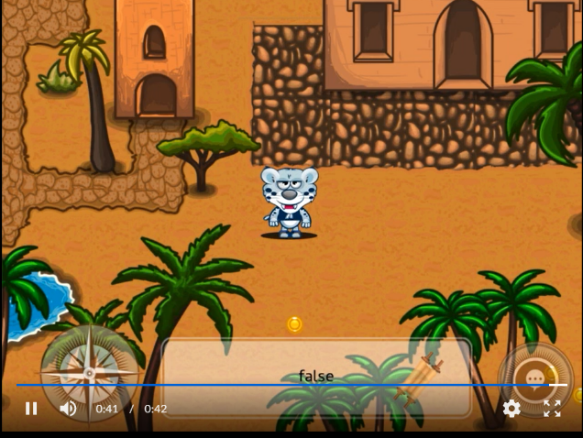
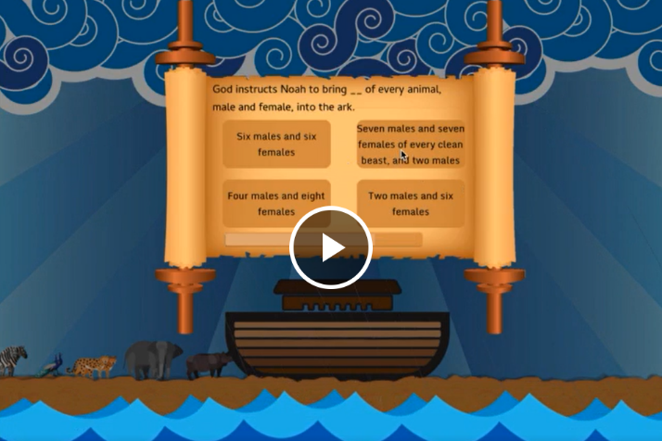

Johnson will assist Heckman in arranging a non-commercial Creative Commons license for World Lit Live. 3D-printed objects will also be used to help students experience aspects of material culture, and these will have Standard Sketchfab licenses. World Lit Live can be stored in Affordable Learning Georgia’s repository; storage space is also available through a spots account based at Augusta University and in Augusta University’s Institutional Repository, Scholarly Commons. The resource will be made available to users through a hyperlink that can be embedded in D2L Brightspace courses.
The initial pilot design for the first unit of World Lit Live (the Ancient Near East) is in development during spring 2022. Heckman is designing the content, editing textual selections and writing original quizzes and interactive learning activities for the unit. Mastromonico and Steinberg are designing the activities based on the content. In the Ancient Near East unit, for example, these interactive activities include a quote-identification matching game based on the creation story in the book of Genesis; a game in which students’ knowledge of the Genesis text allows them to outwit the serpent and reach the Tree of Life; a game in which students, based on their reading of the Genesis text, must help Noah build the ark before the rains begin; and a virtual reality scenario based on the Passover meal, through which students must demonstrate recall and comprehension of the primary text. During Fall 2022, Heckman will pilot the Ancient Near East unit in her courses, using surveys to assess student feedback and gather data about the resource’s effectiveness. Changes in curriculum alignment will not be necessary.
World Lit Live will be hosted in the Affordable Learning Georgia repository and/or Augusta University’s Institutional Repository. A shared spots account is also available through Augusta University. A link to World Lit Live will be shared with users for embedding in D2L Brightspace courses.
Detailed Timeline
Spring 2022:
Mastromonico and Steinberg work with Heckman to develop art, virtual reality scenarios, mini-games for Ancient Near East unit and collaborate on troubleshooting, testing, etc.
Summer 2022:
Supported by requested salary, Heckman develops content for South Asia, East Asia, Ancient Greece and Rome units
Advised and assisted by Mastromonico and Steinberg, Heckman develops virtual reality scenarios, mini-games for above units
Collaborate on troubleshooting, testing, etc.
Fall 2022:
Heckman develops content for Africa and Islamic Empire unit
Advised and assisted by Mastromonico and Steinberg, Heckman develops virtual reality scenarios, mini-games for Africa and Islamic Empire unit
Heckman pilots Ancient Near East unit in ENGL 2111 World Literature I and HUMN 2010 Human Experience and Meaning
Collaborate on troubleshooting, testing, etc.

Spring 2023:
Heckman develops content for Medieval and Renaissance Europe unit
Heckman pilots first five units (Ancient Near East, South Asia, East Asia, Ancient Greece and Rome, Africa and Islamic Empire) in courses, using surveys to assess student engagement and learning
Advised and assisted by Mastromonico and Steinberg, Heckman works on development of virtual reality scenarios and mini-games for Medieval and Renaissance Europe unit
Collaborate on troubleshooting, testing, etc.
Resource complete and Final Report submitted in December 2022

Budget
Please enter your project’s budget below. Include personnel and projected expenses, keeping in mind that this grant funds the estimated time in your Action Plan. The maximum amounts for the award are as follows:
- $2,000 maximum per team member for salary, course release, travel, etc.
- Additional project expenses allowed, but must be adequately justified in this section
- $10,000 maximum total award per grant
- $2,000.00 - salary (and fringe) for the Project Lead to support work on the project during June and July 2022. (She has a 9-month academic appointment.)
- $2999.99 – Dell XPS 15 (2021) laptop computer. This laptop is highly recommended for video and image editing, graphic design, and game development; it includes a discrete graphics card, a touch screen, and ample storage for large video and image files. Heckman does not currently have access to a computer with the necessary specifications for this project.
- $79.99 Dell Active Premium Pen (PN579X) – for use with Dell XPS 15; includes multi-protocol capability for editing images.
- $300.00 ($25.00 subscription for 12 months) – subscription to GameSalad for Heckman. This software supports the design and development of interactive games to be embedded within the units of World Lit Live. These are essential for developing students’ skills in reading comprehension and assessing their understanding of the cultures they study. Mastromonico already has access to GameSalad through a limited-use license and is using it to develop games for the pilot unit during Spring 2022.
- $348.00 – Oculus Quest 2 128GB all-in-one virtual reality headset with carrying case for Heckman. Steinberg already has access to a headset; Augusta University also provides the use of headsets for students. While students will able to engage with the virtual reality environments in World Lit Live without headsets, this equipment will greatly enhance the experiential nature of these environments.
- $298.00 – Formlabs Model Resin, 2 1-liter tanks. Steinberg will use this material to 3D print objects to provide students with hands-on experiences during their completion of the units. These objects may include a tablet from the Epic of Gilgamesh, a 3D model of Noah’s ark, or other objects. Augusta University’s Center for Instructional Innovation has a 3D printer available.

Creative Commons Terms
I understand that any new materials or revisions created with Affordable Learning Georgia funding will, by default, be made available to the public under a Creative Commons Attribution License (CC-BY), with exceptions for modifications of pre-existing resources with a more restrictive license.

Accessibility Terms
I understand that any new materials or revisions created with Affordable Learning Georgia funding must be developed in compliance with the specific accessibility standards defined in the Request for Proposals.

Letter of Support
The Department Chair from the corresponding project, or the Department Chair’s direct report such as the Dean or Provost, must provide a signed Letter of Support for the project. This letter should acknowledge the following:
- The department will provide support for fund disbursement in correspondence with the Grants/Business Office.
- The department approves of the work on the proposal by the applicant(s).
- The department acknowledges the sustainability of these affordable resources after the grant work is complete.

In the case of multi-institutional affiliations, all participants’ institutions must provide a letter of support.

Please provide the name and title of the department chair (or other administrator) who provided you with the Letter of Support.
Dr. Seretha Williams
Professor of English
Chair, Department of English and World Languages, Augusta University

Grants or Business Office Acknowledgment Form
Institutional Grants/Business Offices will be responsible for fund disbursement, often in correspondence with the Department Chair, including expense and travel reimbursement. All applicants will need to provide a signed Acknowledgement Form, the template for which is linked on the RFP page, stating that the Grants/Business Office knows about the applicant’s intent to apply for an Affordable Materials Grant. Either the Department Chair or the Project Lead can work with the Grants/Business Office to get this signed form.
In the case of multi-institutional affiliations, all participants’ institutions must provide this form.
Please provide the name and title of the grants or business office representative who provided you with the acknowledgement form.
Sheree Martin Wright
Interim Executive Director/AURI
Interim Senior Director, Pre-Award Services
Division of Sponsored Program Administration
Augusta University
1120 15th Street, CJ 3305
Phone: 706-721-6480
Fax: 706-721-6478
Email: ogc@augusta.edu

