Affordable Materials Grants, Round 18:

Continuous Improvement Grants

(Fall 2020 – Fall 2021)
  - Proposal Form and Narrative

Notes
- The proposal form and narrative .docx file is for offline drafting and for our review processes. Submitters must use the online Google Form for proposal submission, including uploading this document.
- The only way to submit the official proposal is through the Google Form. The link to the online application is on the Round 18 RFP Page.
- The italic text provided below is meant for clarifications and can be deleted.

Applicant and Team Information
The applicant is the proposed Project Lead for the grant project. The submitter is the person submitting the application (which may be a Grants Officer or Administrator). The submitter will often be the applicant—if so, just leave the submitter blank.
Requested information | Answer
Institution | Georgia Southern University
Applicant name | Shainaz Landge
Applicant email | slandge@georgiasouthern.edu
Applicant position/title | Assistant Professor of Chemistry
Submitter name
Submitter email
Submitter position/title
Please provide the first/last names and email addresses of all team members within the proposed project. Include the applicant (Project Lead) in this list. Do not include prefixes or suffixes such as Ms., Dr., Ph.D., etc.
Team member | Name | Email address
Team member 1 | Shainaz Landge | slandge@georgiasouthern.edu
Team member 2 | Abid Shaikh | malnu@georgiasouthern.edu
Team member 3 | Elizabeth Sargent | esargent@georgiasouthern.edu
Team member 4 | Dawn Cannon-Rech | dcannonrech@georgiasouthern.edu
Team member 5
If you have any more team members to add, please enter their names and email addresses in the text box below.
NA

Project Information
Requested information | Answer
Type of Project | - Creation of ancillaries for existing OER courses
Requested Amount of Funding  $10,000 maximum total award per grant | $10,000
Course Titles and Course Numbers | Remote Mentoring of Undergraduate Research Students (ReMentURS)
Final Semester of Project | - Fall 2021 (December)
Currently Existing Resource(s) to be Revised/Ancillaries Created  Please provide a title and web address (URL) to each of the currently existing resources that you are revising, creating new ancillary materials for, or replacing. If replacing, please include a title and web address (URL) to the new OER as well. | This is a new material to be created for undergraduate research students, based on a similar idea from  http://www.eqpoint.info/ which is open access and available to public.

Project Goals
In at least one paragraph, describe your project’s goals and what materials will be created or revised.
For sciences, research is generally carried out with hands-on activities and in-person lab training. In emergency and unprecedented situations that prevent students from access to laboratories and research groups, such as COVID-19 and natural disasters, students lose valuable face to face training time. Desperate situations call for creative solutions and hence the idea of “Remote Mentoring of Undergraduate Research Students” (ReMentURS) took shape. The primary objective of the proposed work is to design a remotely available professional development (PD) workshop series that will provide rigorous research training to new, incoming undergraduate (UG) research students. Our plan is to create a ten-week remote learning program which will include digital presentations, short informational video clips, virtual demonstrations, and aligned worksheets to foster student mindsets towards becoming independent research scientists. ReMentURS material will be shared with any students who are interested in joining a research group to get familiarize with basic research methods, lab techniques, instrumentation training, professional etiquettes, scientific literacy (writing and presenting), and applying to various internships/awards. At Primarily Undergraduate Institutions (PUIs), UG students are the major workforce that carries out campus research. Providing formal training through the ReMentURS online platform is a novel, creative method to help make UGs STEM ready regardless of whether in person access to laboratories is available. The proposed work is significant considering the current requirements of physical distancing and increase in remote course offerings due to COVID19. ReMentURS modules will be made publically available, so post-COVID these materials will also be a valuable resource (repository) for all institutions during natural disaster closures and will increase access to training for UGs.

Action Plan
Describe the tasks needed to complete the project in as much detail as possible. If this application has more than one team member, include the major roles for each person and which tasks this role is assigned. Estimate the amount of time (e.g. number of hours) each task will take. Include plans for open licensing and plans for making your materials accessible. Indicate if you are using other platforms in addition to the repository to host your created materials.

Through the ReMentURS program, we plan to develop human capital for the greater scientific community and promote continuing STEM education even in remote conditions. Our idea is to provide students with focused, planned PD activities through ten weeks of comprehensive training to nurture UG scholars’ exploratory minds. An intense and diverse high-quality research experience, along with the supportive growth mindset environment will enhance students’ learning processes.
The modules created can be used as a proper ten-week training workshop or in parts (as per students need and time) and hence it can be beneficial for all, even non-STEM students, such as those needing support during completion of CORE science requirements. The full workshop will cover many aspects necessary to develop UGs into effective researchers including - professional etiquettes training, safety – do’s and don’ts (in and outside the lab); basic lab skills, instrument training sessions, scientific writing, virtual lab visits, a day in a life of scientists (through the lenses of student as well as faculty), ethics training, applying for internships and grants, creating resume and personal statements.
A tentative ten-week agenda for this workshop/course is included below and provides topics to be covered as well as materials to be generated and shared. For example, in the first module the students will focus on soft skills through peer introductions and a virtual meet and greet with ReMentURS leaders and research mentors. Students will learn about professional etiquettes, such as “how to write an email” and “how to present themselves” in a virtual setting. This first module will set the tone for remote course behavior and would be a benefit to students taking any online course. The following weeks will focus on Safety and Ethics; Literature Search and Reading, Writing and Finding References, Data Analysis, Scientific Presentations (Poster and Oral); Creating Figures and finally Scientific Literacy focusing on introduction, abstract, methods and results. The full program will help students to generate a good virtual poster presentation as a final, evaluated product. This will help us assess all the techniques taught and learning outcomes achieved during the ten-week program.
Virtual Summer Schedule - Emergency plan (E.g: COVID-19)
Week | Topics to be covered | Title (Materials to be Generated and Shared)
1 | - Greet and Meet  - Professional Etiquettes  - Time Management | - Introductions(Video Demo and Discussion)  - How to write an email – (Video and Worksheet)  - How to be “present” in the virtual setting –  Netiquette (Demo Video)  - Are you managing your time? (Video and worksheet with examples)
2 | Safety and Ethics | - The Do’s and Don’ts in the lab setting (Video and worksheet with examples)  - Are you ethical? (Video and worksheet with examples)  - Role plays for both the topics.
3 | Literature Search and Reading | - How to find scientific literature? (Video and Worksheet with examples)  - Intro Literature Review Activity- (Worksheet with examples)  - Instrument Training, I – STEM focused
4 | Writing References  -Endnote  -Refworks | - How to create a bibliography (Video and Worksheet with examples)  - Advanced Literature Review activity (Worksheet with examples)  - Instrument Training II – STEM focused
5 | Data Analysis  - Making Data Bearable  - Excelling in Excel | - How to read data? (Interactive data tutorial)  - Excel Workshop (Demo Video and Worksheet with example)  - Instrument Training III – STEM focused
6 | Creating Figures  - Drawing software: ImageJ/Adobe/ ppt  - ChemDraw : Inside secrets. | - How to make scientific figures (Demo video for each software)  - Data interpretation activity (Worksheet with examples)  - Figure creation activity (Worksheet with examples)  - Instrument Training IV – STEM focused
7 | Scientific Presentations  Poster/Virtual/  Face to Face | How to make an amazing poster (Demo videos )  Poster creation activity (template provided)  - Instrument Training V – STEM focused
8 | Scientific Writing  -Thinking about Titles!  -Abstract Writing and Introduction | - How to write a title/abstract/introduction to your research (Intro videos)  - Titles activity (worksheet with examples)  - Abstract activity (template provided)  - Introduction activity (template provided)  - Instrument Training VI – STEM focused
9 | Scientific Writing -  Methods and Results | - How to write methods/results of your research (Intro videos)  - Methods activity (template provided)  - Results activity (template provided)  - Instrument Training VII – STEM focused
10 | Presentation – Virtual | - How to give a poster presentation (Intro video)  - Virtual student poster presentations (Video submissions)

The weekly schedule will supplement each activity with materials such as short introductory videos (what to expect), demo videos (instrumentation or lab techniques) with UG students as role models, and templates/worksheets for assessment purposes to check if the student are on track and grasped the material. For some topics, experienced faculty or staff members will be called to collaborate on trainings for the workshop (e.g: Ethics training or Safety training). During seven of the 10 weeks instrument training videos for equipment commonly used in science labs (Gas Chromatography, Infrared Spectroscopy, Ultraviolet Spectroscopy etc.) will be shared. Not all research students will utilize all the instruments present in the department during their research and hence a mix of chemistry and biology instrument training videos will be demonstrated. In this regard, the ReMentURS program exposes UG researchers to broader research methods and instrumentation compared to strictly in-person research pathways, which often focus mostly on the methods/instruments in a single mentor’s laboratory.

Student Population: The targeted student population for this study are the student who for any reason (natural calamity or personal) unable to conduct out research by face to face setting. At GSU, UG researchers which are present during summer term working in labs are:
- Summer Undergraduate Research Experience (SURE) program – it is for any UG student doing research at summer term (~15-20 students).
- Incorporation of Freshmen in Research for Early Experience (iFREE) – a program initiated at GSU where students are exposed to research in their freshmen year (~10-15 students at each campus (Armstrong and Statesboro)).
- CEMITURE (Chemistry Summer REU) program – 8 students from national universities are involved in research during summer term.
- ICPS (Biology Department REU) program – 10 students from national universities are involved in research during summer term.
- McNair Program – Open for any underrepresented minority or underserved population who wants to conduct research (~15-20 students)
These are only selected few research programs from chemistry and biology department. Due to the general soft and professional skills provided in this project, this workshop will be useful to non-STEM students as well.

In addition to the weekly summer schedule shared above, a more detailed breakdown (weekly) for representative example modules (1 and 3) is shown below. We expect students to be committed to this workshop weekly at least for 2 to 3 hours.

Detailed Schedule for Week 1 and Week 3.

Week | MONDAY | TUESDAY | WEDNESDAY | THURSDAY | FRIDAY
Week 1  Professional Etiquettes/  Trainings | Research group Virtual Meeting – 10 am  Introduction and Expectations | Introduction Discussion Due | Email Etiquettes  (Video and Worksheet) | Online presence Netiquettes  (Video and Worksheet) | Are you managing your time? (Video and worksheet with examples).  All the worksheets are due on Friday.
Week 3  Literature –  Searching and Reading | Research group Virtual Meeting – 10 am  What to expect this week?  Discussion of suggestions - Last week  Dissemination of week’s materials | How to find scientific literature?  (Scifinder etc)  (Video and Worksheet) | Literature Review Activity  Find 4 articles related to your research | Read and find two difficult questions from each article. | Literature questions due – ONLINE  Email/ Dropbox/Drive  All the worksheets are due on Friday.

Team Members
There are six members involved in this project:
The project leads Drs. Shainaz Landge and Abid Shaikh are responsible for creating the majority of materials.
Dr. Shainaz Landge: She will lead the PD activities focusing on soft and basic skills in and around lab setting; create the worksheets and demo videos for the same.
Dr. Abid Shaikh: He will primarily be involved in creating instrumentation videos, safety videos in real lab settings; create the worksheets and demo videos for the same.
Dr. Elizabeth Sargent: Our lead on Armstrong campus will be involved in creating the assessment tools, data sharing on Armstrong Campus and data assessing for this study.
Dr. Dawn Cannon-Rech: Our College of Science and Mathematics (COSM) library liaison will help with searching scientific literature, data management and bringing the materials to OER libguides.
Undergraduate Scholars: Two UG scholars will be involved in the creation and participating in the videos as role models.

Estimated Time
After the grant is funded, November and December months will be primarily used for planning and selection of module materials. The overall creation and sharing of the material will be carried out in spring 2021 semester (4 months), so that the material is available in summer term for students to use. Module dissemination and data collection will be the prime objectives in summer of 2021. We estimate that at least 4-5 hours per week is needed to create the videos and necessary aligned materials per week by each lead team member in spring term.
Similar time commitments are needed for creating the assessment tools and making the libguide active.
Undergraduate students will be hired in Spring and Summer semester accordingly for 5 hours per week for 20 weeks (10 weeks in spring and 10 weeks in summer).

Dissemination
The material will be available on libguides; first it will be open on a weekly basis to only the GSU students in our summer pilot cohort. Periodic feedback will be collected. After student and faculty feedback at the end of summer semester – modules will be amended and adjusted accordingly to prepare for public availability in fall semester. The material will be hosted on OER libguides platform on GSU library website to all in the scientific community. The libguide links will also be shared with the USG host website. All the materials will follow the open licensing protocol and will be shared with creative commons attribution (CC BY).

Timeline
Provide a project timeline aligned with the action plan above. Include major milestones and deadlines, keeping in mind your selected Final Semester.

November-December 2020
● Review and selection of free, online materials available on the OER websites such as OpenStax, Merlot, and other relevant websites.
January 2021
● Development of the workshop objectives, learning outcomes, and existing PD activities through various programs running at GSU and creating a libguide template.
● Dissemination of workshop plans with all the members involved in the grant.
February – May 2021
● Generation of module videos (lightboard or Kaltura or in-lab technique demos), PowerPoint slides, and worksheets for the ten week workshop by the project leads.
● Development of libguide materials and alignment with learning objectives for the ReMentURS workshop.
Summer 2021
● Dissemination of new materials to GSU UG research students, who for any given conditions are unable to participate in face to face research
● Assessment and evaluation of the workshop and participants
● Revision of modules for fall semester as needed and incorporated for the fall semester.
Fall 2021
● Publication of edited and adapted course materials through the OER libguide GSU library website.
● Continued assessment and evaluation of the workshop
● Continued revision of modules as needed
December 2021/ Spring 2021
● Data collection and analysis of assessments and student and faculty feedback
● Dissemination of results in USG/STEM Learning and Teaching conferences, and/or at a regional Chemistry conference and peer-reviewed publications.

Budget
Please enter your project’s budget below. Include personnel and projected expenses, keeping in mind that this grant funds the estimated time in your Action Plan. The maximum amounts for the award are as follows:
• $2,000 maximum per team member for salary, course release, travel, etc.
• Additional project expenses allowed, but must be adequately justified in this section
• $10,000 maximum total award per grant
Dr. Shainaz Landge, $2000: Dr. Landge will need time during the spring and summer semester to develop new PD materials (PowerPoints for the PD activities, videos, worksheets), align the activities for the ten weeks course work, plan the assessment tools, and disseminate new materials on GSU libguides.
Dr. Abid Shaikh, $2000: Dr. Shaikh will need time during the spring and summer semester to develop new lab materials (PowerPoints for the PD activities, videos, worksheets), align the activities for the ten weeks course work, and disseminate new materials on GSU libguides.
Dr. Elizabeth Sargent, $2000: Dr. Sargent will need time during the spring and summer to develop new assessment tools, provide the tools to the students and assess the data for summer and fall semester. She is also responsible for sharing the material on Armstrong Campus (GSU)
Undergraduate Students, $2000: Two UG students will be hired for 20 weeks in Spring and Summer semester for 5 hours per week @ 10 dollars per hour to work on creating the videos and participating in training videos.
Supplies, $2000 dollars: Funds will be used for supplies and printing charges. It will primarily be used to print materials for library retention on both (Statesboro and Savannah) campuses.

Creative Commons Terms
I understand that any new materials or revisions created with Affordable Learning Georgia funding will, by default, be made available to the public under a Creative Commons Attribution License (CC-BY), with exceptions for modifications of pre-existing resources with a more restrictive license. – Yes, We Agree

Accessibility Terms
I understand that any new materials or revisions created with Affordable Learning Georgia funding must be developed in compliance with the specific accessibility standards defined in the Request for Proposals. – Yes, we Agree

Letter of Support –
Please provide the name and title of the department chair (or other administrator) who provided you with the Letter of Support.
Will E. Lynch, Ph.D.
Professor of Chemistry
Department Chair
Department of Chemistry and Biochemistry
Georgia Southern University
11935 Abercorn Street
Savannah GA 31419

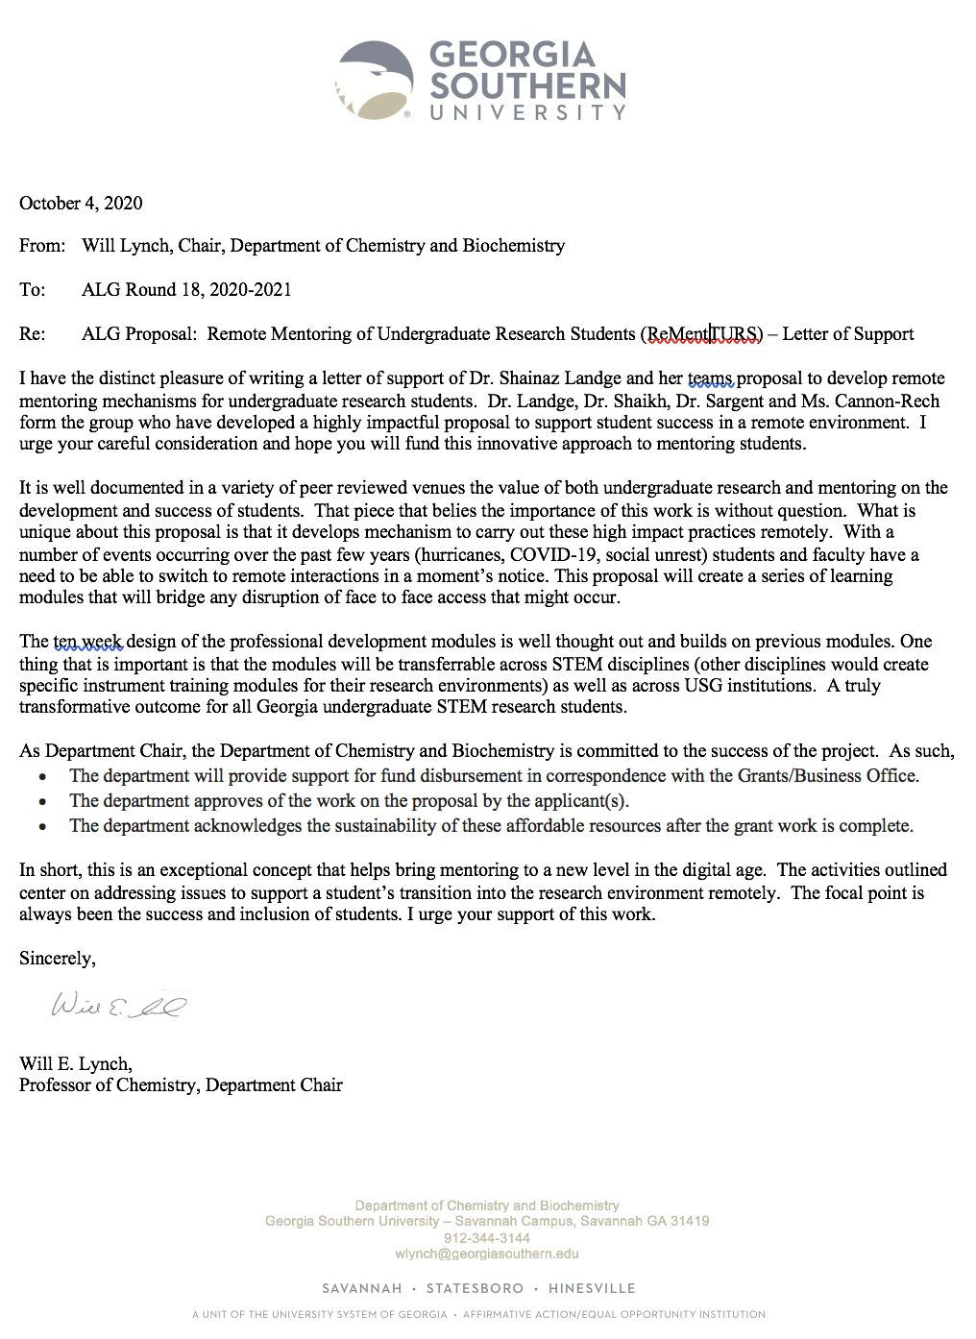

Grants or Business Office Letter of Acknowledgment
The letter from the ORSSP.
Please provide the name and title of the grants or business office representative who provided you with the Letter of Acknowledgment.
Bruxanne E. Hein, Ed.S., M.Ed., C.R.A.
Director, Office of Research Services & Sponsored Programs
Executive Director, Georgia Southern Research & Service Foundation
Georgia Southern University

