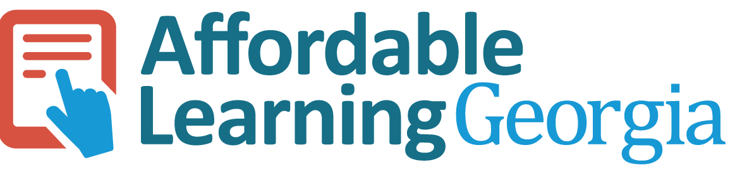

Grants/Business Office Acknowledgement Form

The Grants or Business Office signature below indicates the following:
- The Grants/Business Office is aware of this applicant’s intent to apply for an Affordable Materials Grant.
- The applicant has contacted the institution’s appropriate Grants/Business Office to discuss application and funding procedures.

_____________________________
Applicant Name

_____________________________
Grants/Business Office Representative Name

_____________________________
Grants/Business Office Representative Signature

