Affordable Materials Grants, Round 20:

Transformation Grants

(Fall 2021-Fall 2022)
Proposal Form and Narrative

Notes
- The proposal form and narrative .docx file is for offline drafting and for our review processes. Submitters must use the online Google Form for proposal submission.
- The only way to submit the official proposal is through the online Google Form. The link to the online application is on the Round 20 RFP Page.
- The italic text provided below is meant for clarifications and can be deleted.
The Round 20 Kickoff will include an asynchronous training module, required for all team members to complete, followed by the synchronous Kickoff Meeting on December 10, 2021 from 1pm-4pm. At least two team members from each awarded team (unless the award is for one individual) are required to attend the synchronous Kickoff Meeting.

Applicant and Team Information
The applicant is the proposed Project Lead for the grant project. The submitter is the person submitting the application (which may be a Grants Officer or Administrator). The submitter will often be the applicant—if so, just list leave the submitter blank.
Requested information | Answer
Institution(s) | Georgia Southern University
Applicant name | Shainaz Landge
Applicant email | slandge@georgiasouthern.edu
Applicant position/title | Assistant Professor of Chemistry and BioChemistry
Submitter name
Submitter email
Submitter position/title
Please provide the first/last names and email addresses of all team members within the proposed project. Include the applicant (Project Lead) in this list. Do not include prefixes or suffixes such as Ms., Dr., Ph.D., etc.
Team member | Name | Email address
Team member 1 | Shainaz Landge (Project Lead) | slandge@georgiasouthern.edu
Team member 2 | Debanjana Ghosh | dghosh@georgiasouthern.edu
Team member 3 | Elizabeth Sargent | esargent@georgiasouthern.edu
Team member 4 | Dawn Cannon-Rech (Library Liaison) | dcannonrech@georgiasouthern.edu
Team member 5 | Jeffrey Mortimore (Library Liaison) | jmortimore@georgiasouthern.edu
Team member 6 | Deborah Walker (The Faculty Center) | dwalker@georgiasouthern.edu
If you have any more team members to add, please enter their names and email addresses in the text box below.

Project Information
Requested information | Answer
Priority Category / Categories | Priority categories:  - Collaborative Projects with Professional Support  - Student Participation in Materials Evaluation and/or Development  - Departmental Scaling Projects
Requested Total Amount of Funding  $30,000 maximum total award per grant | $20,000
Final Semester of Project | All Transformation Grants for Round 20 end in Fall 2022.
Using OpenStax Textbook?  This is to indicate to OpenStax that they can provide additional support and resources to your team during the adoption process. | NO  Some links available on Libretexts and Merlot.  https://chem.libretexts.org/Ancillary_Materials/Exemplars_and_Case_Studies/Exemplars/Forensics/Chemistry_in_Forensics). (Link: https://www.merlot.org/merlot/viewMaterial.htm?id=773402761).

Impact Data
Please fill in the data below with impact data below with one course (all sections) in each table, and only include courses and instructors that are specifically part of the scope of this grant proposal. Add or remove tables as needed. Please only put a single averaged or totaled (as appropriate) number in each box. Do not put ranges or mathematical equations in any of these boxes. If the materials used by different instructors in a course vary drastically, it is possible to enter one course per instructor.
For a multi-course project, if a significant number of students are assumed to take courses in a sequence and only one textbook is used for these courses, please take this into account in your total (i.e. only include that book in the first course they would purchase it for OR adjust the number of students affected. Please explain in the notes section if making such adjustments).

Course 1
Row # | Requested information | Answer
N/A | Course title and number | Forensic Chemistry (CHEM 4160)
N/A | Course instructors | Shainaz Landge
1 | Average number of students enrolled per section | 32
2 | Average number of affected course sections scheduled in a summer semester | 0
3 | Average number of affected course sections scheduled in a fall semester | 0
4 | Average number of affected course sections scheduled in a spring semester | 1
5 | Total number of course sections scheduled in an academic year  Add up rows 2-4. | 1
6 | Total number of student section enrollments per academic year  Multiply row 1 and row 5. | 32
7 | Original required commercial materials | Basic Principles of Forensic Chemistry  by Javed I. Khan, Thomas J. Kennedy,  Donnell R. Christian Jr.  ISBN-13: 978-1934115060  ISBN-10: 1934115061
8 | Original cost per student section enrollment  Add up the cost of all materials in row 7. | $110
9 | Average post-project cost per student section enrollment | 0
10 | Average post-project savings per student section enrollment  Subtract row 9 from row 8. | $110
11 | Projected total annual student savings per academic year  Multiply row 10 and row 6. | $3520

Course 2
Row # | Requested information | Answer
N/A | Course title and number | Forensic Chemistry  (CHEM 7090)
N/A | Course instructor | Dr. Shainaz Landge
1 | Average number of students enrolled per section | 16
2 | Average number of course sections scheduled in a summer semester | 0
3 | Average number of course sections scheduled in a fall semester | 0
4 | Average number of course sections scheduled in a spring semester | 1
5 | Total number of course sections scheduled in an academic year | 1
6 | Total number of student section enrollments per academic year | 16
7 | Original required commercial materials | Basic Principles of Forensic Chemistry  by Javed I. Khan, Thomas J. Kennedy,  Donnell R. Christian Jr.  ISBN-13: 978-1934115060  ISBN-10: 1934115061
8 | Original cost per student section enrollment  Add up the cost of all materials in row 7. | $ 110
9 | Average post-project cost per student section enrollment | 0
10 | Average post-project savings per student section enrollment | $ 110
11 | Projected total annual student savings per academic year | $1760

Course 3
Row # | Requested information | Answer
N/A | Course title and number
N/A | Course instructor
1 | Average number of students enrolled per section
2 | Average number of course sections scheduled in a summer semester
3 | Average number of course sections scheduled in a fall semester
4 | Average number of course sections scheduled in a spring semester
5 | Total number of course sections scheduled in an academic year  Add up rows 2-4.
6 | Total number of student section enrollments per academic year  Multiply row 1 and row 5.
7 | Original required commercial materials  Include each title, author, price for a new copy purchased from either your campus bookstore, the publisher, or Amazon, and a URL to the book showing the price.
8 | Original cost per student section enrollment  Add up the cost of all materials in row 7.
9 | Average post-project cost per student section enrollment
10 | Average post-project savings per student section enrollment  Subtract row 9 from row 8.
11 | Projected total annual student savings per academic year  Multiply row 10 and row 6.

Course 4
Row # | Requested information | Answer
N/A | Course title and number
N/A | Course instructor
1 | Average number of students enrolled per section
2 | Average number of course sections scheduled in a summer semester
3 | Average number of course sections scheduled in a fall semester
4 | Average number of course sections scheduled in a spring semester
5 | Total number of course sections scheduled in an academic year  Add up rows 2-4.
6 | Total number of student section enrollments per academic year  Multiply row 1 and row 5.
7 | Original required commercial materials  Include each title, author, price for a new copy purchased from either your campus bookstore, the publisher, or Amazon, and a URL to the book showing the price.
8 | Original cost per student section enrollment  Add up the cost of all materials in row 7.
9 | Average post-project cost per student section enrollment
10 | Average post-project savings per student section enrollment  Subtract row 9 from row 8.
11 | Projected total annual student savings per academic year  Multiply row 10 and row 6.
If you have more courses to add, copy the table as many times as needed to complete all courses on the grant.

Narrative Section

1. Project Goals
Goals for a Transformation Grant project go beyond just cost savings. Include goals for student savings, student success, materials creation, and pedagogical transformation here.
The goal of this project is to develop free online open-educational resources (OER) material for the forensic chemistry course (CHEM 4160; CHEM 7090). Our aim is to also provide supplementary materials in terms of case studies, investigative approaches, technique videos, etc. which will align with the course materials and department needs. All developed resources will not only be shared in the department, but also be shared annually on the Galileo OER commons platform. Students are currently required to purchase a costly Forensic Chemistry text book for the course and this proposal will help to provide a no-cost instruction option which will improve student success and remove financial barriers to participation.
Following are the goals of this project:
1. To develop free online open-educational resources (OER) content for the Forensic chemistry course, CHEM 4160, CHEM 7090 aligned with the Course-based Undergraduate Research Experience instruction.
2. To create supplementary materials in terms of case studies, techniques, demo videos, which will align with the course materials and department needs in Forensic chemistry.
3. Publish finished products to Georgia Southern (GS) University’s libguide that will be the open educational resource for student accessibility and effectively reducing cost for GS students.

4. To develop assessment tools for measuring learning outcomes corresponding to learning objectives of CHEM 4160, CHEM 7090 course and use assessment results to improve future course offerings.
Project Goal 1: To develop free online open-educational resources (OER) content for the Forensic chemistry course, CHEM 4160, CHEM 7090 aligned with the Course-based Undergraduate Research Experience instruction.
The Forensic Chemistry course (CHEM 4160, CHEM 7090) at GS University will be taught in Spring 2022. This is a specialized course that will be offered face-to-face only once in an academic year. The prerequisites are a full year of general chemistry, organic chemistry, and analytical chemistry courses, one of which already uses OER materials (organic chemistry). Students taking this course will be able to describe and define the major topics in forensic science such as demonstrating lab safety, processing a crime scene, collecting, and analyzing evidence, critique the use of forensic evidence in historical crime scenes and finally drawing conclusions based on collected data and key findings. The courses will be set to align with the techniques of a Course-based Undergraduate Research Experiences (CURE) learning environment.¹ CURE courses are different from traditional knowledge inquiry-based courses and provide opportunities to create and innovate course content in a way that is of interest to a broader scientific community. It extends the comfortability to hypothesize, search and review literature, engage in iterative experimentation, collaborate to analyze research findings, and generate meaningful scientific conclusions.
Overall, this offers more authentic experience towards the practical applicability of science avoiding limitations of cookbook laboratory exercises. This high impact practices (HIPs) has seen to improve learning outcomes that resulted in improved student learning. Blending CURE with the curriculum of Forensic Chemistry makes the course a realistic combination towards the real-world application.
The course instruction will include a mix of lecture and demonstration of case studies. To accomplish learning goals, the project team will be involved in developing modules for CHEM 4160; CHEM 7090 that will be in adherence to the CURE instruction structure. So, that at the end of this course, students understand what forensic experts do, they are able to formulate a quantifiable hypothesis to test with research experimentation, design individual experiment, will be confident to execute their research project utilizing appropriate instrumental and statistical methods and finally communicate the results with scientific merit both orally and in writing.
Project Goal 2: To create supplementary materials in terms of case studies, techniques, demo videos, which will align with the course materials and department needs in Forensic chemistry.
Supplementary materials such as PowerPoint slide decks, problem sets, case studies pertaining to individual modules will be developed for students to apply their knowledge. Lab videos will be created to demonstrate case studies for certain modules.
Project Goal 3: Publish finished products to GS University’s libguide that will be the open educational resource for student accessibility and effectively reducing cost for GS students.
Georgia Southern University is a comprehensive university and one of the largest institutions in Southeast Georgia. Despite the pandemic, over 27,000 students enrolled for Fall 2021 to receive an overall academic experience at GS to pursue their future dream.² However, many of them face roadblocks in terms of affording college expenses, with a large section of them unable to bear the cost of textbooks and course supplies.³ This creates a tremendous pressure on their academic success, impacting their growth mindset and the sense of belonging. This often diminishes the urge to stay in college. Development of OERs and posting them through GS University’s libguide will provide equal accessibility to the course content without any cost. Ms. Dawn Cannon-Rech and Mr. Jeffrey Mortimore, GS University Library personnel at the Statesboro campus will be assisting to deploy the OER to libguide. This will definitely reduce the burden on the students to check on their finances for course supplies and receive uniform accessibility to course materials which eventually will motivate them to stay focused on the course objectives.
Project Goal 4: To develop assessment tools for measuring learning outcomes corresponding to learning objectives of CHEM 4160, CHEM 7090 course and use assessment results to improve future course offerings.

It is essential for any course to link learning outcomes to assessment. This often ensures how the students perceive classroom instruction and its reinforcement of the course objective and that mastery of material is effectively emphasized in course delivery. Forensic Chemistry course is more focused on hands-on skills and practical applications of forensic chemistry for real-life applications. So, knowledge will be formatively assessed using questions in the form of quizzes and learning activities through a combination of concepts testing, ability to decipher strategies for case studies and summatively assessed using exams and implementation of CURE based learning towards individual discoveries and student ability to disseminate their findings through oral presentation. The assessments, activities, case studies, and other instructional materials will be created in accordance with the learning outcomes. Course level assessment will also include pre and post surveys and subsequent data analysis to determine student satisfaction, retention, self-efficacy, science identity and other metrics of student success.

2. Statement of Transformation
Transformation Grants are awarded to focused on creating impactful changes. This section allows teams to describe why the project should be awarded. Include the following:
- A description of the current state of the course, department, and/or institution if relevant.
- An overall description of the project and how it will impact the course, department, and institution as described previously. Include references to scholarly literature to support the claims of your impact if possible.
Current State of the course:
Different disciplines of Forensic Science (e.g., Forensic Anthropology, Forensic Biology, Introduction to Forensic Nursing and the Law etc.) are offered at GS including Forensic Chemistry. CHEM 4160 and CHEM 7090 has been listed as a specialized course. Pertaining to the growing interest of developing real-world forensic questions and demand among the incoming freshmen who have career goals in forensic chemistry, this course will be offered for the Spring 2022 semester. So, for the project team it will be a complete reformation of the course with a new outlook through incorporation of CURE model.
Forensic Chemistry course [(CHEM 4160 focusses on Undergraduate students), (CHEM 7090 focusses on Graduate students)] introduce the fundamental concepts of forensic chemistry, which may include utilization of physical evidence in law enforcement, processing a crime scene, the application of chemistry principles to the identification and analysis of physical evidence, toxicology, microscopy, and aspects of arson. The prerequisite(s) for this course requires a minimum grade of "C" in Instrument chemistry (CHEM 3100) and Organic Chemistry II (CHEM 3402).

We propose to reduce the required cost for course materials from $110 per year to $0 by developing free course content to be available through the learning management system (LMS), folio. To strengthen student learning, supplementary lightboard videos will also be developed by the team members to allow the student to learn about forensic science.
Overall description of the project:
1. The team leaders in this project will be involved in creating a course syllabus detailing the prerequisites of this course, student learning outcomes (SLOs) and plan for a timeline of content delivery, assignments and inquiry based deliverables. Their time and effort will be dedicated to developing content for this course. A framework will be like the following:
Complying SLO #1. Define and describe the major topics in forensic science, including processing a crime scene, physical evidence, firearms and impressions, hairs and fibers, drugs, serology, and questioned documents.
Content to be developed: Foundations of Chemistry and the Law (Measurements, Uncertainty, and Statistics), Spectroscopy and Spectrometry, Chromatography (Gas/Liquid), Sample preparation, Crime scene sketching and collection of evidence.
Complying SLO #2. Analyze and critique the use of forensic evidence in historical crimes.
Content to be developed: Drugs as physical evidence, analysis of seized drugs, forensic drugs and drugs in the body, classification of fingerprints, chemistry of combustion and arson, explosives and firearms chemical evidence, chemistry of colorants, polymers, forensic analysis of inks, impressions on glass and chemical analysis of materials (hair, fiber, paints etc.)
Complying SLOs #3 & 4. Follow protocol for general lab safety, conduct primary literature search, form hypotheses, assess, and execute experiments aligned with research questions; and Perform analyses of evidence in a mock crime scene using appropriate statistical and spectroscopic techniques, draw conclusions based on class data, and present key findings in written/oral form.
Content to be developed: CURE model will be incorporated in these SLOs. This will include assignments to be completed in a group. There will be 3 assignments: (a) An experimental plan that will be covering the aim of research, previous results or past works, a laboratory protocol, and a list of necessary materials, (b) a finalized experimental plan if the original plan needs modification or there are questions about the feasibility of exploiting the experiments, and (c) report documenting for experimental goals and communicate their new discoveries.
Project Impact: Students who will choose to attend GS and take up the course will be benefited with this no-cost course structure. This course is meant for individuals who have interest in forensic science and have career goals in that field. They will no longer have to face the financial burden of choosing a specialized course and will be allowed to focus on learning. Moreover, this course will be designed on the framework of CURE that will provide them a truly interactive environment compassing the practical applicability and receiving hands-on skills on various instrumentation required for forensic chemistry. Research has shown that students are more motivated to learn science when the content is more relevant to experiences in their everyday lives.⁴
Impact on the course: This course will be offered typically once in an academic year and intermittently in short summer terms. The newly designed course will be shared among faculties in the department and the course materials will be uploaded in library repository for equal access by the students. Starting from syllabus to the entire content and supplementary materials of this course shared in a common folder of the department will constitute the resources for future advancement in teaching and reformation as needed. With complete availability to the course content and supplementary material, the students will take advantage of the opportunity and thus be able to achieve higher student learning gains. Since these materials will also remain publicly available and freely accessible in perpetuity, students will also be able to access the material for review of content after the course has ended.
Impact on department and institution: All the team members in this project are part of the forensic chemistry group in the Statesboro campus of the department and hence will be involved and aware of each part of the implementation process. This no-cost transformation of the forensic chemistry course will potentially increase admission rates in the Chemistry and Biochemistry department which eventually will influence the overall enrollment in the institution. This curriculum is focused on the chemistry aspects of forensic science in parallel to the other forensic science disciplines at GS (Forensic Anthropology, Forensic Biology, Introduction to Forensic Nursing and the Law etc.). This has the potential to create a new curriculum of bachelor programs in science with a concentration in forensic chemistry. The Inclusive access to the course materials for all of the students taking the course is expected to increase student success, which will be clearly seen at the university level in terms of retention, progression, and graduation rates.
Georgia Southern acquired the old Georgia Bureau of Investigation (GBI) crime laboratory in Savannah. The GBI laboratory encompasses five buildings and in future we envision using for offices, conference rooms, classrooms, and labs. Our current OER course development will definitely impact the institution’s mission in forensic science at multiple campuses.

3. Action Plan
Transformation Grant projects are work-intensive and require project management in order to be successful. This section allows teams to describe how the team will fulfill the goals of the project. This section must include:
- The role(s) of each team member in the project with details as to the major tasks team members will complete, with an estimate of how long each task will take (e.g. number of hours).
- A review of existing open, no-cost, and/or low-cost course materials for the course(s).
- The plan for the selection, adoption, adaptation, and/or creation of new course materials (if applicable). Include plans for open licensing and plans for making your materials accessible.
- The plan for redesigning your course(s), including any instructional design work, curriculum alignment, course accessibility changes, etc.
- The plan for providing open access to the new materials. Affordable Learning Georgia will host any newly created materials in our repository; please indicate if you are using other platforms in addition to the repository to host them.
Implementation of this project will involve both the content developers (Drs. Landge and Ghosh) who will be teaching forensic chemistry [now (Landge) and in future (Landge and Ghosh)] at the Statesboro campus. The roles of the team members and efforts are mentioned below:
Project lead: Dr. Shainaz Landge will be responsible for identifying, aligning, preparing, and adapting the course content for the Forensic Chemistry course. She will be a lead contact for the team members, the COSM library liaisons, the Faculty Center and any other faculty members who plan to teach this course in future and students. She will oversee the development of new materials for the forensic chemistry course with the help of team members. She will align the new resources and assessment instruments with the textbook and student learning outcomes. She will be involved throughout the course of the project.
Team Member: Dr. Debanjana Ghosh will be responsible for identifying, aligning, preparing, adapting, and assessing all new videos for the Forensic Chemistry course. She will also help the project lead to develop the course content. She will be involved throughout the course of the project.
Team Member: Dr. Elizabeth Sargent will be responsible for creating the assessment tools, data sharing, data collection and data assessing for this study. She will be involved throughout the course of the project.
The COSM library liaisons (Dawn Cannon-Rech and Jeffrey Mortimore) will assist in training, identifying and finally distributing the newly created resource material as modules by uploading on common resources GALILEO OER website and library guides (lib guide). They will help us in summer to update the libguides website.
The Faculty Center Interim Director (Deborah Walker) will help us to edit and brand the supplementary videos created for this project. She will help us in the Spring semester to edit the video modules.
The undergraduate student assistants (TBD) will aid in all areas of assessment of this project.
Few of the libretext links on forensic chemistry are available as open content; for example (Link: https://chem.libretexts.org/Ancillary_Materials/Exemplars_and_Case_Studies/Exemplars/Forensics/Chemistry_in_Forensics).⁵ Also an “Interdisciplinary Perspectives on - Chemistry in Crime and Law Enforcement” material is available open access on merlot website (Link: https://www.merlot.org/merlot/viewMaterial.htm?id=773402761).⁶ Similar content will be developed especially for the demonstration of forensic cases and shared with students. The material curated in this project will help other course mentors who want to teach this course and will align with our departmental student learning outcomes.
All course materials will be redesigned to ensure they refer to the new content appropriately. The material will be linked with the libguides as modules on the GS library webpage and on Galileo OER platform. Once uploaded on libguides and shared on USG – Affordable Learning Georgia (ALG) website it will be free for anybody to use under CC BY 4.0 license.

4. Quantitative and Qualitative Measures
All Transformation Grant projects must measure student satisfaction, student performance, and course-level retention (drop/fail/withdrawal rates), but teams and institutions will do this in varied ways. Outstanding applications will include measures beyond the minimum to gain meaningful insights into the impact of the project. Include the following:
Forensic chemistry course taught during the Spring 2022 will undergo a textbook transformation. If successful, all future semesters will also undergo systematic updated transformation. The team leaders Dr. Shainaz Landge and Dr. Debanjana Ghosh are members of the departmental assessment committee. Dr. Landge will oversee the development of assessment tools and collection of the data focusing on student satisfaction, performance, and course level retention. An assessment personnel (Dr. Sargent) is part of our current team who will be responsible for development of surveys, collection, and assessment of data. Two undergraduate research students will assist with all assessment activities and also to help Team leaders.
Student satisfaction – In addition to the university-administered course evaluations, student satisfaction will be measured via an adapted version of the 2018 Jaggers et al.⁷ We will ask students to compare their OER experience to previous science courses which did not use OER materials. Questions will be rated on a five point Likert scale (1 = a lot worse, 5 = a lot better) and will include student satisfaction in the following categories: quality of OER materials, Integration of OER materials with course assessment, and use experience of OER materials.
Student performance – Overall course grades (mid and final exam) will be assessed periodically to this new OER offering as a measure of general student outcomes. More specific student learning outcomes within this OER forensic chemistry courses will be evaluated using summative assessments throughout the term, such as exam and team performance.
Course-level retention – After the initial roll out of these OER materials in Spring 2022, changes will be made to improve the course for future semesters. After multiple iterations of this course are run using OER materials, a longitudinal assessment of course-level retention and graduation rates will be conducted. The DFW rates will also be compared with previous iterations of this course using traditional materials as a measure of the effectiveness of OER on student success and long-term retention.
Additional Quantitative measures – Metrics likely to influence student retention in the sciences more broadly will be assessed using an adapted version of the 2016 Hanauer et al. Jaggers et al. College Student Persistence in the Sciences survey.⁸ We will ask students to rate their self-efficacy and science identity at the beginning and end of the course to compare change over time.
Additional Qualitative measures – The faculty experience of OER materials will also be qualitatively assessed through focus groups at the end of the semester. Faculty will be asked to reflect on their experience of leading the course using OER materials compared to traditional materials and to discuss improvement of materials for future use.
Institutional Review Board (IRB) – An IRB approval will be sought in December of 2021 before implementing the materials and gathering the data from the student in the Spring 2022 course. Students will be given informed consent documents and those that choose to participate will have their anonymized data used for assessment purposes.
Proper attention will be given to the above generated qualitative and quantitative assessment tools to check their reliability, incorporation during the semester, and alignment to the material

5. Timeline
This section allows teams to describe how the project will progress from its inception to the Final Report. Please provide a list of major milestones, events, and deadlines, aligned with your Action Plan and the final semester of your project. Include the submission of your Final Report in this list.
November-December 2021
● Review and selection of free, online materials available on the OER websites such as OpenStax, Merlot, libretexts and other relevant free content websites.
● Development of the course objectives, learning outcomes, demo activities, assessment plan and creating a libguide template to be uploaded on GS universities library websites.
● Dissemination of course plans with all the members involved in the grant.
● IRB approval process

January – May 2022
● Generation of supplementary module videos (lightboard or YuJa or in-lab technique demos), PowerPoint slide deck, and demo workshops for the semester-long course by the project leads.
● Development of libguide materials and alignment with learning objectives for the
Forensic Chemistry course.
● Dissemination of new materials to students who are enrolled in the forensic chemistry course.
● Introduction of the pre and post course surveys to the students to assess their mindset and motivation towards the newly generated OER materials.

Summer 2022
● Data collection and analysis of assessments and student and faculty feedback
● Assessment and evaluation of the course and participants
● Revision of modules as needed for incorporation in future semesters.
Fall 2022
● Publication of edited and adapted course materials through the OER libguide GSU
library website.
● Continued assessment and evaluation of the course materials.
● Continued revision of modules as needed

December 2022/Spring 2023
● Submission of the final report to the USG - ALG grant
● Dissemination of results in USG/STEM Learning and Teaching conferences, and/or at a
regional Chemistry conference and peer-reviewed publications.

6. Budget
Please enter your project’s budget below. Include personnel and projected expenses, keeping in mind that this funds the estimated time in your Action Plan. The maximum amounts for the award are as follows:
- $5,000 maximum per team member for salary, course release, travel, etc.
- Additional project expenses allowed, but must be adequately justified in this section
- $30,000 maximum total award per grant

Dr. Shainaz Landge, $5000

Dr. Landge will need time to review, create, assess, and finalize the online resources available for the forensic chemistry textbook, coordinate team members, develop supplementary materials, create assessment tools, and disseminate new materials on library websites as libguides.

Dr. Debanjana Ghosh, $5000
Dr. Ghosh will need time to review, create, assess, and finalize the online resources available for the textbook, coordinate team members, and develop supplementary materials.
Dr. Elizabeth Sargent, $5000
Dr. Sargent will need time during the spring and summer to develop new assessment tools,
provide the tools to the students and assess the data for the Spring and Summer semester.
She is also responsible for sharing the material on Armstrong Campus (GSU)

Undergraduate Students, $2000
Two UG students will be hired for 20 weeks in the Spring and Summer semester for 5 hours
per week @ 10 dollars per hour to work on creating the demo videos and participating in training videos. They will also help the team members as needed.

Supplies, $2000
Funds will be used to purchase student demo experimental (at least 12 set ups) supplies such as:
Fake Blood; Cloth material; demo crime scenes; forensic finger printing kits; drug detection kits; soil detection kits; cation (lead; arsenic) and anion (fluoride) detection kits or papers. Chromatographic papers (ink analysis); solvents to run the chromatographic techniques; thin layer chromatographic plates; fake money detection pen; UV lights etc. $2000 will be used to create student demo kits.

Travel, $1000
Funds will be used for registration and travel to attend University System of Georgia (UGA) or STEM or Scholarship of Teaching and Learning conference.

Total = $ 20,000

7. Sustainability Plan
Transformation Grants should have a lasting impact on the course for years to come. In order for this to happen, a Sustainability Plan needs to be in place after the end of the project. Please include here your plans for offering the course in the future, including:
Currently, Forensic Chemistry will be taught only by the PI, but in future it will be taught by other team members as well. With the overall team overseeing the course, maintaining the continuity, sustainability and updating of the course materials is ensured for years to come. The team will be responsible and guarantee that the:
- course materials are up to current standards and applicable in future semesters.
- first roll out of the forensic chemistry course will be used as a pilot and will make necessary changes to the generated Libguides to optimize it for future and continued use.
- generated product will be hosted as an Open Educational Resource (OER) on the Library Guides (LibGuides) platform of Georgia Southern University
- OER LibGuide for future offerings of this Department of Chemistry course across all Georgia Southern campuses and will make it available for use at other institutions by sharing the link University System of Georgia website as well as through the Affordable Learning Georgia website providing long term sustainable solutions.
- assessment results will be shared and promote this OER resource through scientific presentations on various local, regional, and national conferences focused on teaching and learning (USG, STEM, SoTL), and chemical education (American Chemical Society) conferences. It will also be disseminated via peer-reviewed journals such as Journal of Chemical Education or International Journal of Scholarship of Teaching and Learning (IJSoTL).
- student feedback will be gathered to improve and enhance the LibGuide materials and will continue to maintain and update the LibGuide materials in response to user feedback.

Creative Commons Terms
I understand that any new materials or revisions created with ALG funding will, by default, be made available to the public under a Creative Commons Attribution License (CC-BY), with exceptions for modifications of pre-existing resources with a more restrictive license.

Accessibility Terms
I understand that any new materials or revisions created with Affordable Learning Georgia funding must be developed in compliance with the specific accessibility standards defined in the Request for Proposals.

Letter of Support
The Department Chair from the corresponding project, or the Department Chair’s direct report such as the Dean or Provost, must provide a signed Letter of Support for the project. This letter should acknowledge the following:
- The department will provide support for fund disbursement in correspondence with the Grants/Business Office.
- The department approves of the work on the proposal by the applicant(s).
- The department acknowledges the sustainability of the use of these affordable resources after the grant work is complete.

In the case of multi-institutional affiliations, all participants’ institutions must provide a letter of support.

Please provide the name and title of the department chair (or other administrator) who provided you with the Letter of Support.
Dr. Will Lynch
Chair, Department of Chemistry and Biochemistry
Georgia Southern University
Statesboro, GA - 30460

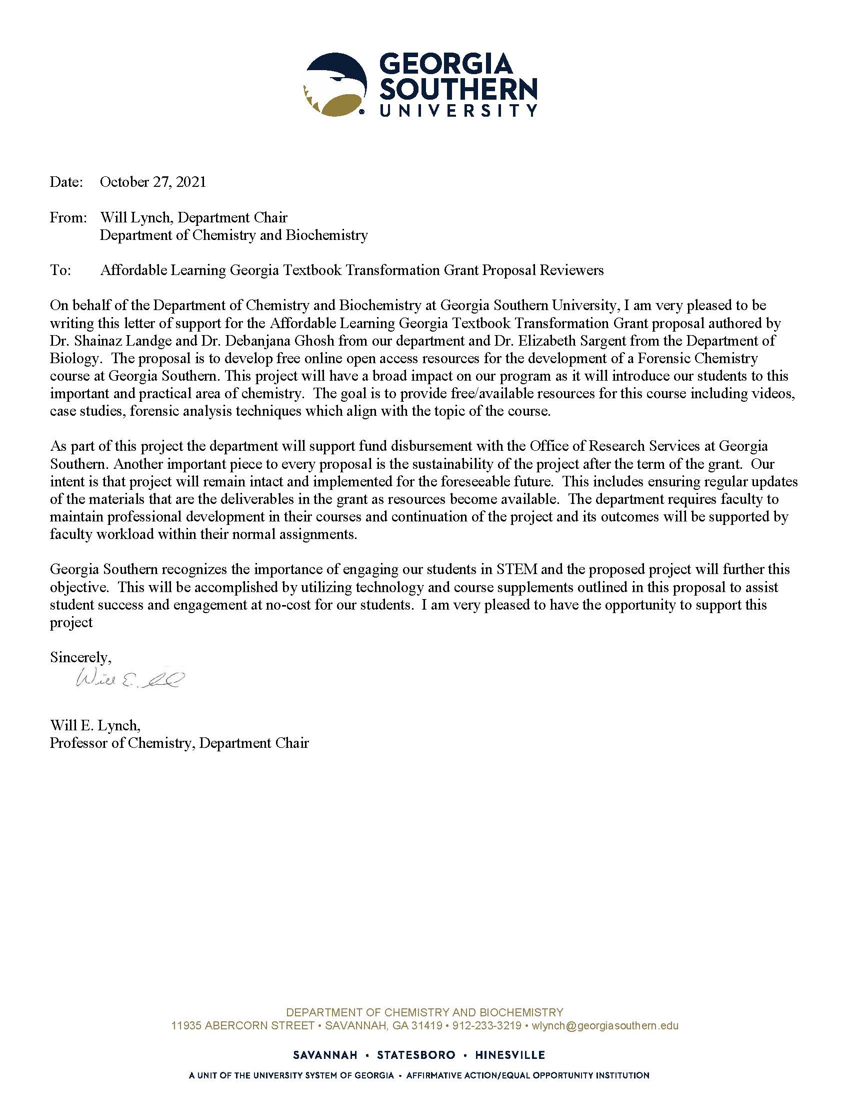

Grants or Business Office Acknowledgment Form
Institutional Grants/Business Offices will be responsible for fund disbursement, often in correspondence with the Department Chair, including expense and travel reimbursement. All applicants will need to provide a signed Acknowledgement Form, the template for which is linked on the RFP page, stating that the Grants/Business Office knows about the applicant’s intent to apply for an Affordable Materials Grant. Either the Department Chair or the Project Lead can work with the Grants/Business Office to get this signed form. In the case of multi-institutional affiliations, all participants’ institutions must provide this form. Please provide the name and title of the grants or business office representative who provided you with the acknowledgement form.
Dr. Laura Regassa
Interim Associate Provost for Research
lregassa@georgiasouthern.edu

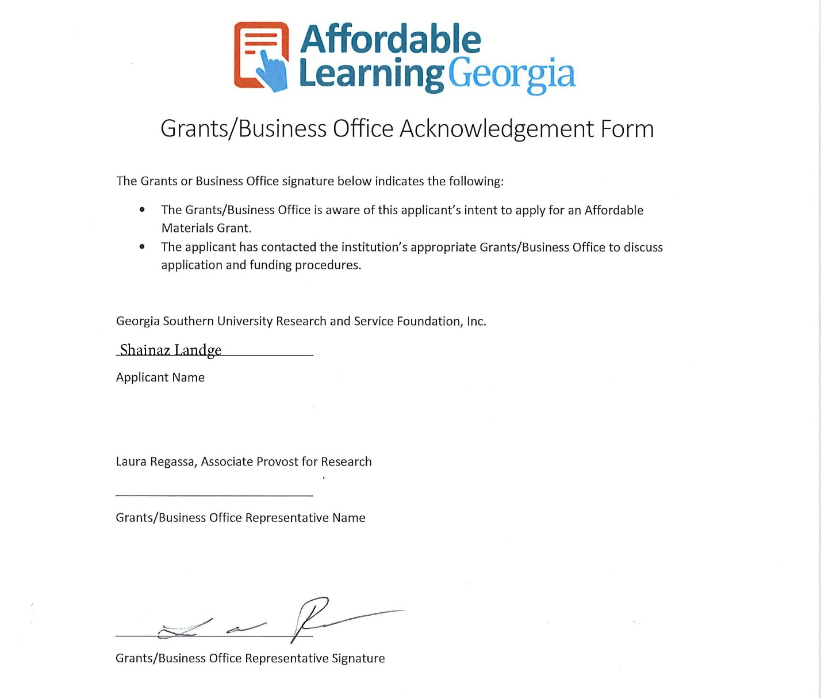
Appendix I
References:
- (a) Gita Bangera and Sara E. Brownell; CBE—Life Sciences Education 2014 13:4, 602-606; (b) Lisa Corwin Auchincloss, Sandra L. Laursen, Janet L. Branchaw, Kevin Eagan, Mark Graham, David I. Hanauer, Gwendolyn Lawrie, Colleen M. McLinn, Nancy Pelaez, Susan Rowland, Marcy Towns, Nancy M. Trautmann, Pratibha Varma-Nelson, Timothy J. Weston, and Erin L. Dolan CBE—Life Sciences Education 2014 13:1, 29-40; (c) Dolan (2017). Course-based Undergraduate Research Experiences: Current knowledge and future directions].
- https://www.statesboroherald.com/local/marrero-gs-enrollment-should-top-27000-now-29000-2026/ [Last accessed on October 25th, 2021]
- https://www.usnews.com/news/articles/2014/01/28/report-high-textbook-prices-have-college-students-struggling, https://www.insidehighered.com/news/2018/07/26/students-sacrifice-meals-and-trips-home-pay-textbooks [Last accessed on October 25th, 2021]
- Etkina, E.; Mestre, P. J., Implications of Learning Research for Teaching Science to Non-Science Majors. 2004.
- https://chem.libretexts.org/Ancillary_Materials/Exemplars_and_Case_Studies/Exemplars/Forensics/Chemistry_in_Forensics [Last accessed on October 25th, 2021]
- https://www.merlot.org/merlot/viewMaterial.htm?id=773402761 [Last accessed on October 25th 2021]
- Shanna Smith Jaggars, Amanda L. Folk, David Mullins, (2018) "Understanding students’ satisfaction with OERs as course materials", Performance Measurement and Metrics, Vol. 19 Issue: 1, pp.66-74, https://doi.org/10.1108/PMM-12-2017-0059.
- David I. Hanauer, Mark J. Graham, and Graham, F. Hatfull, (2016) " A Measure of College Student Persistence in the Sciences (PITS)", CBE – Life Sciences Education, Vol. 15 Issue: 4, ar54 https://doi.org/10.1187/cbe.15-09-0185

