2022
Affordable Materials Grant ALG #563
Final Report

Diana Mindrila, Ph.D.
Mary Alice Varga, Ph.D.
Mandi Campbell, Ed.S.
University of West Georgia

Affordable Materials Grant (AMG) #563
Final Report
The plan for this project grew from the dissatisfaction of using dated textbooks to teach a course when there is a wealth of current resources online that might better meet student needs. The courses impacted by this project were all taught in an asynchronous, online format so we had additional goals related to online learning and professional development for our students. Creating opportunities for students to engage with the course content in a variety of ways and to explore meaningful applications of course content for their specific professional interests added great value to the courses. A final goal was to include support for student discussions and collaborative work.
This project supported the development of topic modules that replaced the former textbook. Each module provided an outline of key information for the topic and included links to online open educational resources (OER) and library resources for deeper learning. To have the most impact on student saving, the topic modules were designed to be easily modified and flexible enough to meet individual instructor needs so that they could be used for several different courses. Additional goals for this project included instructional design strategies to support transformative pedagogy and engaged student learning by inviting students to collaborate with the development, revision, and expansion of the modules. To be sustainable, these resources needed to be continually updated and expanded to meet student needs and to represent new developments in education and in classroom assessment. Each topic module engaged students to pursue further research in areas of personal interest, critically examine issues and trending topics, and contribute through discussions and collaborative work. Each module linked to a Google Doc that allowed students to share resources, discuss issues, and work collaboratively. Instructors updated modules with appropriate resources and other student contributions each semester and linked a new Google Doc to each module when a new course began.
All learning materials developed or collected for this project were from open sources. They consisted of videos developed by the instructor, videos provided online by through other educational sources, reading materials, presentations, exercises, etc. At the completion of the course, students were asked to fill out a survey assessing the effectiveness of the instructional materials. Specifically, we asked students to rate their level of satisfaction with each instructional module and to indicate the extent to which learning materials in each module effectively supported their learning. Additionally, we asked students to specify what type of materials were most helpful (i.e. videos, websites, lectures, etc.) and to provide suggestions for improvement.
On the first question, students rated their satisfaction with the course learning module on a scale from 0 (Very Unsatisfied) to 5 (Very Satisfied). As indicated in Figure 1, the great majority of students was satisfied or very satisfied with all learning modules, and only three learning modules received neutral ratings (Table 1). Average overall ratings were high and ranged between 4.29 and 4.86 (Table 2). The learning modules with the lowest ratings were “Why is Assessment Essential?” (M=4.29, SD=0.70) and “Learning Goals and Taxonomies” (M=4.29, SD=0.70). The learning module with the highest rating (M=4.86, SD=0.35) was “Grading and Communicating about Student Achievement”.
Figure 1. Student satisfaction with course learning modules: Response frequencies
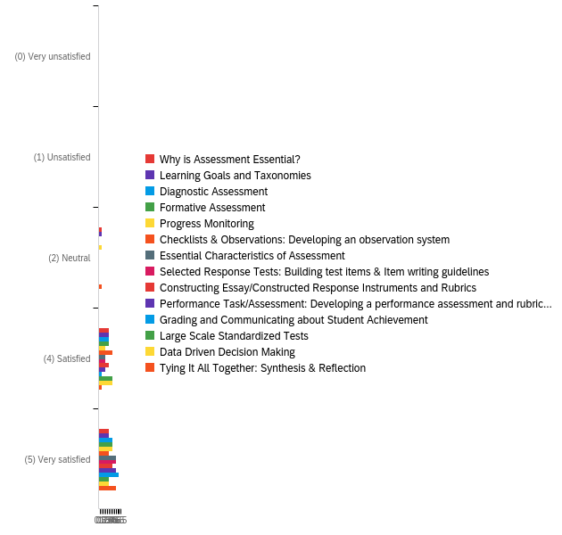

Table 1.
Student Satisfaction with Course Learning Modules: Item Response Distribution
Learning Module | (0) Very unsatisfied |  | (1) Unsatisfied |  | (2) Neutral |  | (4) Satisfied |  | (5) Very satisfied
 | % | n | % | n | % | n | % | n | % | n
Why is Assessment Essential? | 0.00% | 0 | 0.00% | 0 | 14.29% | 1 | 42.86% | 3 | 42.86% | 3
Learning Goals and Taxonomies | 0.00% | 0 | 0.00% | 0 | 14.29% | 1 | 42.86% | 3 | 42.86% | 3
Diagnostic Assessment | 0.00% | 0 | 0.00% | 0 | 0.00% | 0 | 42.86% | 3 | 57.14% | 4
Formative Assessment | 0.00% | 0 | 0.00% | 0 | 0.00% | 0 | 42.86% | 3 | 57.14% | 4
Progress Monitoring | 0.00% | 0 | 0.00% | 0 | 14.29% | 1 | 28.57% | 2 | 57.14% | 4
Checklists & Observations: Developing an observation system | 0.00% | 0 | 0.00% | 0 | 0.00% | 0 | 57.14% | 4 | 42.86% | 3
Essential Characteristics of Assessment | 0.00% | 0 | 0.00% | 0 | 0.00% | 0 | 28.57% | 2 | 71.43% | 5
Selected Response Tests: Building test items & Item writing guidelines | 0.00% | 0 | 0.00% | 0 | 0.00% | 0 | 28.57% | 2 | 71.43% | 5
Constructing Essay/Constructed Response Instruments and Rubrics | 0.00% | 0 | 0.00% | 0 | 0.00% | 0 | 42.86% | 3 | 57.14% | 4
Performance Task/Assessment: Developing a performance assessment and rubric for use in the classroom | 0.00% | 0 | 0.00% | 0 | 0.00% | 0 | 28.57% | 2 | 71.43% | 5
Grading and Communicating about Student Achievement | 0.00% | 0 | 0.00% | 0 | 0.00% | 0 | 14.29% | 1 | 85.71% | 6
Large Scale Standardized Tests | 0.00% | 0 | 0.00% | 0 | 0.00% | 0 | 57.14% | 4 | 42.86% | 3
Data Driven Decision Making | 0.00% | 0 | 0.00% | 0 | 0.00% | 0 | 57.14% | 4 | 42.86% | 3
Tying It All Together: Synthesis & Reflection | 0.00% | 0 | 0.00% | 0 | 14.29% | 1 | 14.29% | 1 | 71.43% | 5

Table 2.
Student Satisfaction with Course Learning Modules: Summary Statistics
Learning module | Minimum | Maximum | Mean  (M) | Standard Deviation  (SD) | Variance
Grading and Communicating about Student Achievement | 4.00 | 5.00 | 4.86 | 0.35 | 0.12
Essential Characteristics of Assessment | 4.00 | 5.00 | 4.71 | 0.45 | 0.20
Selected Response Tests: Building test items &amp; Item writing guidelines | 4.00 | 5.00 | 4.71 | 0.45 | 0.20
Performance Task/Assessment: Developing a performance assessment and rubric for use in the classroom | 4.00 | 5.00 | 4.71 | 0.45 | 0.20
Diagnostic Assessment | 4.00 | 5.00 | 4.57 | 0.49 | 0.24
Formative Assessment | 4.00 | 5.00 | 4.57 | 0.49 | 0.24
Constructing Essay/Constructed Response Instruments and Rubrics | 4.00 | 5.00 | 4.57 | 0.49 | 0.24
Tying It All Together: Synthesis and Reflection | 3.00 | 5.00 | 4.57 | 0.73 | 0.53
Progress Monitoring | 3.00 | 5.00 | 4.43 | 0.73 | 0.53
Checklists &amp; Observations: Developing an observation system | 4.00 | 5.00 | 4.43 | 0.49 | 0.24
Large Scale Standardized Tests | 4.00 | 5.00 | 4.43 | 0.49 | 0.24
Data Driven Decision Making | 4.00 | 5.00 | 4.43 | 0.49 | 0.24
Why is Assessment Essential? | 3.00 | 5.00 | 4.29 | 0.70 | 0.49
Learning Goals and Taxonomies | 3.00 | 5.00 | 4.29 | 0.70 | 0.49

The survey also asked students how well the course learning modules assisted their learning of the specific topics. Student responses were measured on a scale from 0 (Very Unsatisfied) to 5 (Very Satisfied). As indicated in Figure 2, all students were satisfied or very satisfied with the extent to which learning modules supported their learning (Table 3). Average overall ratings for the perceived learning value of content modules were very high and ranged between 4.50 and 4.75. Table 4 lists the mean ratings and other summary statistics for all learning modules.
Figure 2. Module learning value: Response frequencies
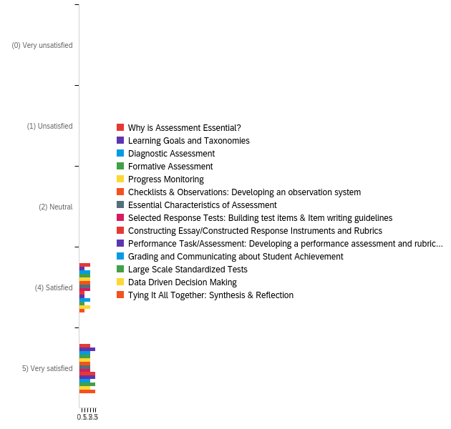

Table 3.
Module Learning Value: Item Response Distribution
Module | (0) Very unsatisfied |  | (1) Unsatisfied |  | (2) Neutral |  | (4) Satisfied |  | 5) Very satisfied
 | % | n | % | n | % | n | % | n | % | n
Why is Assessment Essential? | 0.00% | 0 | 0.00% | 0 | 0.00% | 0 | 50.00% | 2 | 50.00% | 2
Learning Goals and Taxonomies | 0.00% | 0 | 0.00% | 0 | 0.00% | 0 | 25.00% | 1 | 75.00% | 3
Diagnostic Assessment | 0.00% | 0 | 0.00% | 0 | 0.00% | 0 | 50.00% | 2 | 50.00% | 2
Formative Assessment | 0.00% | 0 | 0.00% | 0 | 0.00% | 0 | 50.00% | 2 | 50.00% | 2
Progress Monitoring | 0.00% | 0 | 0.00% | 0 | 0.00% | 0 | 50.00% | 2 | 50.00% | 2
Checklists & Observations: Developing an observation system | 0.00% | 0 | 0.00% | 0 | 0.00% | 0 | 50.00% | 2 | 50.00% | 2
Essential Characteristics of Assessment | 0.00% | 0 | 0.00% | 0 | 0.00% | 0 | 50.00% | 2 | 50.00% | 2
Selected Response Tests: Building test items & Item writing guidelines | 0.00% | 0 | 0.00% | 0 | 0.00% | 0 | 50.00% | 2 | 50.00% | 2
Constructing Essay/Constructed Response Instruments and Rubrics | 0.00% | 0 | 0.00% | 0 | 0.00% | 0 | 25.00% | 1 | 75.00% | 3
Performance Task/Assessment: Developing a performance assessment and rubric for use in the classroom | 0.00% | 0 | 0.00% | 0 | 0.00% | 0 | 25.00% | 1 | 75.00% | 3
Grading and Communicating about Student Achievement | 0.00% | 0 | 0.00% | 0 | 0.00% | 0 | 50.00% | 2 | 50.00% | 2
Large Scale Standardized Tests | 0.00% | 0 | 0.00% | 0 | 0.00% | 0 | 25.00% | 1 | 75.00% | 3
Data Driven Decision Making | 0.00% | 0 | 0.00% | 0 | 0.00% | 0 | 50.00% | 2 | 50.00% | 2
Tying It All Together: Synthesis & Reflection | 0.00% | 0 | 0.00% | 0 | 0.00% | 0 | 25.00% | 1 | 75.00% | 3

Table 4.
Module Learning Value: Summary Statistics
Module | Minimum | Maximum | Mean  (M) | Standard Deviation  (SD) | Variance
Learning Goals and Taxonomies | 4.00 | 5.00 | 4.75 | 0.43 | 0.19
Constructing Essay/Constructed Response Instruments and Rubrics | 4.00 | 5.00 | 4.75 | 0.43 | 0.19
Performance Task/Assessment: Developing a performance assessment and rubric for use in the classroom | 4.00 | 5.00 | 4.75 | 0.43 | 0.19
Large Scale Standardized Tests | 4.00 | 5.00 | 4.75 | 0.43 | 0.19
Tying It All Together: Synthesis & Reflection | 4.00 | 5.00 | 4.75 | 0.43 | 0.19
Why is Assessment Essential? | 4.00 | 5.00 | 4.50 | 0.50 | 0.25
Diagnostic Assessment | 4.00 | 5.00 | 4.50 | 0.50 | 0.25
Formative Assessment | 4.00 | 5.00 | 4.50 | 0.50 | 0.25
Progress Monitoring | 4.00 | 5.00 | 4.50 | 0.50 | 0.25
Checklists &amp; Observations: Developing an observation system | 4.00 | 5.00 | 4.50 | 0.50 | 0.25
Essential Characteristics of Assessment | 4.00 | 5.00 | 4.50 | 0.50 | 0.25
Selected Response Tests: Building test items &amp; Item writing guidelines | 4.00 | 5.00 | 4.50 | 0.50 | 0.25
Grading and Communicating about Student Achievement | 4.00 | 5.00 | 4.50 | 0.50 | 0.25
Data Driven Decision Making | 4.00 | 5.00 | 4.50 | 0.50 | 0.25

As shown in Figure 3, students indicated that the most helpful types of educational resources were websites, followed by instructional videos created by the instructor or by someone other than the course instructor (Table 5). Some responded that “other” instructional resources were most helpful and specified that the examples provided for each course assignment were the most useful resources. Table 6 lists open student responses providing feedback on the usefulness of the course learning materials.

Figure 3. Perceived helpfulness of instructional resources: Response frequencies

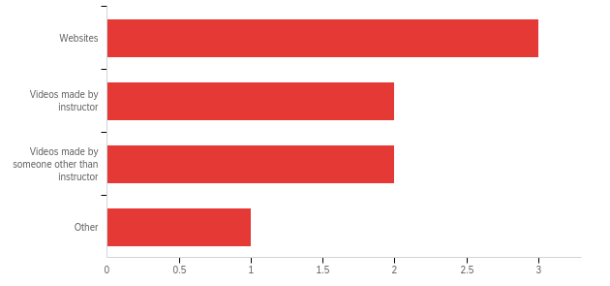
Table 5
Perceived Helpfulness of Instructional Resources: Response Distribution
Instructional Resource | %
Websites | 37.50%
Videos made by instructor | 25.00%
Videos made by someone other than instructor | 25.00%
Other | 12.50%
Total | 100%

Table 6.
Student Feedback on Course Materials
Question | Response
What were the most helpful materials in your learning of school and classroom assessment? | “The most helpful thing was the examples!! This provides a tool for us to see what you expect & what the assignment is asking”!
 | “The tasks we completed were very helpful”.
 | “I liked the websites and videos the best”.
What were the least helpful materials in your learning of school and classroom assessment? | “Everything was very helpful”.
 | “None. All were helpful”.
Do you have additional feedback that would support the further development of the course materials? | “The course was good”!!
 | “No”.

Conclusion
In summary, results from the evaluation survey showed that students were very satisfied with the course materials. Students indicated that all course materials in all learning modules were effective in supporting their learning and specified that websites, videos, and task examples were the most helpful instructional resources. Students indicated that all course materials were useful and no improvements were necessary.

