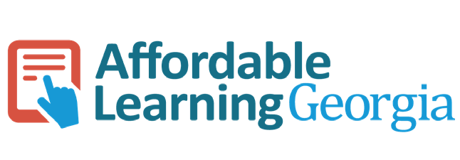

Jeff Gallant, Program Manager
Marie Lasseter, Ed.D., Director, Academic Technologies Affordable Learning Georgia

2018 USG Survey Report on
Open Educational Resources
2018 USG Survey Report on Open Educational Resources

Jeff Gallant, Program Manager
Marie Lasseter, Ed.D., Director, Academic Technologies
Affordable Learning Georgia
An initiative of Library Services and GALILEO, Board of Regents of the University System of Georgia

Survey questions and report are open-licensed under a Creative Commons Attribution 4.0 International License.
Contents
Acknowledgments 3
Executive Summary 3
Key Findings 4
Background 5
Purpose of this Survey 5
Who Participated in the Survey 6
Method 6
Definitions of OER and Open Textbooks 6
Results 7
How Decisions are Made to Create, Modify, or Select New Course Materials 7
Types of Courses Represented in Survey Responses 8
Faculty Priorities in Selecting Teaching Materials 10
OER and Course Materials Selection 14
OER and Open Textbook Awareness 14
Current Course Material and OER Usage 16
Deterrents to Using OER or Open Textbooks 18
Deterrent 1: Lack of High-Quality Resources 20
Deterrent 2: Lack of Resources for Subject Area 22
Deterrent 3: Difficulty Finding OER 22
Common Deterrent in Open-Ended Responses: Time to Implement OER 24
USG Faculty Planning on Using OER in the Future 25
Conclusions 26
Key Findings and Implications 26
Final Thoughts 27
References 28
Appendices 29
Appendix A: Email to Participants 29
Appendix B: Survey Questions 30
Appendix C: Survey Responses 46

Acknowledgments
This survey was made possible through the support of the University System of Georgia (USG) Academic Affairs office and Dr. Tristan Denley, Executive Vice Chancellor and Chief Academic Officer of the University System of Georgia, who supported the creation of the survey and assisted in the dissemination of this survey to all 26 USG institutions.
The authors would like to thank Lucy Harrison, Assistant Vice Chancellor and Executive Director of GALILEO, who provided both software support and valuable feedback on the survey instrument, survey dissemination, and the results reported. The authors would also like to thank Joy Woodson, Assistant Director for Marketing Communications of GALILEO, for her assistance in editing the text of the report.
The creation of this survey is based on the national survey of higher education faculty, “Opening the Textbook, Educational Resources in the U.S. Higher Education, 2017” (Seaman & Seaman, 2017) as well as other surveys produced by the Babson Survey Research Group surveying faculty perceptions and use of open educational resources (OER) nationwide since 2012. Their work is a key inspiration and model for the USG survey.
This report represents results obtained from a survey of faculty members and instructional support staff within the University System of Georgia. We would like to thank the respondents who shared with us their experiences in selecting course materials and their perceptions about those materials. We know how busy you are, and we value your time and willingness to provide your thoughts and candid feedback. We hope the information gathered and shared in this report will be helpful to you.

Executive Summary
Open Educational Resources are teaching, learning and research materials in any medium – digital or otherwise – that reside in the public domain or have been released under an open license that permits no-cost access, use, adaptation and redistribution by others with no or limited restrictions (Hewlett Foundation, 2019).
Open textbooks are openly licensed textbooks and are the type of OER most often used by faculty who adopt and implement OER as part of their course materials. Recent studies suggest OER not only save students money, but also improve grades and decrease the rates of students receiving D, F or withdrawal letter grades, or DFW rates, and do so at even greater rates for students historically underserved by higher education (Colvard, Watson, & Park, 2018). Colvard et al., (2018) suggest “OER is an equity strategy for higher education: providing all students with access to course materials on the first day of class to level the academic playing field in course settings” (p. 273).
While the growing body of research suggests there are many benefits for both students and instructors when using OER, many faculty are not aware of OER and the high-quality, peer-reviewed resources available to them (Allen & Seaman, 2016; Seaman & Seaman, 2017). In their most recent survey of over 4,000 faculty and department chairpersons nationwide, Seaman and Seaman (2018) suggest there is steady growth in awareness of OER with 46% of faculty now aware of OER. In an effort to address not only affordability, but also quality, completion, and student success, ALG is engaged in work across the USG to help faculty become more aware of these resources and how they might leverage OER to help provide students with no-cost high-quality course resources on the first day of class.

Key Findings
Through the results of this survey, the authors have identified these key findings:
- Sixty percent of USG faculty reported being at least somewhat aware of OER, but that still leaves an awareness gap of 40%. OER awareness was reported at a 14% higher rate than within the latest national survey, where 46% of respondents reported being at least somewhat aware of OER (Seaman & Seaman, 2018). The support and funding from the University System of Georgia, including the efforts of ALG, may have contributed to awareness of OER in the USG, but further outreach is needed to increase adoption, adaptation, and creation of OER throughout the system.
- OER are being used more often in introductory courses. Through academic initiatives and philanthropic efforts, the Open Educational Resources movement has largely focused on creating resources that would make the most impact on the most students by focusing on high-enrollment courses. This has led to organizations such as OpenStax creating comprehensive open textbooks mostly for introductory courses. In order for use in non-introductory courses to expand, new resources need to be created for these courses.
- Quality was consistently ranked the highest barrier to OER adoption. This included the group of respondents who are currently using OER. Individual assessments of quality within open-ended responses varied, and efforts to improve quality will need to address each of these varied quality determinants.
- Lack of OER within particular subject areas was ranked the second highest barrier to OER adoption. Respondents indicated that upper-level courses, graduate courses, and smaller or less-enrolled subject areas lacked the comprehensive OER necessary for a full replacement of a commercial textbook. This finding is connected to the number of OER created for introductory courses, along with our finding that OER are being used more often in introductory courses.
- Difficulties in finding OER were ranked the third-highest barrier to OER adoption. This discovery issue is connected to other barriers to OER adoption, such as a lack of content for a particular subject.
- When selecting course materials, a large number of respondents indicated using other no-cost and low-cost options alongside OER. These other materials included GALILEO and library resources, with over half of respondents using these within their courses.
- OER usage will increase within the USG within the next three years. Over half of respondents reported they will either use OER or will consider it within that timeframe, and another 20% reported they might consider using OER.
The results of this survey indicate that in order to facilitate the expansion of OER use in USG institutions, the USG and Affordable Learning Georgia will need to:
- Expand OER awareness throughout the USG.
- Increase the availabilty of OER and other no-cost resources to upper-division and graduate courses.
- Work toward increasing the quality of OER across a wide range of quality determinants.
- Explore ways to expand OER to subject areas currently not addressed by high-quality OER.
- Enhance the discoverability of high-quality OER to USG faculty.
- Keep no-cost and low-cost materials without open licenses in mind for future affordability efforts.
- Expand OER support and professional development to faculty interested in adopting OER.

Background
In 2013, a pilot team of librarians, instructional designers, faculty, and administrators was formed within the USG to create an initiative that aimed to lower the cost of course materials to students. The result was Affordable Learning Georgia (ALG), a unit of the USG, which would focus on campus-level advocacy and system-level financial support for the implementation of OER, no-cost library resources, and low-cost resources in USG courses, thereby reducing students’ cost of textbooks and other required course materials.
The initiative was funded starting in the 2015 academic year (summer semester 2014 to spring semester 2015), resulting in the first round of Textbook Transformation Grants for teams of faculty and staff to implement OER, no-cost, and low-cost resources in a course to replace a required commercial textbook. Teams successfully implemented OER and largely sustained the usage of OER past the final semester of the grant, and ALG was funded to continue this work with new rounds of grants in the 2016 academic year. ALG also partnered with eCore, Georgia’s Online Core Curriculum, to convert all eCore courses to OER, providing an early validation of the use of OER at a large scale.

Purpose of this Survey
To help support the mission of ALG, this survey was designed to assist ALG in understanding attitudes and practices related to the selection of teaching materials by faculty and perceptions and use of OER teaching materials within the USG.
Understanding how faculty find, select, and use course content are key factors in determining how ALG can assist in supporting the discovery and adoption of OER and open textbooks. One part of the mission of ALG is to help lower the cost of teaching materials to students. The use of OER and open textbooks can substantially lower these costs. However, studies suggest that faculty members are largely unaware of OER and open textbooks, face barriers to adopting these materials, and are less likely to adopt these resources than they are to adopt traditionally published materials (Allen & Seaman 2014; Seaman & Seaman, 2017; Bell, 2018). While cost is not everything when faculty select teaching materials, it is often cited as an important factor in the selection of teaching resources (Seaman & Seaman, 2017). In addition to costs, faculty also want resources to be high quality, easy to find and comprehensive in the content and activities offered.
Seaman & Seaman (2017) reported the top three barriers to adopting OER most often cited by faculty were:
  - “Difficult to Find What I Need,”
  - “Lack of Resources for my Subject,” and
  - “Concerns About Updates.”
Working with faculty in the USG to assist in the adoption of OER for five years led us to agree that these barriers were likely to impact the adoption of OER in the USG as well. This survey was designed to learn more about the process by which faculty in the USG select and implement teaching materials and their perceptions and use of OER. The findings in this survey provide a better understanding of how ALG can assist in helping to eliminate these barriers for USG faculty and support them in the discovery and inclusion of OER and open textbooks in their instruction.

Who Participated in the Survey
Participants in the survey were faculty and professional staff at institutions in the USG. An email letter (Appendix A) was sent by Dr. Tristan Denley, Executive Vice Chancellor and Chief Academic Officer of the USG to academic administrators (provosts and vice presidents of academic affairs) at 26 USG institutions inviting all faculty and professional staff to participate in the survey. A total of 1,719 faculty and staff from across 25 USG institutions responded to the survey.
Most respondents to the survey were instructional faculty (84.5% instructional faculty, 15.5% all others). Most respondents reported teaching full-time, and most full-time respondents reported teaching primarily face-to-face (58.8% full-time and face-to-face, 13.9% full-time and blended, 11.2% full-time and online). Less than a third reported teaching part-time, and a larger proportion of part-time instructors reported teaching online (14.9% part-time and face-to-face, 3.8% part-time and blended, 8.5% part-time and online).
Throughout this report, we include summary information about how respondents who reported using OER in their courses, including Affordable Learning Georgia Textbook Transformation Grantees, responded to the questions in the survey in comparison with respondents who do not use OER. Overall, 154 respondents out of 1,719 received a Textbook Transformation Grant, and 391 respondents currently use OER in their work. These respondents would be expected to be more aware and informed about OER, open textbooks, and open licensing than other respondents.

Method
The survey was conducted using Survey Gizmo, a data collection platform used by the USG system office. Two forms of data were collected including quantitative and qualitative data. Appendix B contains the complete list of questions asked. Data analysis was conducted in both Survey Gizmo and Atlas.ti. Atlas.ti was used to further analyze qualitative data from 435 write-in responses to the question: “We welcome your comments. Please let us know your thoughts on any of the issues covered in this survey.”

Definitions of OER and Open Textbooks
To ensure accuracy regarding the awareness of OER and open textbooks, definitions were provided for both OER and open textbooks:
Open Educational Resources:
OER is defined as "teaching, learning, and research resources that reside in the public domain or have been released under an intellectual property license that permits their free use and re-purposing by others."
Open Textbooks:
Open textbooks are textbooks that are a type of OER. They are freely available with nonrestrictive licenses. Covering a wide range of disciplines, open textbooks are available to download and print in various file formats from several websites and OER repositories.

Results

How Decisions are Made to Create, Modify, or Select New Course Materials
“I predominantly teach lower-level courses that are in a sequence and the department tells me what textbook and homework system to use. It is difficult to gain support for OER from the department, and it is unclear if I can branch out on my own and use whatever resources I choose.”
To better understand how faculty approach the process of selecting course materials, we asked respondents about their experience in creating or modifying a course.
Findings:
- Most USG respondents have modified course materials at least once.
- Over half of USG respondents make textbook selections on their own for their courses.
- More faculty who use OER make course materials decisions in concert with others than non-OER users.
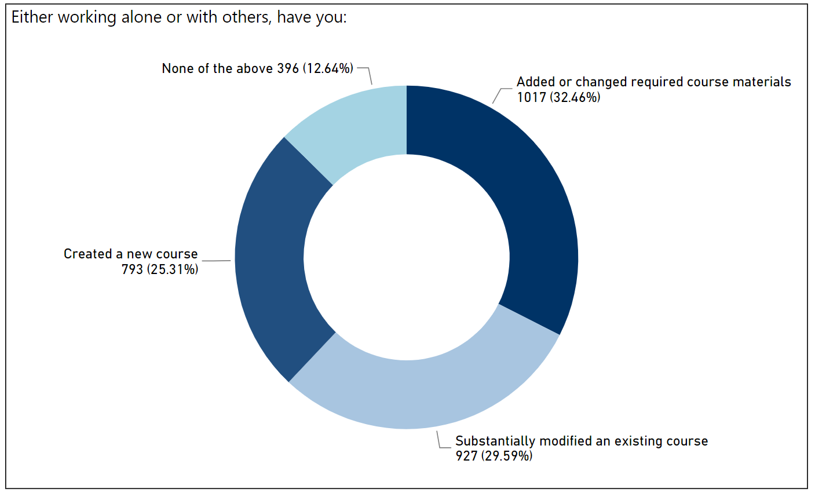
As a follow-up question we asked: Whose decision was it to create the new course/modify the course/select new required course materials?
Respondents indicated both individual and team-based modification of required course materials, with a smaller percentage reporting department-level modifications, and a minimal amount of reporting institution-level decisions on course materials (58.3% individually, 30% in groups, 2.1% institutional). Grantees were more likely to make the decision in concert with others or work with a department on the decision.

Types of Courses Represented in Survey Responses
“For introductory courses OER is a viable option. For advanced courses in my field, it is not.”
“For years, I [have been using] open textbooks in my introductory courses for non-physics majors.”
We asked respondents to select one course they created or modified over the past two years and to use this course to answer questions about how they select course materials.
Findings:
- Most respondents reported teaching an introductory level undergraduate course.
- Most courses were taught face-to-face.
- OER users were more likely to report blended or online courses.
- OER users were more likely to report an introductory course than non-OER users.
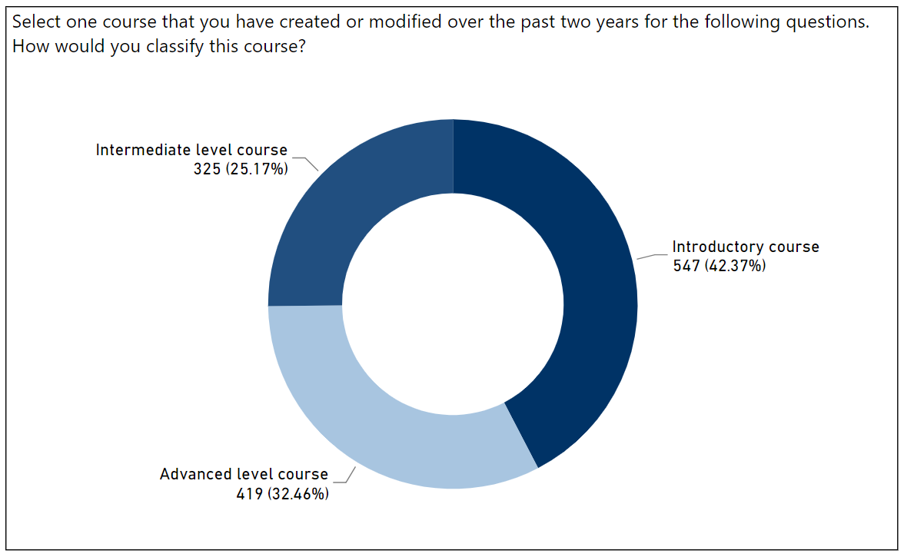
Most introductory course responses are undergraduate introductory courses; only 19 respondents reported teaching a graduate introductory course (10.5% graduate introductory, out of 181 respondents who reported teaching a graduate course).
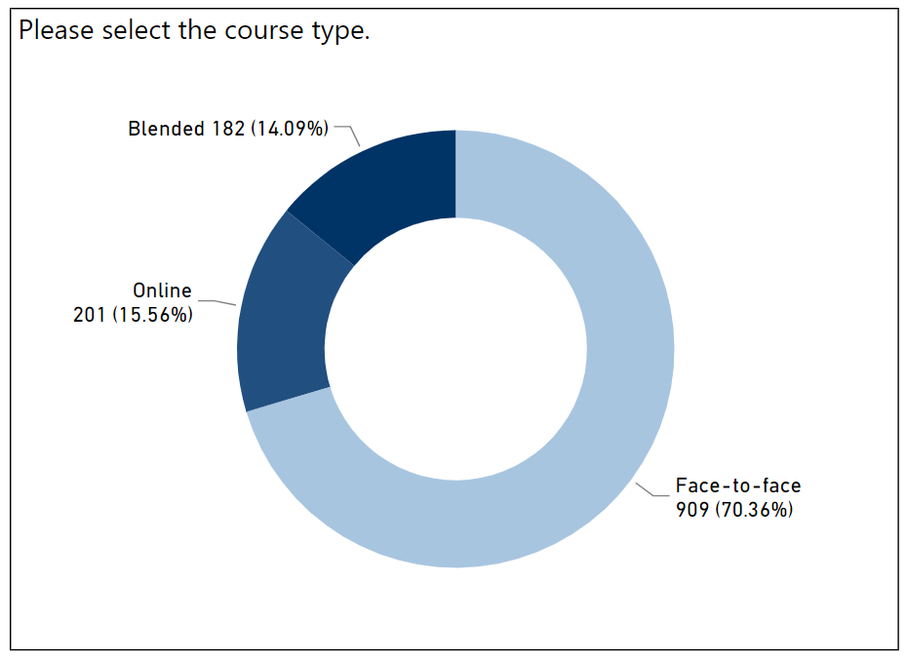
OER users were more likely to report blended or online courses (63% face-to-face, 16.9% blended, 20.1% online) than non-OER users (73.9% face-to-face, 12.2% blended, 14% online). While most respondents overall reported an undergraduate course, OER users overall were slightly more likely to report an undergraduate course than non-OER users (86.3% OER, 80.6% non-OER), and they were more likely to report an introductory course (52.4% OER, 35.2% non-OER).
Grantees were overwhelmingly likely to report an undergraduate course and an introductory course (98.5% grantees, 72% introductory). A large number of introductory courses using OER is to be expected, as most OER efforts to date have focused on large-enrollment, core curriculum courses.

Faculty Priorities in Selecting Teaching Materials
“I teach my classes with no required textbook and all my materials offered in iCollege for my students. I have also created modules for other faculty to use/mix/match with their courses.”
“Research shows students learn better from printed materials, though they prefer e-materials.”
This survey was designed to assist ALG in understanding attitudes and practices related to the selection of teaching materials and perceptions and use of OER, low-cost, and no-cost teaching materials within the USG. To try to understand what factors are important to faculty when selecting course materials, we asked about the types of materials they typically use and how these materials are licensed. We wanted to know what is most important to them in selecting course materials, and how satisfied they are with these factors.
Findings:
- Most respondents require the use of textbooks in their courses, and printed textbooks were the most common format.
- In open-ended responses, some respondents indicated a strong preference for using printed textbooks.
- OER users are more likely to use digital textbooks.
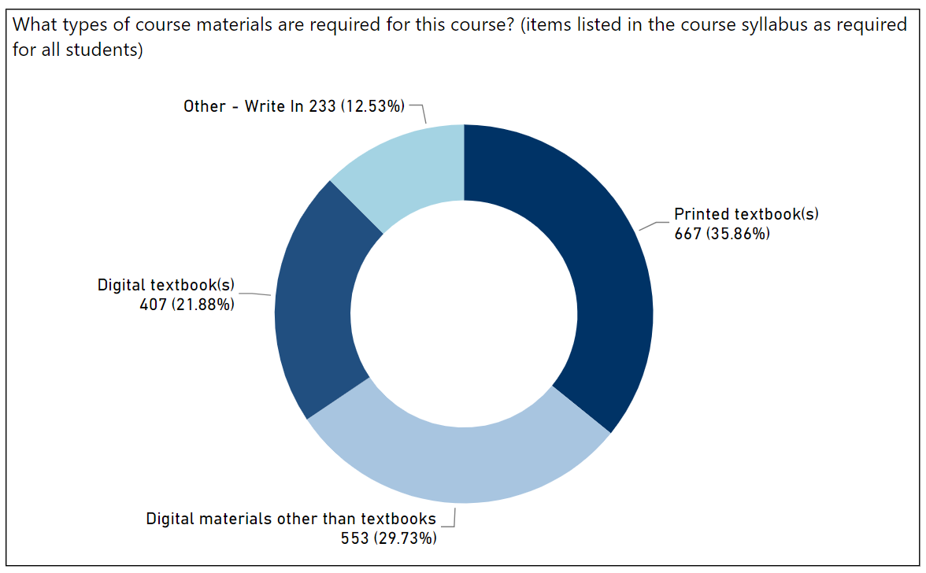
OER users were more likely to report using digital textbooks and other digital materials (digital textbooks: 47.9% OER, 29% non-OER; other digital: 55.3% OER, 44.1% non-OER). Grantee response data were similar. While Open Educational Resources can be printed or have a print option, most OER adopters reported their required materials were primarily available in a digital format.
In open-ended responses, some respondents mentioned a strong preference for print materials, often citing research on the efficacy or preference for print textbooks over digital textbooks. Seaman & Seaman (2017) found faculty continue to report their students prefer printed over digital materials. Some respondents in our survey reported a preference for printed textbooks over OER while suggesting OER are only available in digital formats. Many open textbooks, such as those published by OpenStax, University Presses, and other non-commercial publishers, provide a high-quality, low-cost print option for the texts they offer.
A few open-ended respondents mentioned research on the efficacy of print textbooks over digital textbooks. Early and often-cited print-vs-digital learning research articles, such as Hoffman, Berg, and Dawson (2010), analyzed only the model of commercially-licensed electronic books. Connell, Bayliss, and Farmer attempted to control for the variance in digital devices in their learning and preference study by testing on both an Amazon Kindle and an Apple iPad, but they did not account for the usability issues they encountered during the study: ”participants may have assumed that note-taking was not possible on the Kindle, which may have further reduced their desire to use the Kindle for academic reading” (2012). These earlier studies on digital reading and learning could not measure the efficacy of current digital OER textbooks, which are often printable and do not contain digital rights management restrictions on how they are used – a frequent feature of commercial electronic textbooks.
A recent systematic review on print learning vs. digital learning research concluded that the difference in comprehension between print and digital reading may be dependent on the particular use case, the devices available at the time of the study, the text length, the manipulation of text digitally, the digital skills of the reader, and even what the researchers defined as digital reading. “For those invested in understanding and promoting student learning, therefore, there is little gained from setting up a false dichotomy between reading and digital reading. Consequently, we must arm ourselves with empirical evidence of when, where, and for whom greater benefits are accrued from reading in print, digitally, or in combination” (Singer & Alexander, 2017).
A series of interviews on digital learning suggest the outlook on learning with digital materials may be dependent on finding a true and usable digital equivalent of interacting with print media (O’Malley, 2017). It may be the case that the type of digital platform for reading materials, along with the devices used, must change in order for digital versions to enhance student learning on par with print reading materials – not the digital medium itself. Digital annotation tools such as Hypothesis (https://hypothes.is) and highlighting/annotation-focused responsive reading platforms such as LibreTexts (https://libretexts.org/) and Manifold (https://manifoldapp.org/) may assist in closing this usability gap between OER and print materials.

To determine if the format of the materials affected the type of license applied to them, we asked which type of licensing applied to the required materials used within the reported course.
Findings:
- Most respondents using printed textbooks used all-rights-reserved content.
- Respondents using digital textbooks were less likely to use all-rights-reserved content, but it was still the most common licensing.
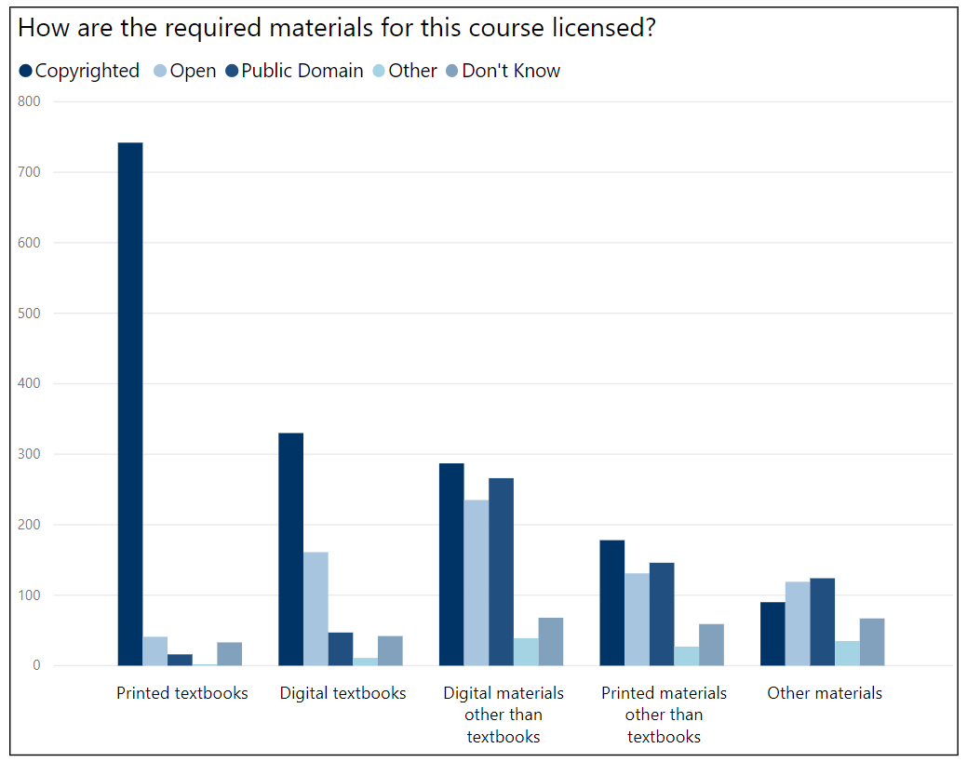
Most respondents using printed textbooks report using textbooks that are under traditional all-rights-reserved copyright (89% all-rights-reserved). Digital textbook users’ responses were more mixed (55.8% all-rights-reserved, 27.2% open, 8% public domain). Other materials, both digital and print, were more evenly distributed between all-rights-reserved copyright, open, and public domain.
Respondents were asked to rate nine factors on how important they are in selecting course materials (see Appendix B for the complete list of factors).
Findings:
- Respondents ranked comprehensive content and activities as the most important factor in selecting course materials.
- Respondents ranked cost to the student as the second most important factor in selecting course materials.
- Respondents ranked materials being easy to find as the third most important factor in selecting course materials.
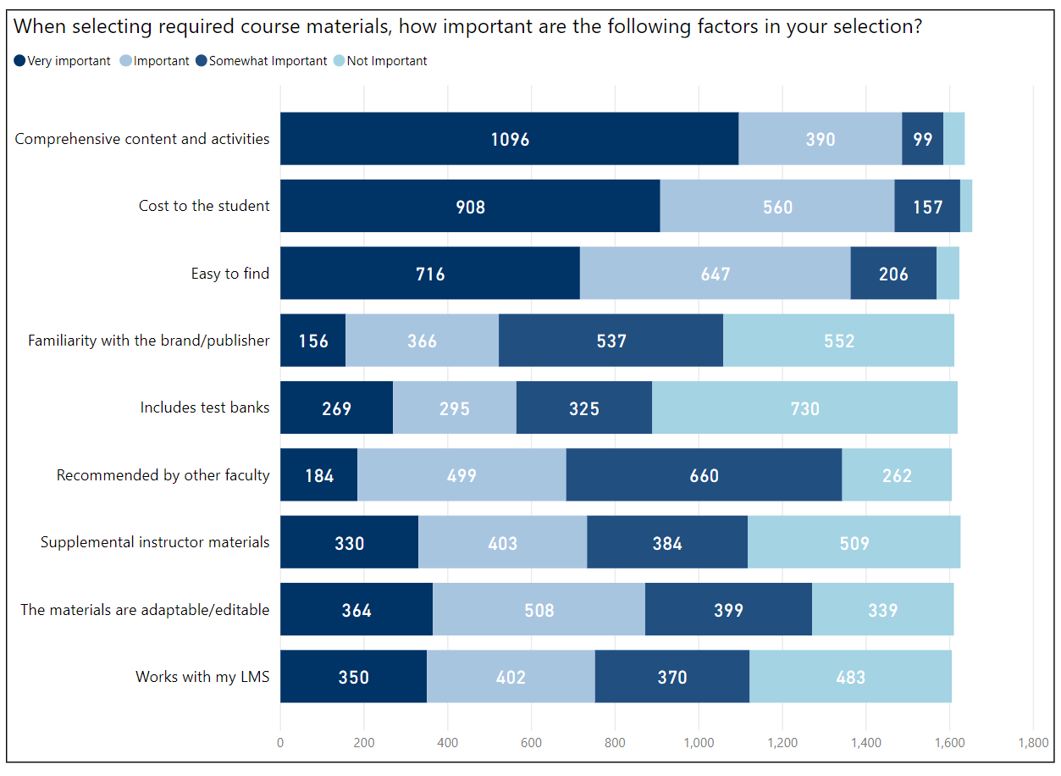
The top three selections are separated from the rest of the factors by a large amount, since many more respondents marked these three as “Very important” and “Important.” This is consistent with the findings reported by Seaman & Seaman (2017), where respondents ranked “Comprehensive Content,” “Cost to Students,” and Easy to Find” as the top three most important factors in selecting course materials.

As a follow-up question, we asked how satisfied respondents were with the quality of their materials.
Findings:
- Most respondents are satisfied with the course materials they are currently using.
Overall, respondents are mostly satisfied with materials available to them, with a slight dip in satisfaction for the cost of materials to students (30.8 very satisfied, 32.5% satisfied, 22.8% somewhat satisfied, 13.9% not satisfied). OER users reported slightly higher levels of cost satisfaction (41.5% very satisfied, 30.5% satisfied, 17.8% somewhat satisfied, 10.2% not satisfied).

OER and Course Materials Selection
In the previous set of questions, we found:
- A majority of respondents select course materials individually, and therefore base their selections on their own evaluations of resources.
- The most important factor in faculty selection of course materials is comprehensive coverage of the scope of their courses’ learning objectives.
- The second most important factor in faculty selection of course materials is cost to students.
- The third most important factor was the ease in finding course materials.
These findings suggest course material selection in the USG is based largely on the individual evaluations of faculty, and that these faculty evaluate materials first and foremost by coverage of their specific learning outcomes and activities within a course. Faculty value cost to students highly, but also discoverability; if affordable, comprehensive materials are to gain adoption throughout the USG, they must also be easily discoverable.
The next set of questions explored faculty perceptions and use of OER. Within the context of the findings above, we would expect OER to be a lesser-known but welcome replacement for higher-priced commercial materials, but only if they comprehensively met the scope of individual faculty’s learning outcomes and activities and did not require excessive amounts of time to discover.

OER and Open Textbook Awareness
“I am already using OER materials after taking several workshops. Departmental coordinators who select English composition textbooks should take into account materials with relevant and highly interesting readings.”
“I confess to being only marginally familiar with Open Educational Resources and Open Textbooks, but am interested in learning more about these resources and best practices for their use.”
“I have never heard of this option and in general assume that like everything else in life, quality and price are positively correlated.”
We asked respondents about their awareness of OER in order to gauge awareness of OER throughout the USG. A lack of OER awareness indicates a strong need for outreach from Affordable Learning Georgia.
Findings:
- About 60% of USG respondents are at least somewhat aware of Open Educational Resources.
- 45.6% of USG respondents are aware of Open Educational Resources.
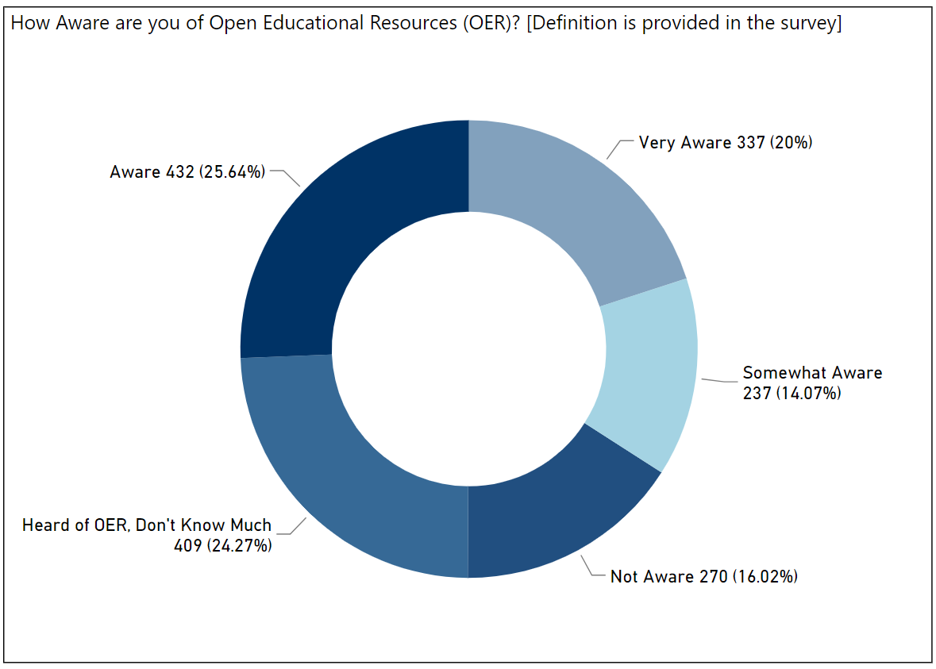
Grantees are far more aware of OER and their use cases (59.1% very aware, 25.6% aware; non-grantees: 16.1% very aware, 25.3% aware).
We also asked respondents about their awareness of open textbooks in order to compare and contrast this to awareness of OER. Because of the larger discussion about textbook costs throughout the USG, it is possible that more USG faculty have heard of open textbooks than OER. This did not turn out to be true—about the same percentage of awareness was reported for open textbooks as it was for OER (22% very aware, 21.3% aware).
Similar to the previous question about OER, Textbook Transformation Grants awardees reported being far more aware of open textbooks than non-grantees (grantees: 64.9% very aware, 20.8% aware; non-grantees: 16.1% very aware, 25.3% aware).

Current Course Material and OER Usage
“We use OER for ALL of our Biology courses at our institution. It requires a little extra legwork for ancillaries, but that is why we have applied for the ALG grants. So far we are pretty satisfied with the transition. The students are enjoying the savings.”
“In literature, it's hard to find a better resource than [a commercial textbook]--cost, footnotes, editing, etc. are all top notch; however, composition courses and special topics courses can easily be taught with materials from the web and the library.”
In order to get a sense of the types of materials that were being used most frequently within the USG, we asked respondents which materials they used in their overall work.
Findings:
- USG faculty most commonly use commercial textbooks.
- Half of respondents use materials available through GALILEO and their institutional libraries.
- About one-quarter of respondents reported using OER.
- Half of OER users also use commercial textbooks in their work.
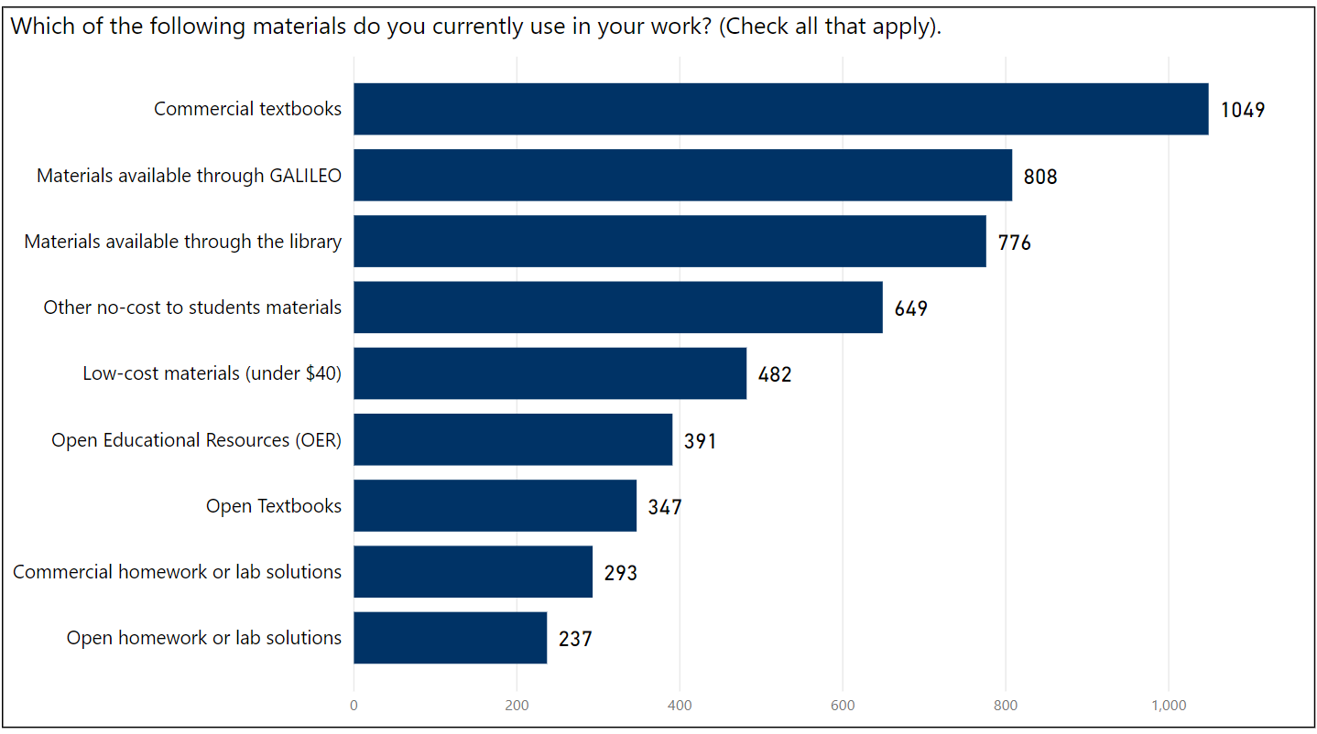
We asked respondents whether or not they have used OER in various ways to get a sense of how, or if, USG faculty are currently using open materials.
Findings:
- Less than one-fifth of respondents use OER as required or supplemental materials.
- More respondents are using open textbooks as required materials than as supplemental materials.

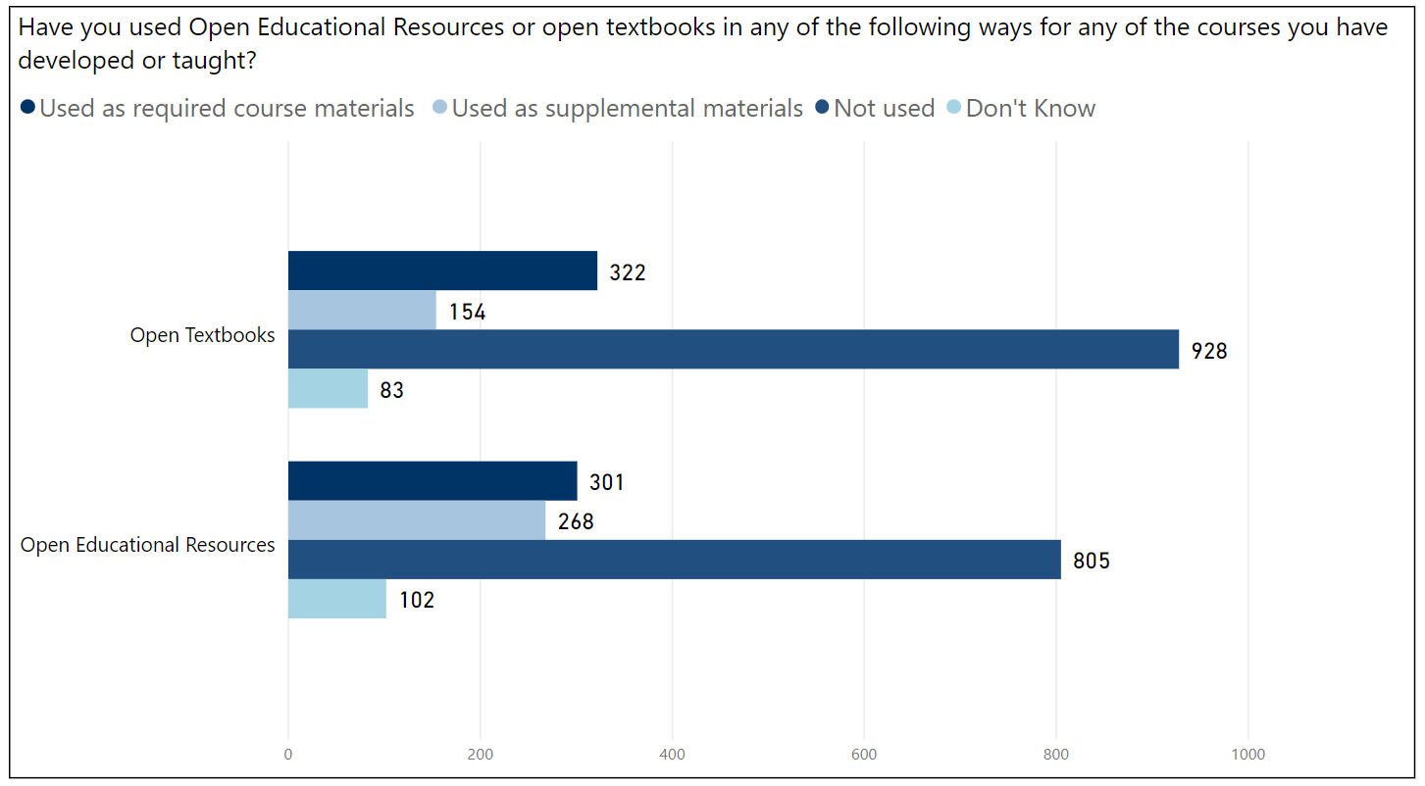
Less than one-fifth of respondents used OER as required or supplemental materials (18.2% required, 16.2% supplemental). While we anticipated open textbooks might be used often as supplementary materials through remixing and revising, respondents indicated that fewer faculty are using open textbooks specifically as supplemental materials as opposed to required materials (19.3% required, 9.2% supplemental).

Deterrents to Using OER or Open Textbooks
Affordable Learning Georgia encourages the adoption, adaptation, and creation of OER; by asking what the most significant deterrents to using OER are, we can determine the issues with OER that need to be addressed within the USG, and we can also determine the perceptions USG faculty have about OER that are stopping them from adopting these resources.
To increase the validity of these responses, the survey authors hid this question from respondents who indicated they were not aware of OER or open textbooks; only respondents who were “somewhat aware,” “aware,” or “very aware” of these were asked about deterrents to their use.
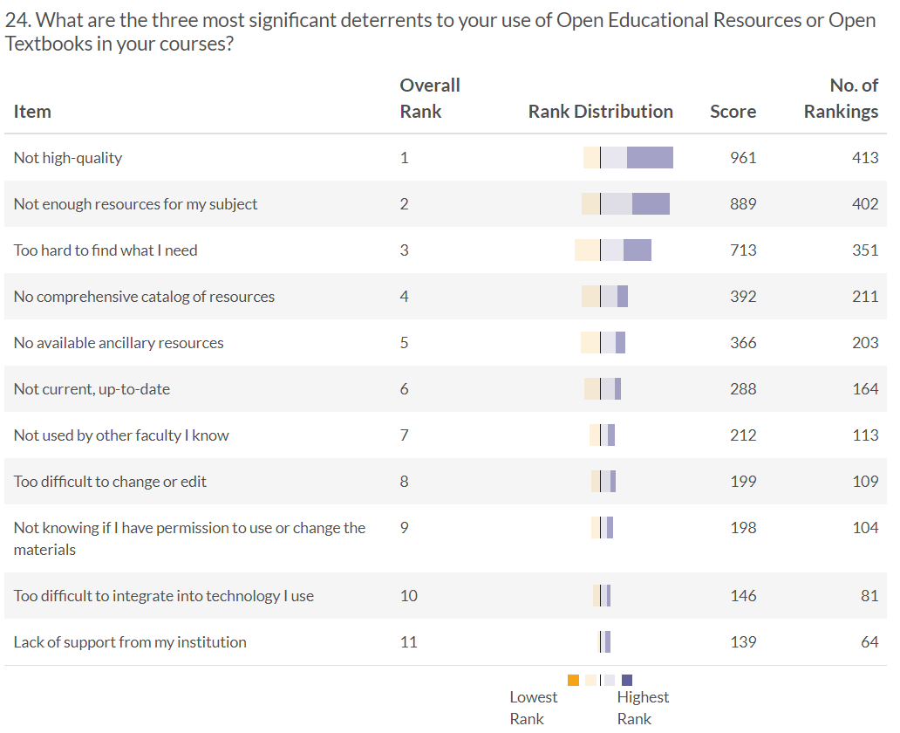
The top three deterrents do not change when filtered by whether respondents have used OER, or whether they use print or digital resources in the course. As with the ranking of which factors are most important in selecting course materials, there is a significant drop in both the score and amount of rankings after the top three responses.

Deterrent 1: Lack of High-Quality Resources
Definitions of what constitutes quality varied greatly among USG respondents within open-ended questions, often including other barriers listed above.
Respondents’ determinants of quality barriers included:
- Content or typographical errors: “Many OER lower-level mathematics textbooks are riddled with errors. There is no pressure to improve their quality. This is bad for students.”
- Differences in the scope of content covered from an instructor’s specific set of learning outcomes for a course: “[The open textbook I reviewed was] lacking in cultural diversity, current information, examples, and missing the mark for information beyond the U.S.”
- Image clarity and availability: “The imagery in OER's is usually poor and thus it requires relying on other public domain imagery.”
- Lack of supplemental materials or low-quality supplemental materials: “They lack the supplemental material to instructors and students that traditional publishers compete with each other to provide.”
- Lack of an external vetting process such as peer review or editorial oversight: “I do not want to use Open Educational Resources because I cannot ensure that the quality is peer reviewed and meets scientific standards.”
USG respondents’ prioritization of quality over other barriers contrasts significantly with national surveys such as the Babson Survey Research Group’s biannual OER survey. In 2017, Babson respondents prioritized discovery difficulties as the top barrier to adoption of OER, followed by the lack of resources for a subject. Quality was ranked fourth.
While we anticipated Textbook Transformation Grants awardees to prioritize quality differently, given their training and experience with replacing commercial textbooks with OER, they did not differ from non-grantees in their top three ranked barriers to OER use.
Along with high quality being listed as the top-priority deterrent in the survey results, we also asked a question to see if the perceived quality of OER differed from the perceived quality of commercial materials.
Findings:
- Respondents ranked traditional publishers higher in quality than OER overall.
- Half of all respondents reported they were unaware of the quality of OER.
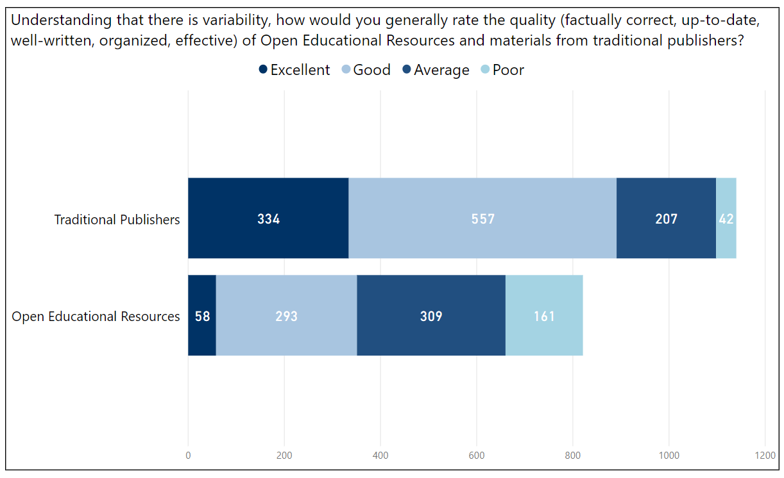
Respondents marked OER quality as “Poor” three times more than traditional publisher materials, but most respondents marked OER as “Good” or “Average.” A substantial amount of respondents marked that they did not know about the quality of their materials, and this happened with OER materials more than traditional publisher materials (820 OER, 512 traditional publishers).
Those who have used OER still distributed largely the same way as all respondents in rating OER quality, aside from less responding “Don’t Know” (8.1% excellent, 38.4% good, 32% average, 10.6% poor). More Textbook Transformation Grantees than non-grantees responded “poor” for OER, which may be because grantees have more experience with the evaluation of both commercial textbooks and OER, and therefore answer “don’t know” far less for both traditional publishers and Open Educational Resources.
With Textbook Transformation Grantees similarly reporting quality as the highest-priority barrier to OER use, the survey suggests quality is likely a barrier more frequently encountered once instructors have had some experience with OER. More awareness leads to more evaluations of quality, and respondents are indicating that quality needs to improve.

Deterrent 2: Lack of Resources for Subject Area
Within open-ended questions, respondents indicated multiple ways in which OER could not fit their particular subject area.
Open-ended comments included:
- Lack of OER for upper-level undergraduate and graduate courses: “I would appreciate assistance in finding more materials specific to my upper level courses. Right now even commercial publisher materials are lacking for the subjects I teach, let alone open educational resources.”
- Lack of OER for smaller or less-enrolled subject areas: “My discipline is small and there are no OER available. I might use them if they were, but right not I do not have that option.”
- Lack of OER for some larger or high-enrolled subject areas: “When I tried to look for material in my area (Spanish) I didn´t find anything.”
- OER revision models too slow to avoid obsolescence in particular subject areas: “I teach in a highly technical, rapidly changing field. I have only found one open resource source and the information is not well vetted and is seldom updated.”
OER creation, whether through Textbook Transformation Grants in the USG or through large open textbook creation programs such as OpenStax, has largely focused on making a large impact on as many students as possible, therefore focusing on courses within a core curriculum which typically have higher-priced commercial textbooks required.
The current impact-focused strategy has succeeded in bringing OER to scale within the USG and across the United States, but in order for OER adoption to progress further, smaller disciplines and less-enrolled subject areas will need to be addressed. This approach to OER creation and revision would be particularly crucial when pursuing a zero-cost degree program (Z-Degree) where every course within a degree program would need high-quality, updated OER.

Deterrent 3: Difficulty Finding OER
While “Hard to find” was the third-highest deterrent to OER adoption among all respondents, comments on why OER were hard to find within open-ended questions varied greatly.
Open-ended comments included:
- Lack of content curation: “I have found a few things, but wish there was something more comprehensive that has done all the hard work searching for resources.”
- Vendors of OER-supported courseware confounding the search process: “I think finding high-quality, open textbooks is the most difficult aspect for faculty at this particular time. Many software platforms that offer OERs are actually charging for them, which defeats the purpose.”
- Lack of OER for a particular subject area: “As far as I know, there are no open educational resources for teaching [my particular course] or any of the other subjects I teach. I don't know where to look for OER.”
Through the trends in these open-ended responses indicating a difficulty finding OER, it is clear that the second-highest deterrent (a lack of resources for a particular subject area) and this deterrent overlap qualitatively. Assistance in the discovery of OER will help faculty find resources within their subject areas, while new OER within smaller / less-enrolled subject areas and courses will increase the amount of discoverable OER, therefore enhancing the discovery process. This survey suggests addressing both discovery and subject area coverage are equally important, and an improvement in one of these areas is likely to improve the other indirectly.
As a follow-up question, we asked respondents to rate the discoverability of commercial textbooks and OER.
Findings:
- Respondents ranked traditional publishers easier to find than OER overall.
- Half of all respondents reported they were unaware of the ease of finding OER.
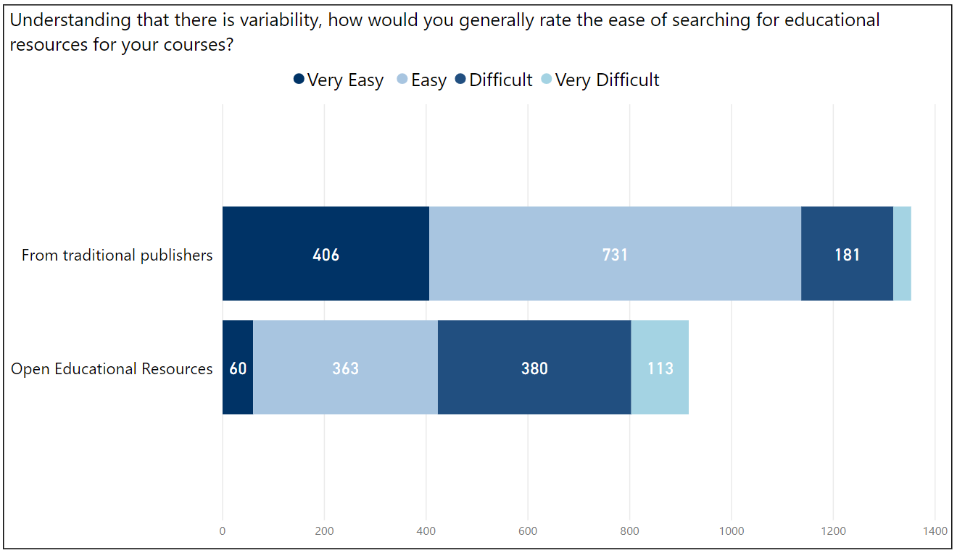
Respondents marked OER discoverability as “Difficult” twice as much as with traditional publishers, and OER received less than one-sixth of the number of “Very Easy” rankings. A substantial amount of respondents marked that they did not know about the discoverability of their materials, and this happened with OER materials more than traditional publisher materials (728 OER, 298 traditional publishers).

Common Deterrent in Open-Ended Responses: Time to Implement OER
“Very interested in OER; just never seem to have time to explore where to find what I would need to replace an expensive textbook that does cover the material that I want to cover.”
“I am using OER now, and it is A LOT more work for me. The students are saving money, but I don't directly benefit.”
“My problem is that we are on 4/4 teaching load and also have to do service and advisement. I find myself exhausted and just keep using the traditional textbooks published to save my time.”
“The only way to expand the movement toward OER proliferation in higher education is to continue offering opportunities to willing faculty to create and adapt resources and share those resources. Many are unwilling to take the time and effort.”
In order to maintain comparability to the Babson Survey Research Group reports, only a select list of deterrents were used in the rankings mentioned above. One prominent deterrent, which was not included on the list, emerged within our survey’s open-ended responses: Implementing OER successfully in the classroom takes extra time from faculty. Affordable Learning Georgia has been addressing the time issue through Textbook Transformation Grants, which are focused on funding the extra time it takes a faculty team to adopt, adapt and create OER to replace a commercial textbook in a course, but more measures must be taken to ensure OER implementation takes less time in the future for all USG faculty.
These time-consuming tasks were mentioned in open-ended responses:
- Revising OER to fit a particular course
- Updating older OER for current developments in a subject area
- Fixing technical difficulties with OER and open platforms
- Creating ancillary materials to supplement open textbooks
- Creating new materials for subjects where OER do not currently exist
- Finding appropriate OER for the subject
- Hosting created OER and maintaining live links to older OER

USG Faculty Planning on Using OER in the Future
“OER are great. There is no good reason to at least consider them for supplementary resources. With a little effort, an entire course can be taught with OER.”
In order to determine the potential for OER use in the near future, we asked respondents whether or not they will use OER within the next three years.
Findings:
- Over half of respondents are considering using OER in their courses within the next three years.
- Another 20% of respondents reported they might consider using OER.
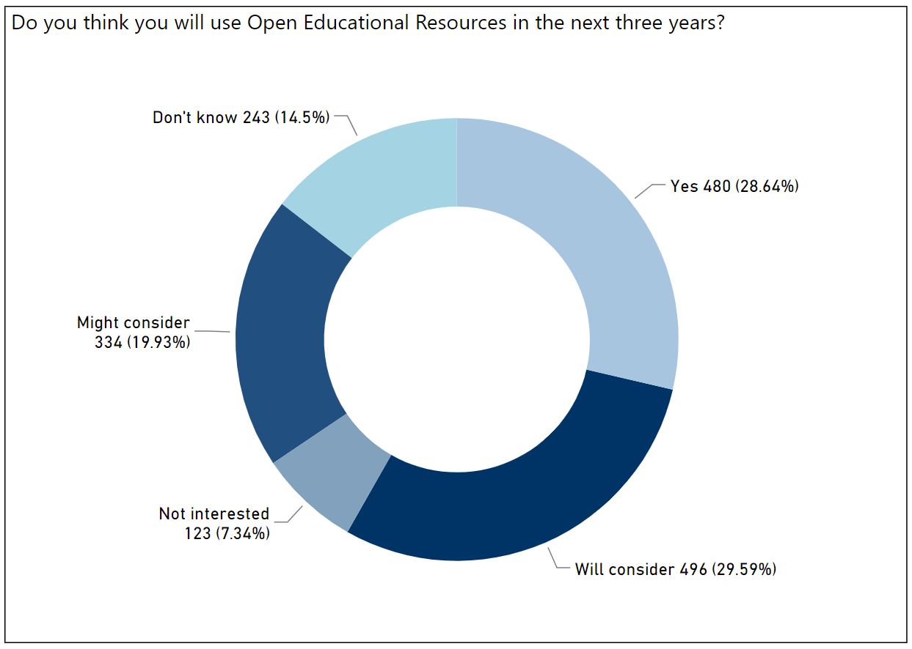
In order to meet the needs of USG faculty considering OER, Affordable Learning Georgia will need to work toward addressing the indicated major OER adoption barriers (quality, subject areas, discoverability), as well as awareness gaps indicated within the survey.

Conclusions

Key Findings and Implications
The USG OER Survey has many implications for the future of the USG in supporting and raising awareness of OER. The authors’ conclusions include:
- ALG and institutional advocates must continue to expand the awareness of OER throughout the USG. While it is likely that USG-funded efforts including ALG have contributed to an increased amount of awareness of OER within the USG, many faculty are still unaware of OER. ALG and advocates for OER within USG institutions must continue to reach out to faculty who are unaware of OER through grant opportunities, professional development, and on-campus marketing. The USG also is pursuing more awareness of OER for both faculty and students through the no-cost and low-cost designators intiative, which went into effect in fall semester 2018.
- ALG should explore ways to expand OER and other no-cost resource use to upper-division and graduate courses. High-quality and comprehensive OER are available for many introductory undergraduate courses, but scarce in upper-division and graduate courses. Encouraging the use of OER in upper-division and graduate courses may involve more authorship and less impact per dollar funded on student savings, but the USG should explore cost-effective ways to provide high-quality OER and other no-cost materials for these courses, including library and GALILEO materials.
- ALG must work toward increasing the quality of OER across a wide range of quality determinants. In order to ensure the sustainability of the USG’s OER effort, ALG must address ways in which to work with faculty to determine quality when evaluating OER materials. OER created through ALG programs could be revised for content scope, typographical errors, accuracy, learning outcomes, clarity of images, availability of supplemental materials, and authority/validity through a peer-review process.
- ALG should explore ways to expand OER and other no-cost resource use to subject areas currently not addressed by high-quality OER. Smaller or less-enrolled subject areas lacked the comprehensive OER necessary for a full replacement of a commercial textbook, and some high-enrollment subjects also lack OER, such as foreign languages. ALG should pursue creative and effective ways to incorporate and/or create both OER and library resources within these subject areas.
- ALG should leverage its position within Library Services and GALILEO to enhance the discoverability of high-quality OER for USG faculty. While the issue of discovery is connected to other barriers to OER adoption, such as a lack of content for a particular subject or a lack of ancillary materials, more can be done to help faculty search for OER and library materials in one place and find the most comprehensive, high-quality materials quickly. Library Services and GALILEO have been addressing the issue of resource discoverability since GALILEO’s inception; ALG can work with librarians both within the system office and throughout the USG on new educational resource discovery methods.
- ALG should keep no-cost and low-cost materials without open licensing in mind for future affordability efforts alongside OER. While the area of commercial low-cost materials has moved slowly and not without controversy (for example, inclusive access programs and opt-out purchasing), the USG should continue to pursue new ways of making no-cost and low-cost materials available beyond what can be openly licensed. Library subscriptions and low-cost publisher deals are examples of ways the USG can continue to make educational resources affordable for more USG students.
- In order to meet the needs of future OER adopters, ALG and institutional advocates must continue to expand OER support and professional development. With over half of respondents reporting they will either use OER or will consider it within three years, Affordable Learning Georgia must meet an increasing need for training on various aspects of adopting, adapting, and creating OER. Topics that must be covered include accessibility, copyright and open licensing, open textbook authoring, and OER-enabled pedagogical practices. The USG must also continue to support the time and funding required for faculty to pilot new uses of OER within their courses.
- A zero-textbook-cost degree program would require significant funding to address the OER gap in upper-level and/or graduate courses. Because the USG is largely focused on four-year degree programs and graduate degrees, a zero-textbook-cost (Z-Degree) program would require OER use within upper-division and graduate courses. Survey respondents overall indicated a lack of comprehensive, high-quality OER for upper-division and graduate courses. The creation of sustainable four-year or graduate Z-Degree programs within the USG would therefore be a challenging pursuit. Comprehensive sets of new OER, including ancillary materials, would need to be authored and peer-reviewed by USG subject matter experts and instructional designers. Implementation of these materials by instructors would need to be supported throughout the system. Regular updates by these same subject matter experts and designers would need to occur in order to keep any Z-Degree program sustainable.

Final Thoughts
“I am writing an Open Textbook with the University Press of North Georgia. I have already used this and its ancillary materials in my courses as a free resource to students. I really believe in this low-cost/no-cost initiative.”
“I received an ALG OER grant this cycle and I am very excited to convert my course to a no-cost course!”
“I am glad the USG is focusing on textbook affordability. There is a lot we can do in this direction.”
The future looks promising for the use of OER and low-cost resources within the USG, with a large share of faculty reporting they will use OER within the next three years. This outlook is positive for USG students. As the adoption of OER and other no-cost and low-cost resources in the classroom increases, students will save more money on textbook costs. Supporting the sustained use of these affordable resources within the USG will require a sustained effort from ALG, including funding OER adoption, adaptation and creation, increasing OER awareness, professional development and training, and the improvement of OER quality within the USG.

References

Allen, J. E., & Seaman, J. (2018). Freeing the Textbook: Educational resources in U.S. higher education, 2018. Retrieved from: https://www.onlinelearningsurvey.com/reports/freeingthetextbook2018.pdf
Allen, I. E., & Seaman, J. (2016). Opening the textbook: Educational resources in U.S. higher education, 2015-16. Retrieved from: https://www.onlinelearningsurvey.com/reports/openingthetextbook2016.pdf
Allen, I. E., & Seaman, J. (2014). Opening the curriculum: Open educational resources in U.S. higher education, 2014. Retrieved from https://www.onlinelearningsurvey.com/reports/openingthecurriculum2014.pdf
Bell, S., (2018). Course materials adoption: A faculty survey and outlook for the OER landscape. ACRL/Choice. Retrieved from: http://choice360.org/librarianship/whitepaper
Berg, S., Hoffman, K., & Dawson, D. (2010). Not on the same page: Undergraduates’ information retrieval in electronic and print books. Journal of Academic Librarianship, 36(6), 518-525.
Colvard. N., Watson, C. E., Park, H. (2018). The impact of open educational resource on various student success metrics. International Journal of Teaching and Learning in Higher Education, volume 30, 262-276. Retrieved from http://www.isetl.org/ijtlhe/pdf/IJTLHE3386.pdf.
Connell, C., Bayliss, L., & Farmer, W. (2012). Effects of eBook readers and tablet computers on reading comprehension. International Journal of Instructional Media, 39(2), 131-140.
Hewlett Foundation. (2019). Open Educational Resources. Retrieved from: https://hewlett.org/strategy/open-educational-resources/
J. E. Seaman & Seaman, J. (2017). Opening the textbook: Educational resources in U.S. higher education, 2017. Retrieved from: http://www.onlinelearningsurvey.com/reports/openingthetextbook2017.pdf
O’Malley, S. (2017). “There’s No Easy Answer.” Inside Higher Education. Retrieved from: https://www.insidehighered.com/digital-learning/article/2017/08/16/which-better-reading-print-or-screen
Singer, L. & Alexander, P. (2017). Reading on paper and digitally: What the past decades of empirical research reveal. Review of Educational Research, 87(6). Retrieved from: https://journals.sagepub.com/doi/abs/10.3102/0034654317722961

Appendices

Appendix A: Email to Participants
Issued February 16, 2018
Dear Colleague:
The University System of Georgia, in pursuance of college affordability, started an initiative in 2014 to lower the cost of textbooks to students, contributing to educational equity and student success. A crucial aspect of the initiative has been enabling faculty to replace commercial textbooks with open educational resources (OER). Many institutions in the University System of Georgia are beginning to pursue alternatives to traditional print textbooks and other educational materials.
Below you will find a link to a web survey being conducted to determine the pervasiveness of Open Educational Resources (OER) on your campus and throughout the USG.
The USG is asking you to respond to this survey on your knowledge, awareness, use, and opinions of OER. Please respond by using the following link:
[link to survey]
Please complete the survey by the end of Tuesday, March 6, 2018.
If you have any questions about the survey, please contact:
Jeff Gallant
Program Manager, Affordable Learning Georgia
Board of Regents of the University System of Georgia
706-583-2144
Jeff.Gallant@usg.edu

Appendix B: Survey Questions

1) What is your primary role?
( ) Professor
( ) Associate Professor
( ) Assistant Professor
( ) Instructor
( ) Lecturer
( ) Senior Lecturer
( ) Academic Professional Associate
( ) Academic Professional
( ) Senior Academic Professional
( ) Adjunct Faculty
( ) Librarian
( ) Library Staff
( ) Instructional Designer
( ) Administrator
( ) Other - Write In: _________________________________________________

2) Please select your USG institution. If you teach at more than one USG institution, select your primary institution.
( ) Abraham Baldwin Agricultural College
( ) Albany State University
( ) Atlanta Metropolitan State College
( ) Augusta University
( ) Clayton State University
( ) College of Coastal Georgia
( ) Columbus State University
( ) Dalton State College
( ) East Georgia State College
( ) Fort Valley State University
( ) Georgia College and State University
( ) Georgia Gwinnett College
( ) Georgia Highlands College
( ) Georgia Institute of Technology
( ) Georgia Southern University
( ) Georgia Southwestern State University
( ) Georgia State University
( ) Gordon State College
( ) Kennesaw State University
( ) Middle Georgia State University
( ) Savannah State University
( ) South Georgia State College
( ) University of Georgia
( ) University of North Georgia
( ) University of West Georgia
( ) Valdosta State University

Logic: Show/hide trigger exists.

3) What kind of teaching do you do?
[ ] Full-time face-to-face
[ ] Part-time face-to-face
[ ] Full-time online teaching
[ ] Part-time online teaching
[ ] Full-time blended teaching
[ ] Part-time blended teaching
[ ] Non-teaching professional staff

Logic: Hidden unless: #3 Question "What kind of teaching do you do?" ("Non-teaching professional staff")
4) How many years have you been teaching?
( ) Less than 1
( ) 1-3
( ) 1-5
( ) 6-9
( ) 10-12
( ) 13-15
( ) 16-20
( ) More than 20

5) Have you received, or been a part of a team that has received, an Affordable Learning Georgia Textbook Transformation Grant?*
( ) Yes
( ) No

Logic: Show/hide trigger exists.
6) Either working alone or with others, have you
[ ] Created a new course (A course that was not previously listed in the course catalog)
[ ] Substantially modified an existing course
[ ] Added or changed required course materials
[ ] None of the above

Logic: Hidden unless: #6 Question "Either working alone or with others, have you" is one of the following answers ("Created a new course (A course that was not previously listed in the course catalog)","Substantially modified an existing course","Added or changed required course materials")
7) Whose decision was it to create the new course/modify the course/select new required course materials?
( ) The decision was mine alone
( ) The decision was made by me in concert with others
( ) The decision was made at the department level
( ) The decision was made at the division level
( ) The decision was made at the institutional level
( ) Other - Write In: _________________________________________________
( ) Not applicable

Logic: Hidden unless: #6 Question "Either working alone or with others, have you" is one of the following answers ("Created a new course (A course that was not previously listed in the course catalog)","Substantially modified an existing course","Added or changed required course materials")
8) Why was this decision taken?
____________________________________________
____________________________________________
____________________________________________
____________________________________________

Logic: Hidden unless: #6 Question "Either working alone or with others, have you" is one of the following answers ("Created a new course (A course that was not previously listed in the course catalog)","Substantially modified an existing course","Added or changed required course materials")
9) Select one course that you have created or modified over the past two years for the following questions.
How would you classify this course?
( ) Introductory course
( ) Intermediate level course
( ) Advanced level course

Logic: Hidden unless: #6 Question "Either working alone or with others, have you" is one of the following answers ("Created a new course (A course that was not previously listed in the course catalog)","Substantially modified an existing course","Added or changed required course materials")
10) What is the level of the course?
( ) Undergraduate
( ) Graduate
( ) Other - Write In: _________________________________________________

Logic: Hidden unless: #6 Question "Either working alone or with others, have you" is one of the following answers ("Created a new course (A course that was not previously listed in the course catalog)","Substantially modified an existing course","Added or changed required course materials")
11) Is the course taught in multiple sections?
( ) Yes
( ) No

Logic: Hidden unless: #6 Question "Either working alone or with others, have you" is one of the following answers ("Created a new course (A course that was not previously listed in the course catalog)","Substantially modified an existing course","Added or changed required course materials")
12) Please select the course type
( ) Face-to-face
( ) Blended
( ) Online

Logic: Hidden unless: #6 Question "Either working alone or with others, have you" is one of the following answers ("Created a new course (A course that was not previously listed in the course catalog)","Substantially modified an existing course","Added or changed required course materials")
13) Is the course required?
( ) Yes, for all students
( ) Yes, for some students (e.g., majors)
( ) No

Logic: Hidden unless: #6 Question "Either working alone or with others, have you" is one of the following answers ("Created a new course (A course that was not previously listed in the course catalog)","Substantially modified an existing course","Added or changed required course materials")
14) Select the discipline for the course you are referencing.
( ) Agriculture
( ) Architecture
( ) Anthropology
( ) Biological Sciences
( ) Business Administration
( ) Chemistry
( ) Communication
( ) Computer and Information Sciences
( ) Criminal Justice
( ) Economics
( ) Education
( ) Engineering
( ) English
( ) Family and Consumer Sciences
( ) Fine and Applied Arts
( ) Foreign Languages
( ) Geological Sciences
( ) Health Professions and Related Programs
( ) History
( ) Humanities
( ) Kinesiology
( ) Law
( ) Learning Support and Developmental Studies
( ) Library Science
( ) Mathematics
( ) Philosophy and Religion
( ) Physics
( ) Political Science
( ) Psychology
( ) Sociology
( ) Other

Logic: Hidden unless: #6 Question "Either working alone or with others, have you" is one of the following answers ("Created a new course (A course that was not previously listed in the course catalog)","Substantially modified an existing course","Added or changed required course materials")
15) What is your role in selecting the required materials for this course?
( ) I am solely responsible for the selection
( ) I lead a group that makes the selection
( ) I am a member of a group that makes the selection
( ) I influence the selection, but do not have decision-making power
( ) Others make the selection, I have no role
( ) Other - Write In: _________________________________________________

Logic: Hidden unless: #6 Question "Either working alone or with others, have you" is one of the following answers ("Created a new course (A course that was not previously listed in the course catalog)","Substantially modified an existing course","Added or changed required course materials")
16) What types of course materials are required for this course? (Items listed in the course syllabus as required for all students.)
[ ] Printed textbook(s)
[ ] Digital textbook(s)
[ ] Digital materials other than textbooks
[ ] Other - Write In: _________________________________________________

Logic: Hidden unless: #6 Question "Either working alone or with others, have you" is one of the following answers ("Created a new course (A course that was not previously listed in the course catalog)","Substantially modified an existing course","Added or changed required course materials")
17) How are the required materials for this course licensed? (check all that apply.)
 | Copyrighted | Open | Public Domain | Other | I don't know
Printed textbooks | [ ] | [ ] | [ ] | [ ] | [ ]
Digital textbooks | [ ] | [ ] | [ ] | [ ] | [ ]
Printed materials other than textbooks | [ ] | [ ] | [ ] | [ ] | [ ]
Digital materials other than textbooks | [ ] | [ ] | [ ] | [ ] | [ ]
Other materials | [ ] | [ ] | [ ] | [ ] | [ ]

18) When selecting required course materials, how important are the following factors in your selection?
 | Very important | Important | Somewhat important | Not important
Cost to the student | ( ) | ( ) | ( ) | ( )
Easy to find | ( ) | ( ) | ( ) | ( )
Comprehensive content and activities | ( ) | ( ) | ( ) | ( )
Works with my institution's Learning Management System (LMS) | ( ) | ( ) | ( ) | ( )
Recommended by other faculty members | ( ) | ( ) | ( ) | ( )
The materials are adaptable/editable | ( ) | ( ) | ( ) | ( )
Familiarity with the brand/publisher | ( ) | ( ) | ( ) | ( )
Includes test banks | ( ) | ( ) | ( ) | ( )
Includes supplemental instructor materials | ( ) | ( ) | ( ) | ( )

19) How satisfied are you with the following aspects of the materials available to you for selections as required materials for your courses?
 | Very satisfied | Satisfied | Somewhat satisfied | Not satisfied
Cost to the student | ( ) | ( ) | ( ) | ( )
Easy to find | ( ) | ( ) | ( ) | ( )
Comprehensive content and activities | ( ) | ( ) | ( ) | ( )
Works with my institution's Learning Management System (LMS) | ( ) | ( ) | ( ) | ( )
Recommended by other faculty members | ( ) | ( ) | ( ) | ( )
The materials are adaptable/editable | ( ) | ( ) | ( ) | ( )
Familiarity with brand/publisher | ( ) | ( ) | ( ) | ( )
Includes test banks | ( ) | ( ) | ( ) | ( )
Includes supplemental instructor materials | ( ) | ( ) | ( ) | ( )

20) How aware are you of each of the following licensing mechanisms?
 | Very Aware | Aware | Somewhat aware | Unaware
Copyright | ( ) | ( ) | ( ) | ( )
Public Domain | ( ) | ( ) | ( ) | ( )
Creative Commons | ( ) | ( ) | ( ) | ( )

21) How aware are you of Open Educational Resources (OER)? OER is defined as "teaching, learning, and research resources that reside in the public domain or have been released under an intellectual property license that permits their free use and re-purposing by others."
( ) I am not aware of OER
( ) I have heard of OER, but don't know much about them
( ) I am somewhat aware of OER, but I am not sure how they can be used
( ) I am aware of OER and some of their use cases
( ) I am very aware of OER and know how they can be used in the classroom

22) How aware are you of Open Textbooks? Open textbooks are textbooks that are a type of OER. They are freely available with nonrestrictive licenses. Covering a wide range of disciplines, open textbooks are available to download and print in various file formats from several web sites and OER repositories.
( ) I am not aware of Open Textbooks
( ) I have heard of Open Textbooks, but don't know much about them
( ) I am somewhat aware of Open Textbooks, but I'm not sure if they are appropriate for my needs
( ) I am aware of Open Textbooks and some of their use cases
( ) I am very aware of Open Textbooks and know how they can be used in the classroom

23) Which of the following materials do you currently use in your work? (Check all that apply).
[ ] Open Educational Resources (OER)
[ ] Open Textbooks (textbooks with open licenses)
[ ] Materials available through GALILEO
[ ] Materials available through the library
[ ] Open homework or lab solutions (no-cost to students)
[ ] Other no-cost to students materials
[ ] Low-cost materials (under $40 total for the course)
[ ] Commercial textbooks
[ ] Commercial homework or lab solutions

24) Have you used Open Educational Resources or Open Textbooks in any of the following ways for any of the courses you have developed or taught?
 | Used as required course materials | Used as supplemental course materials | Not used | Don't know | N/A
Open Educational Resources | ( ) | ( ) | ( ) | ( ) | ( )
Open Textbooks | ( ) | ( ) | ( ) | ( ) | ( )

Logic: Hidden unless:
(#21 Question "How aware are you of Open Educational Resources (OER)? OER is defined as "teaching, learning, and research resources that reside in the public domain or have been released under an intellectual property license that permits their free use and re-purposing by others." " is one of the following answers ("I am somewhat aware of OER, but I am not sure how they can be used","I am aware of OER and some of their use cases","I am very aware of OER and know how they can be used in the classroom")
AND #22 Question "How aware are you of Open Textbooks? Open textbooks are textbooks that are a type of OER. They are freely available with nonrestrictive licenses. Covering a wide range of disciplines, open textbooks are available to download and print in various file formats from several web sites and OER repositories." is one of the following answers ("I am somewhat aware of Open Textbooks, but I'm not sure if they are appropriate for my needs","I am aware of Open Textbooks and some of their use cases","I am very aware of Open Textbooks and know how they can be used in the classroom"))
25) What are the three most significant deterrents to your use of Open Educational Resources or Open Textbooks in your courses?
________Too hard to find what I need
________Not enough resources for my subject
________Not high-quality
________Not current, up-to-date
________No comprehensive catalog of resources
________Not knowing if I have permission to use or change the materials
________Lack of support from my institution
________Too difficult to change or edit
________Too difficult to integrate into technology I use
________Not used by other faculty I know
________No available ancillary resources

26) Understanding that there is variability, how would you generally rate the quality (factually correct, up-to-date, well-written, organized, effective) of Open Educational Resources and materials from traditional publishers?
 | Excellent | Good | Average | Poor | Don't know
Traditional Publishers | ( ) | ( ) | ( ) | ( ) | ( )
Open Educational Resources | ( ) | ( ) | ( ) | ( ) | ( )

27) Understanding that there is variability, how would you generally rate the ease of searching for educational resources for your courses?
 | Very Easy | Easy | Difficult | Very Difficult | Don't Know
From traditional publishers | ( ) | ( ) | ( ) | ( ) | ( )
Open Educational Resources | ( ) | ( ) | ( ) | ( ) | ( )

28) Do you think you will use Open Educational Resources in the next three years?
( ) Yes
( ) Will consider
( ) Might consider
( ) Not interested
( ) Don't know

29) We welcome your comments. Please let us know your thoughts on any of the issues covered in this survey.
____________________________________________
____________________________________________
____________________________________________
____________________________________________

Thank You!

Appendix C: Survey Responses

1.What is your primary role?
Value | Percent | Count
Professor | 19.10% | 328
Associate Professor | 20.10% | 345
Assistant Professor | 19.60% | 337
Instructor | 8.80% | 151
Lecturer | 4.40% | 75
Senior Lecturer | 2.30% | 39
Academic Professional Associate | 0.10% | 2
Academic Professional | 0.90% | 16
Senior Academic Professional | 0.30% | 6
Adjunct Faculty | 8.90% | 152
Librarian | 2.10% | 36
Library Staff | 0.70% | 12
Instructional Designer | 0.60% | 10
Administrator | 7.00% | 120
Other - Write In | 5.10% | 88
 | Totals | 1,717

2.Please select your USG institution. If you teach at more than one USG institution, select your primary institution.
Value | Percent | Count
Abraham Baldwin Agricultural College | 2.60% | 44
Albany State University | 2.40% | 40
Atlanta Metropolitan State College | 0.40% | 7
Augusta University | 6.10% | 103
College of Coastal Georgia | 3.20% | 54
Columbus State University | 5.40% | 91
Dalton State College | 2.10% | 35
East Georgia State College | 0.90% | 15
Fort Valley State University | 1.70% | 28
Georgia College and State University | 3.00% | 51
Georgia Gwinnett College | 5.30% | 89
Georgia Highlands College | 9.60% | 163
Georgia Institute of Technology | 1.00% | 17
Georgia Southern University | 6.30% | 107
Georgia Southwestern State University | 2.90% | 49
Georgia State University | 9.20% | 156
Gordon State College | 1.30% | 22
Kennesaw State University | 2.60% | 44
Middle Georgia State University | 5.70% | 97
Savannah State University | 4.70% | 79
South Georgia State College | 1.90% | 32
University of Georgia | 4.90% | 83
University of North Georgia | 9.10% | 154
University of West Georgia | 3.80% | 65
Valdosta State University | 4.00% | 67
 | Totals | 1,692

3.What kind of teaching do you do?
Value | Percent | Count
Full-time face-to-face | 58.80% | 1,005
Part-time face-to-face | 14.90% | 255
Full-time online teaching | 11.20% | 191
Part-time online teaching | 8.50% | 146
Full-time blended teaching | 13.90% | 237
Part-time blended teaching | 3.80% | 65
Non-teaching professional staff | 9.10% | 155

4.How many years have you been teaching?
Value | Percent | Count
Less than 1 | 5.20% | 77
1-3 | 7.00% | 105
1-5 | 10.50% | 157
6-9 | 14.00% | 208
10-12 | 14.20% | 211
13-15 | 4.60% | 68
16-20 | 16.10% | 240
More than 20 | 28.50% | 425
 | Totals | 1,491

5.Have you received, or been a part of a team that has received, an Affordable Learning Georgia Textbook Transformation Grant?
Value | Percent | Count
Yes | 9.00% | 154
No | 91.00% | 1,565
 | Totals | 1,719

6.Either working alone or with others, have you
Value | Percent | Count
Created a new course (A course that was not previously listed in the course catalog) | 46.50% | 793
Substantially modified an existing course | 54.30% | 927
Added or changed required course materials | 59.60% | 1,017
None of the above | 23.20% | 396

7.Whose decision was it to create the new course/modify the course/select new required course materials?
Value | Percent | Count
The decision was mine alone | 33.10% | 432
The decision was made by me in concert with others | 36.70% | 479
The decision was made at the department level | 17.90% | 234
The decision was made at the division level | 3.10% | 41
The decision was made at the institutional level | 2.10% | 27
Other - Write In | 6.90% | 90
Not applicable | 0.20% | 2
 | Totals | 1,305

9.Select one course that you have created or modified over the past two years for the following questions. How would you classify this course?
Value | Percent | Count
Introductory course | 42.40% | 547
Intermediate level course | 25.20% | 325
Advanced level course | 32.50% | 419
 | Totals | 1,291

10.What is the level of the course?
Value | Percent | Count
Undergraduate | 82.90% | 1,070
Graduate | 14.10% | 182
Other - Write In | 2.90% | 38
 | Totals | 1,290

11.Is the course taught in multiple sections?
Value | Percent | Count
Yes | 52.40% | 676
No | 47.60% | 613
 | Totals | 1,289

12.Please select the course type.
Value | Percent | Count
Face-to-face | 70.40% | 909
Blended | 14.10% | 182
Online | 15.60% | 201
 | Totals | 1,292

13.Is the course required?
Value | Percent | Count
Yes, for all students | 24.40% | 315
Yes, for some students (e.g., majors) | 51.90% | 669
No | 23.70% | 306
 | Totals | 1,290

14.Select the discipline for the course you are referencing.
Value | Percent | Count
Agriculture | 0.90% | 12
Anthropology | 0.50% | 6
Biological Sciences | 7.60% | 97
Business Administration | 7.40% | 94
Chemistry | 2.90% | 37
Communication | 3.10% | 39
Computer and Information Sciences | 3.20% | 41
Criminal Justice | 1.50% | 19
Economics | 1.60% | 21
Education | 7.80% | 100
Engineering | 1.60% | 20
English | 9.90% | 127
Family and Consumer Sciences | 0.20% | 3
Fine and Applied Arts | 3.20% | 41
Foreign Languages | 3.20% | 41
Geological Sciences | 0.80% | 10
Health Professions and Related Programs | 7.50% | 96
History | 4.90% | 62
Humanities | 1.80% | 23
Kinesiology | 1.30% | 16
Law | 0.30% | 4
Learning Support and Developmental Studies | 0.20% | 3
Library Science | 0.50% | 6
Mathematics | 6.20% | 79
Philosophy and Religion | 1.20% | 15
Physics | 1.70% | 22
Political Science | 2.90% | 37
Psychology | 3.70% | 47
Sociology | 1.80% | 23
Other | 10.60% | 136
 | Totals | 1,277

15.What is your role in selecting the required materials for this course?
Value | Percent | Count
I am solely responsible for the selection | 58.30% | 669
I lead a group that makes the selection | 10.10% | 116
I am a member of a group that makes the selection | 20.80% | 239
I influence the selection, but do not have decision-making power | 4.40% | 51
Others make the selection, I have no role | 2.70% | 31
Other - Write In | 3.60% | 41
 | Totals | 1,147

16.What types of course materials are required for this course? (Items listed in the course syllabus as required for all students.)
Value | Percent | Count
Printed textbook(s) | 58.10% | 667
Digital textbook(s) | 35.50% | 407
Digital materials other than textbooks | 48.20% | 553
Other - Write In | 20.30% | 233

17.How are the required materials for this course licensed?
(check all that apply.)
 | Copy-  righted |  | Open |  | Public Domain |  | Other |  | I don't know |  | Total Checks
Printed textbooks | 742 | 89% | 41 | 4.9% | 16 | 1.9% | 2 | 0.2% | 33 | 4% | 834
Digital textbooks | 330 | 55.8% | 161 | 27.2% | 47 | 8% | 11 | 1.9% | 42 | 7.1% | 591
Printed materials other than textbooks | 178 | 32.9% | 131 | 24.2% | 146 | 27% | 27 | 5% | 59 | 10.9% | 541
Digital materials other than textbooks | 287 | 32.1% | 235 | 26.3% | 266 | 29.7% | 39 | 4.4% | 68 | 7.6% | 895
Other materials | 90 | 20.7% | 119 | 27.4% | 124 | 28.5% | 35 | 8% | 67 | 15.4% | 435
Total Checks | 1627 |  | 687 |  | 599 |  | 114 |  | 269 |  | 3296
% of Total Checks | 49.4 |  | 20.8 |  | 18.2 |  | 3.5 |  | 8.2 |  | 100

18.When selecting required course materials, how important are the following factors in your selection?
 | Very important |  | Important |  | Somewhat important |  | Not important |  | Respon-ses
Cost to the student | 908 | 54.9% | 560 | 33.9% | 157 | 9.5% | 29 | 1.8% | 1,654
Easy to find | 716 | 44.1% | 647 | 39.9% | 206 | 12.7% | 54 | 3.3% | 1,623
Comprehensive content and activities | 1,096 | 67.0% | 390 | 23.8% | 99 | 6.1% | 51 | 3.1% | 1,636
Works with my institution's Learning Management System (LMS) | 350 | 21.8% | 402 | 25.0% | 370 | 23.1% | 483 | 30.1% | 1,605
Recommended by other faculty members | 184 | 11.5% | 499 | 31.1% | 660 | 41.1% | 262 | 16.3% | 1,605
The materials are adaptable/editable | 364 | 22.6% | 508 | 31.6% | 399 | 24.8% | 339 | 21.1% | 1,610
Familiarity with the brand/publisher | 156 | 9.7% | 366 | 22.7% | 537 | 33.3% | 552 | 34.3% | 1,611
Includes test banks | 269 | 16.6% | 295 | 18.2% | 325 | 20.1% | 730 | 45.1% | 1,619
Includes supplemental instructor materials | 330 | 20.3% | 403 | 24.8% | 384 | 23.6% | 509 | 31.3% | 1,626

19.How aware are you of each of the following licensing mechanisms?
 | Very Aware |  | Aware |  | Somewhat aware |  | Unaware |  | Responses
Copyright | 819 | 48.9% | 584 | 34.9% | 212 | 12.7% | 60 | 3.6% | 1,675
Public Domain | 604 | 36.2% | 643 | 38.5% | 315 | 18.9% | 106 | 6.4% | 1,668
Creative Commons | 389 | 23.5% | 434 | 26.2% | 402 | 24.3% | 430 | 26.0% | 1,655

20.How aware are you of Open Educational Resources (OER)? OER is defined as "teaching, learning, and research resources that reside in the public domain or have been released under an intellectual property license that permits their free use and re-purposing by others."
Value | Percent | Count
I am not aware of OER | 16.00% | 270
I have heard of OER, but don't know much about them | 24.30% | 409
I am somewhat aware of OER, but I am not sure how they can be used | 14.10% | 237
I am aware of OER and some of their use cases | 25.60% | 432
I am very aware of OER and know how they can be used in the classroom | 20.00% | 337
 | Totals | 1,685

21.How aware are you of Open Textbooks? Open textbooks are textbooks that are a type of OER. They are freely available with nonrestrictive licenses. Covering a wide range of disciplines, open textbooks are available to download and print in various file formats from several web sites and OER repositories.
Value | Percent | Count
I am not aware of Open Textbooks | 17.20% | 290
I have heard of Open Textbooks, but don't know much about them | 23.70% | 400
I am somewhat aware of Open Textbooks, but I'm not sure if they are appropriate for my needs | 15.90% | 269
I am aware of Open Textbooks and some of their use cases | 21.30% | 360
I am very aware of Open Textbooks and know how they can be used in the classroom | 22.00% | 371
 | Totals | 1,690

22.Which of the following materials do you currently use in your work? (Check all that apply).
Value | Percent | Count
Open Educational Resources (OER) | 24.20% | 391
Open Textbooks (textbooks with open licenses) | 21.50% | 347
Materials available through GALILEO | 50.00% | 808
Materials available through the library | 48.00% | 776
Open homework or lab solutions (no-cost to students) | 14.70% | 237
Other no-cost to students materials | 40.20% | 649
Low-cost materials (under $40 total for the course) | 29.80% | 482
Commercial textbooks | 64.90% | 1,049
Commercial homework or lab solutions | 18.10% | 293

23.Have you used Open Educational Resources or Open Textbooks in any of the following ways for any of the courses you have developed or taught?
 | Used as required course materials |  | Used as supplemental course materials |  | Not used |  | Don't know |  | N/A |  | Responses
Open Educational Resources | 301 | 18.2% | 268 | 16.2% | 805 | 48.6% | 102 | 6.2% | 182 | 11.0% | 1,658
Open Textbooks | 322 | 19.3% | 154 | 9.2% | 928 | 55.6% | 83 | 5.0% | 181 | 10.9% | 1,668

25.Understanding that there is variability, how would you generally rate the quality (factually correct, up-to-date, well-written, organized, effective) of Open Educational Resources and materials from traditional publishers?
 | Excellent |  | Good |  | Average |  | Poor |  | Don't know |  | Responses
Traditional Publishers | 334 | 20.2% | 557 | 33.7% | 207 | 12.5% | 42 | 2.5% | 512 | 31.0% | 1,652
Open Educational Resources | 58 | 3.5% | 293 | 17.9% | 309 | 18.8% | 161 | 9.8% | 820 | 50.0% | 1,641

27.Understanding that there is variability, how would you generally rate the ease of searching for educational resources for your courses?
 | Very Easy |  | Easy |  | Difficult |  | Very Difficult |  | Don't Know |  | Responses
From traditional publishers | 406 | 24.6% | 731 | 44.3% | 181 | 11.0% | 35 | 2.1% | 298 | 18.0% | 1,651
Open Educational Resources | 60 | 3.6% | 363 | 22.1% | 380 | 23.1% | 113 | 6.9% | 728 | 44.3% | 1,644

28.Do you think you will use Open Educational Resources in the next three years?
Value | Percent | Count
Yes | 28.60% | 480
Will consider | 29.60% | 496
Might consider | 19.90% | 334
Not interested | 7.30% | 123
Don't know | 14.50% | 243
 | Totals | 1,676

