Affordable Learning Georgia Textbook Transformation Grants
Final Report
Date: 5/29/2015
Grant Number: ALGR113
Institution Name(s): Dalton State College
Team Members (Name, Title, Department, Institutions if different, and email address for each):
Molly Zhou, Assistant Professor of Education, School of Education, Dalton State College, mzhou@daltonstate.edu
David Brown, Instruction and Technology Librarian, Derrell C. Roberts Library, Dalton State College, dobrown@daltonstate.edu
Project Lead: Molly Zhou, Assistant Professor of Education, School of Education, Dalton State College, mzhou@daltonstate.edu
Course Name(s) and Course Number(s): EDUC2130 Exploring Teaching and Learning
Semester Project Began: Fall 2014
Semester of Implementation: Spring 2015
Average Number of Students Per Course Section: 30
Number of Course Sections Affected by Implementation:
One section of the course offered in Spring 2015
Total Number of Students Affected by Implementation:
A total of 28 enrolled in the course. During the semester, one student changed the major and therefore dropped the course and one student dropped the course due to health reasons.
1. List of Resources Used in the Textbook Transformation

There are 12 sources that are used as primary readings for the course. These are:

Chapter 1 Source: Standridge, M. (2002). Behaviorism. In M. Orey (Ed.), Emerging perspectives on learning, teaching, and technology. Retrieve from http://epltt.coe.uga.edu/

Chapter 2 Source: Wood, K. C., Smith, H., & Grossniklaus, D. (2001). Piaget's stages of cognitive development. In M. Orey (Ed.), Emerging perspectives on learning, teaching, and technology. Retrieved from http://epltt.coe.uga.edu/

Chapter 3 Source: Denler, H., Wolters, C., & Benzon, M. (2014). Social cognitive theory. Retrieved from http://www.education.com/reference/article/social-cognitive-theory/

Chapter 4 Source: Alpay, E. (n.d.). The contribution of Vygotsky’s theory to our understanding of the relation between the social world and cognitive development. Retrieved from http://www.imperial.ac.uk/chemicalengineering/common_room/files/psyched_5.pdf

Chapter 5 Source: Absolute Astronomy. (n.d.). Kohlberg’s stages of moral development. Retrieved from http://www.absoluteastronomy.com/topics/Kohlberg%27s_stages_of_moral_development
Chapter 6 Source: Oxendine, C., Robinson, J., & Willson, G. (2004). Experiential learning. In M. Orey (Ed.), Emerging perspectives on learning, teaching, and technology. Retrieved from http://epltt.coe.uga.edu/index.php?title=Experiential_Learning
Chapter 7 Source: Bronfenbrenner, U. (1977). Toward an experimental ecology of human development. American Psychologist, 513-530. Retrieved from https://www.uncg.edu/hdf/facultystaff/Tudge/Bronfenbrenner%201977.pdf
Chapter 8 Source: Huitt, W. (2008). Socioemotional development. Educational Psychology Interactive. Valdosta, GA: Valdosta State University. Retrieved from http://www.edpsycinteractive.org/topics/affect/erikson.html
Chapter 9 Source: Giles, E., Pitre, S., & Womack, S. (2003). Multiple intelligences and learning styles. In M. Orey (Ed.), Emerging perspectives on learning, teaching, and technology. Retrieved from http://epltt.coe.uga.edu/
Chapter 10 Source: Forehand, M. (2005). Bloom's taxonomy: Original and revised. In M. Orey (Ed.), Emerging perspectives on learning, teaching, and technology. Retrieved from http://epltt.coe.uga.edu/
Chapter 11 Source: Maslow, A. H. (1943). A theory of human motivation. Psychological Review, 50, 370-396.
Chapter 12 Source: Schraw, G., & McCrudden, M. (n. d.). Information processing theory. Retrieved from http://www.education.com/reference/article/information-processing-theory/
A total of 233 other sources were also used as recommended/additional readings for the course. They are listed in APA style including websites, Galileo articles, Dalton state library books, journal articles, and tutorials.
The learning materials can be accessed through the following URLs:
Digital Repository Link for Educ2130:
http://rrscholar.openrepository.com/rrscholar/pages/educ2130.html

LibGuide for Educ2130:
http://libguides.daltonstate.edu/educ2130
2. Narrative
A. Describe the key outcomes, whether positive, negative, or interesting, of your project. Include:
- Summary of your transformation experience, including challenges and accomplishments
This experience has been a wonderful one. I enjoyed working with the team member from the library. I enjoyed searching and creating new learning materials for students. I especially enjoyed seeing that students were engaged and were all participatory in the learning process and they were also proud of their learning as well. My experience has been overall positive on this project. Challenges during the learning materials creation stage was about copy right issues. We were not very sure about the type of materials that we could use and what we could do with the type of permission given. Fortunately, with Jeff’s help, we were able to get through that with much more clarity. During the implementation stage, I had administered a midterm reflection and students voiced that they enjoyed the activities so much and they would love to have more and more activities and in class discussions. This was a little challenging in terms of time and learning objectives. The class was well designed to have appropriate activities for each different learning unit/theory and the time for each class session was well designed and well managed so it was challenging to add additional activities in class. That type of comments from students made it bit challenging to respond to but was a good problem to have. The accomplishments of the project include the finished product: the learning materials, the corresponding PPT slides, zero cost on learning materials for students, increased students’ engagement in the learning process and learning results, and excellent student evaluation 5 out of 5.
- Transformative impacts on your instruction
The newly created learning materials fit into my teaching style, teaching methods, course delivery methods, and the learning objectives of this course. I have enjoyed teaching the group of students from the Spring 2015 semester.
From my teaching perspective, I had actively involved in the learning materials development process, so I felt very comfortable about the learning materials and I knew exactly what goes into which chapter, what activities go where, and what assignments will go with which reading. I felt at ease when instructing the materials and assessing students’ learning progress. I enjoyed teaching the newly created learning materials to students with students’ need, levels, knowledge base, and participation, and level of technology in mind.
- Transformative impacts on your students and their performance
I could definitely see that students embraced the idea of OER. They also liked the idea and fact that course learning materials, instructional methods, teaching styles, course delivery, class assignment, and course activities all went together really well. On the Learning Materials Questionnaire, all of them marked that they liked the learning materials and some especially commented that they liked to see more or all of their classes were like that.
I thoroughly enjoyed seeing the magic change in my classroom during the Spring 2015 semester. Students came to class with smile, they inquired about their learning in class, they actively inquired about tests and quizzes, and they creatively showcased their talents in learning in class activities. This is the type of learning environment that fosters true learning.
B. Describe lessons learned, including any things you would do differently next time.
Student loved to have PPT slides to be part of their learning materials. They liked the idea that PPT slides were brief, concise, and to the point to help them learn. They also pointed out that they would like to see videos embedded in the slides instead of listing video websites in APA styles only. That aspect of improvement has already been made. Students like the fact they were able to electronically and easily access the learning materials. Due to the content coverage and sources introduced, the length of the document was long, which made it uncomfortable to scroll to the proper chapter as the semester went along. Regarding that, the whole reading text has been broken into different shorter sections by chapter so that it will be easier for them to locate the chapter with more ease in D2L starting Fall 2015.
3. Quotes
- Provide three quotes from students evaluating their experience with the no-cost learning materials.

- I liked the cost free learning materials better, because they were better suited for the specific topics of the class. They went along with what was being taught.
- These materials were better and more concise than many modern textbooks. There was no waste of time of extra information. I loved it. They were tailored specifically to the course and went very well with the professor’s methods and techniques of teaching. They were so great. I liked everything in the class. The learning materials were an excellent supplement to this class.
- I liked the learning materials because it is financially free. Also, I can go online and access materials instead of flipping through a textbook. The learning materials were very detailed.
4. Quantitative and Qualitative Measures
A total of 28 students enrolled in the section selected for the implementation of the project in Spring 2015. During the third week, one student changed her major and had to drop the course. In the fourth week of the semester, a student dropped the course due to health reasons. The rest of 26 students completed the course satisfactorily with 20 As (77%), 5 Bs (19%), and 1 C (4%). The results on the proposed assessment measures including both quantitative and qualitative measures are summarized below from Table 1 to Table 5:
Based on the semester’s learning, students showed tremendous learning on theories. The quiz results were slightly lower on the first and the last quiz focusing on Skinner, Piaget, Maslow and Information Processing theory. Their quiz results showed highest overall class learning on quiz 2, quiz 3 and quiz 5 on Bandura, Vygotsky, Kohnberg, Dewey, Gardner, and Bloom.
Table 1. Students’ Performance by Quiz and By Theory
Quiz# | Quiz#1 |  | Quiz#2 |  | Quiz#3 |  | Quiz#4 |  | Quiz#5 |  | Quiz#6
Theory | Skinner | Piaget | Bandura | Vygotsky | Kohnberg | Dewey | Bronfenbrenner | Erikson | Gardner | Bloom | Maslow | Information
 | 188.00 | 213.00 | 219.00 | 234.00 | 237.00 | 232.00 | 210.00 | 220.00 | 248.00 | 212.00 | 168.00 | 200.00
Total | 407.00 |  | 453.00 |  | 469.00 |  | 430.00 |  | 460.00 |  | 368.00
Note. N=26

The results of the pre and posttest were summarized in Table 2. Students’ gain on different theories was evident. The average gain from pre to post test was 12.58 point, an average increase of 62.88 % from pretest to posttest. Among the theories, their learning on Piaget and Vygotsky increased the most.
Table 2. Descriptive Statistics of Pre and Post Test
 | Case study 1 (10 pts) |  |  | Case Study 2 (10 pts)
 | Decision | Piaget | Vygotsky | decision | Piaget | Erickson | Kohnberg | Mean
Pre | 1.81 | 0.31 | 0.19 | 0.62 | 0.65 | 0.31 | 0.00 | 3.92
Post | 2.00 | 3.38 | 3.62 | 1.00 | 2.50 | 2.15 | 1.85 | 16.50
DIF | 0.19 | 3.07 | 3.43 | 0.38 | 1.85 | 1.84 | 1.85 | 12.58
DIF % |  |  |  |  |  |  |  | 62.88
Note. N=26

On the summative assessments, slight increase on theory, reflection of theory, and reflection on the application of theories was observed from Fall 2014 semester to Spring 2015 semester (see Table 3). However, it would be difficult to determine the significance of that difference due to the small number of students on the project.
Table 3. Means of Summative Assessments
 | Theory Reflection Paper |  |  | Field Experience Paper
 | Theory (5 pts) | Reflection (5 pts) | % | Reflection (3 pts) | %
Fall 2014 | 4.73 | 4.73 | 94.62 | 2.39 | 89.74
Spring 2015 | 5.00 | 4.77 | 97.69 | 2.73 | 91.03
Note. N=26

The Learning Materials Satisfaction Survey was administered to all 26 students in class toward the end of the Spring 2015 semester. All surveys returned. The results indicated an overall positive experience by this group of students. On the 1-5 point scale with 5 means highest level of satisfaction, the class had a class mean of 4.7 with the highest ratings on items 1 and 9 on easy online access of learning materials (m=4.88) and preference for a class when students are not required to buy textbooks (m=4.96). See Table 4.
Table 4. Descriptive Statistics of the Questionnaire Results
 | IT1 | IT2 | IT3 | IT4 | IT5 | IT6 | IT7 | IT8 | IT9 | IT10 | IT11 | IT12 | Items
Total | 127.00 | 124.00 | 120.00 | 122.00 | 116.00 | 117.00 | 118.00 | 125.00 | 129.00 | 124.00 | 126.00 | 118.00 | 1466.00
Mean | 4.88 | 4.77 | 4.62 | 4.69 | 4.46 | 4.50 | 4.54 | 4.81 | 4.96 | 4.77 | 4.85 | 4.54 | 56.38
Grand Mean |  |  |  |  |  |  |  |  |  |  |  |  | 4.70
Note. N=26

The results from the open-ended questions from the Questionnaire affirmed the results from the ratings from Part I of the Survey. Overall students were very satisfied with the learning materials in that they were able to easily access them online and they did not have to spend money on their learning materials. The open ended questions also showed some areas students would like to see improvement on the learning materials provided to them, such as linkage between D2L and websites and videos to be available in PPT instead of providing links only in APA format. A suggestion was noted that the formatting of the tables from selected articles may need a check. See Table 5.
Table 5. Summary of Top Themes on Open-ended Questions
 | Tally #
Suggestions
Links to Extra Sources | 2
Design: Table Layout | 2
Videos | 3
About Learning Materials
Easy Online Access | 20
Cost | 20
Content | 13
Note. N=26

5. Sustainability Plan
The hard copies of the learning materials have been made available in the College library and the School of Education model classroom. Electronic access to the materials is made available through course LibGuide and Digital Repository. The learning materials have been shared with other colleagues who may be interested in using the materials. Colleagues who will be teaching the course in the Fall 2015 semester have been informed about the learning materials. I have been assigned to teaching one section of the course in the Fall of 2015 and I will continue to use the learning materials for the course. I have made changes to the learning materials based on the feedback from the 2015 semester’s implementation and I will continue to dialogue with others who will be using the materials on possible changes or improvement on the learning materials.
6. Future Plans
I liked the fact that students welcomed this type of change in the classroom. My experience has been very positive. I am thinking about make more and more learning materials available through OER to students for classes that I will be teaching in the future. Through this project, I am better at identifying OER sources and the process of getting permission to use copy righted materials for classes as well. I will continue to explore more opportunities that will support college recruitment, retention, and graduation efforts to realize USG’s Complete Georgia and Affordable Learning Georgia Initiatives.
As a result of this project, I have presented at an international conference on education in Hong Kong, China in December 2014. My proposal for the International conference on Education and Social Science has been accepted for presenting in August 2015 in New York. One paper is in the process of submission for publication. Another paper will be finalized after the New York conference and will be submitted for publication. As a result of working on this project, I have been invited to present at the OER Submit in Rome Georgia on April 3, 2015. I have also been invited to host a symposium June 25, 2015 on OER as well.
7. Description of Photograph
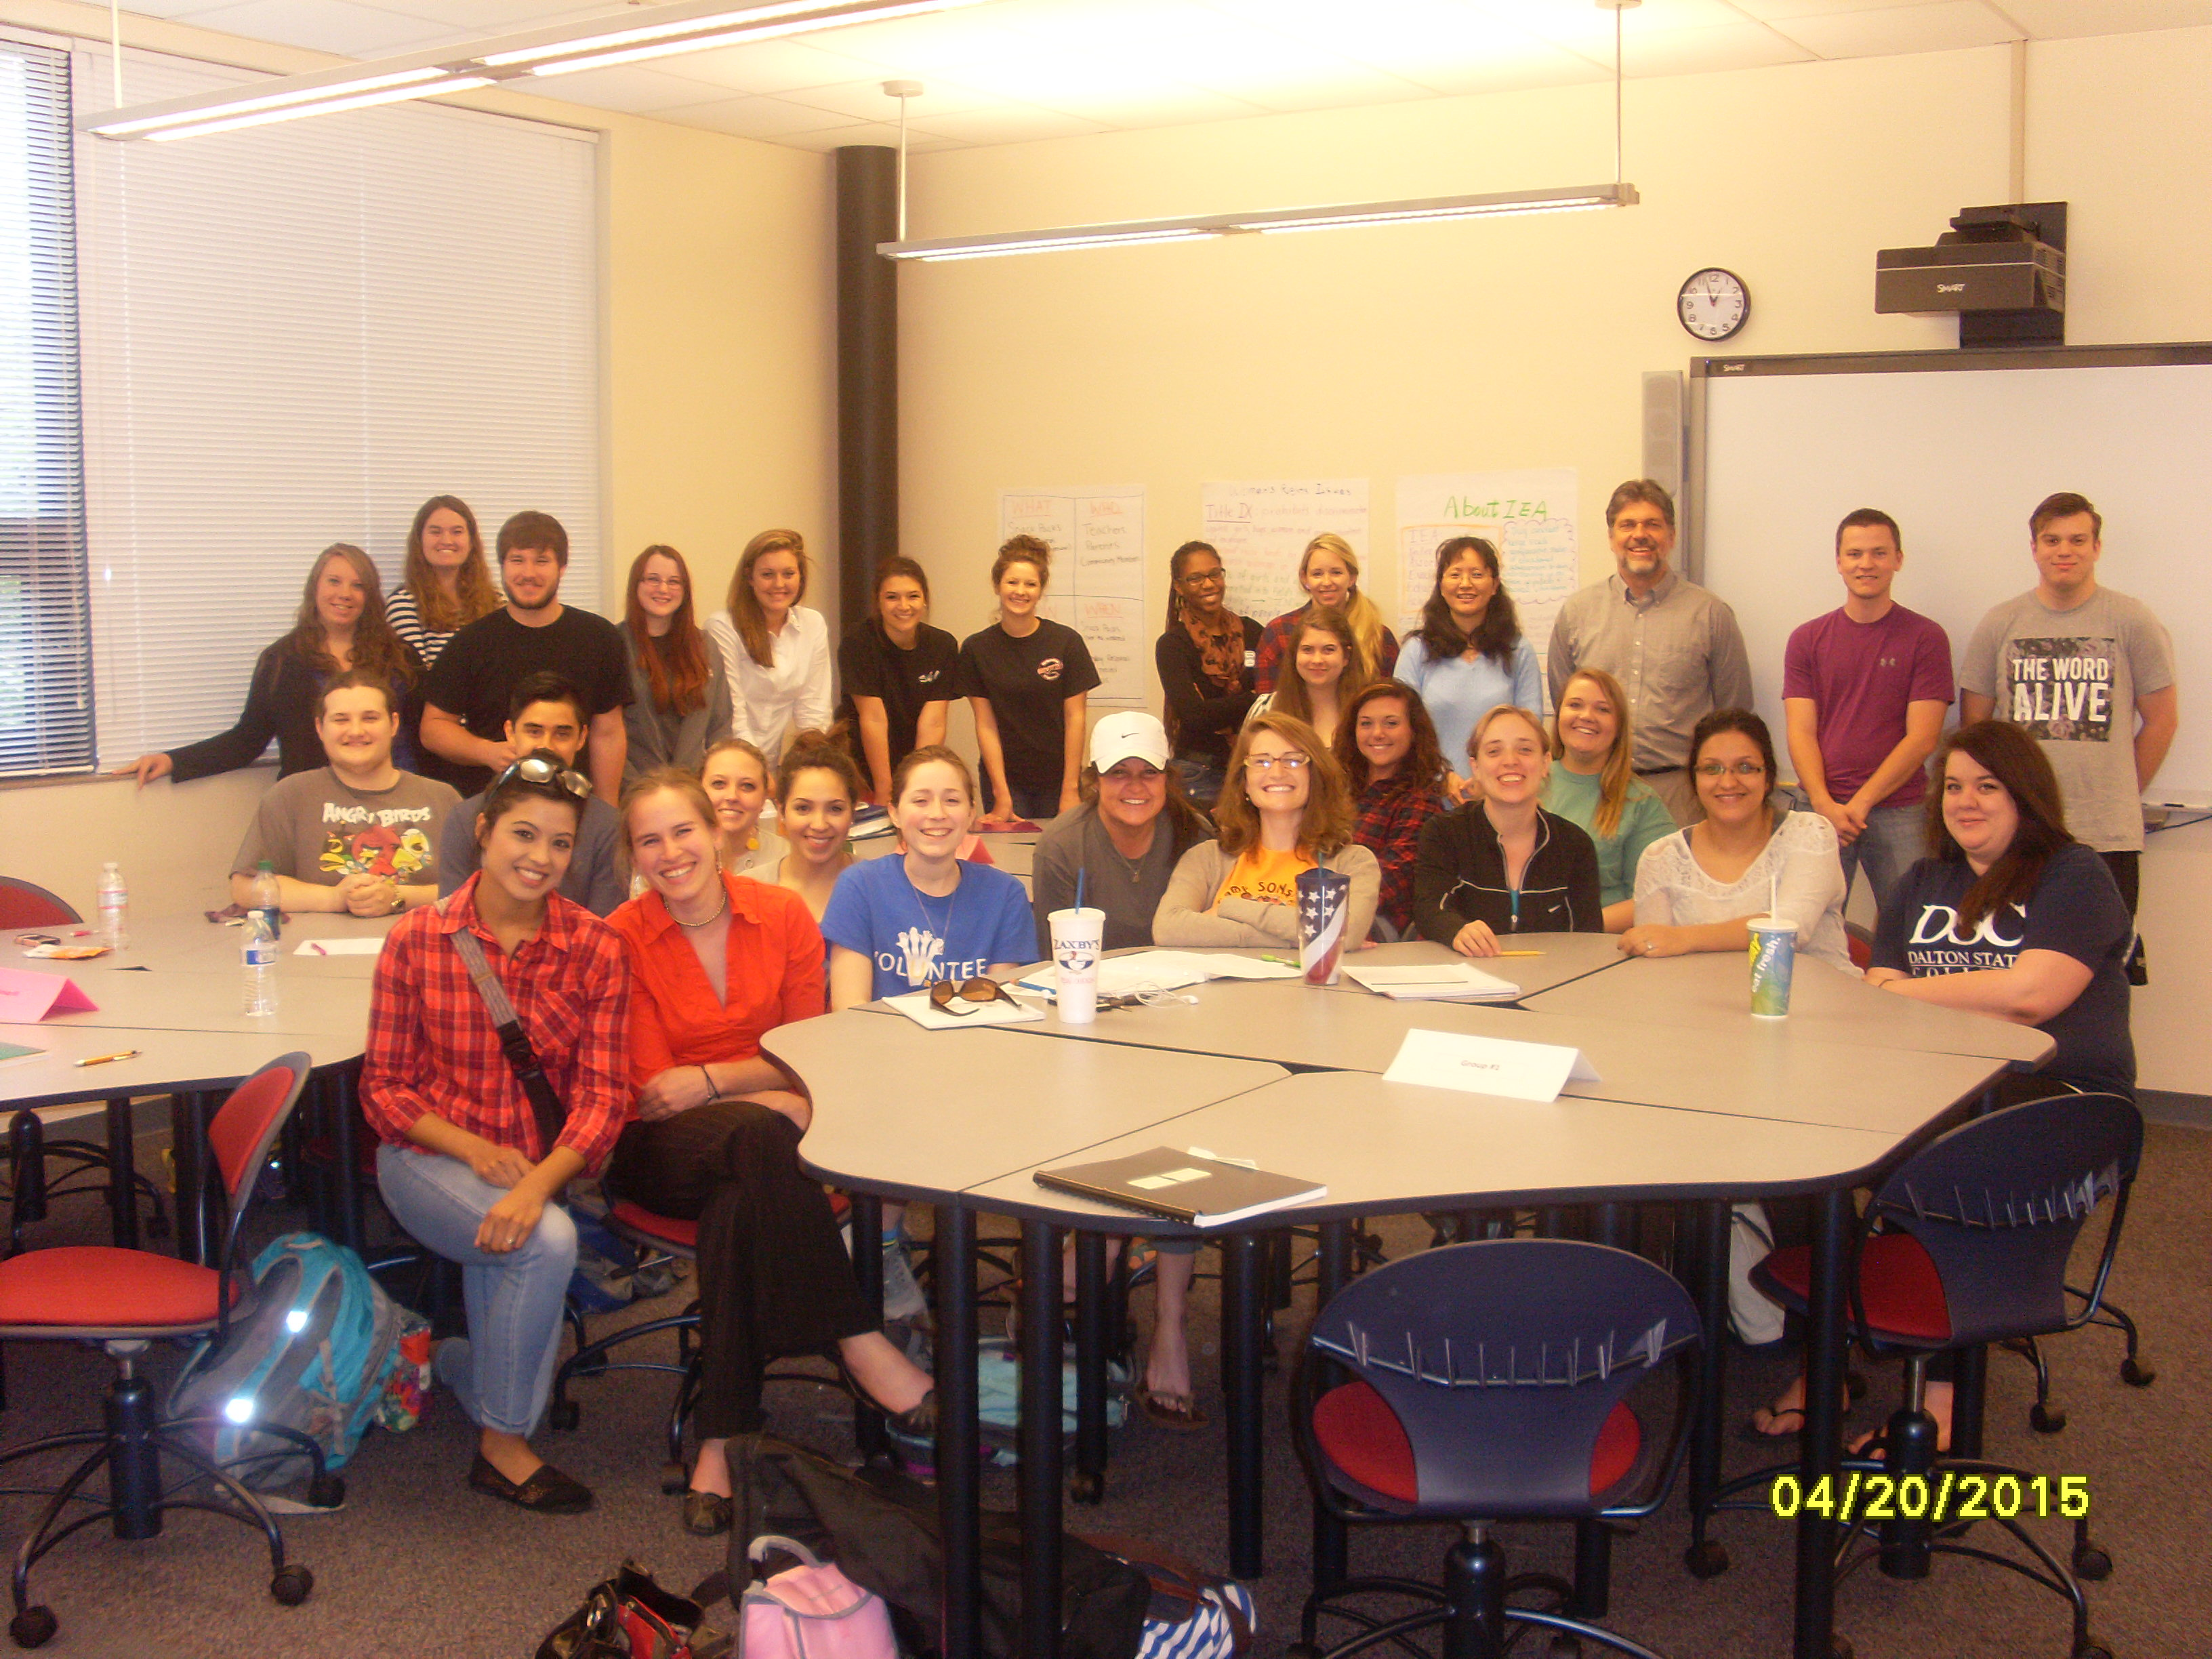
This is a whole class picture with the project professor and the librarian.
Back row: from left to the right
Students: Erica Owens, Alison Parker, Steven Worley, Amber Deal, Karly Newman, Shelby Bielling, Madicyn Jenkins, Tiara Robinson, Sarah Thurman
Project Lead Professor: Molly Zhou
Team member: David Brown
Students: Chase Horne, Samuel Worley
Left Middle Row:
Students: Derrick Belanger, Benjamin Morales
Front Row: from left to right
Students: Nanci Quintero, Lauren Sieg, Lani Watkins, Kelsey Carver, Elizabeth Beatty, Alleigh Voyles, Jordan Jones, Jennifer Pyles, Gabriela Pantoja, Christina Rodriguez, Amanda B Floyd, Maria Ramirez, Sarah Goins

