Affordable Learning Georgia Textbook Transformation Grants
Final Report
Date: May 28, 2015
Grant Number: 46
Institution Name(s): Georgia College
Team Members (Name, Title, Department, Institutions if different, and email address for each):
Jeff Dowdy, Graduate Librarian, Russell Library, jeffrey.dowdy@gcsu.edu
Matt Roessing, Assistant Professor, J. Whitney Bunting College of Business, matt.roessing@gcsu.edu
Project Lead: Matt Roessing
Course Name(s) and Course Numbers: LENB - 3135 Legal Environment of Business
Semester Project Began: Fall 2014
Semester of Implementation: Spring 2015
Average Number of Students per Course Section: 41
Number of Course Sections Affected by Implementation: 3
Total Number of Students Affected by Implementation: 124

1. List of Resources Used in the Textbook Transformation
- Students in the class researched and compiled sources for each topic in the class. The submitted sources are currently being compiled on the course Libguide: http://libguides.gcsu.edu/businesslaw
2. Narrative
The project saved students a significant amount of money. New books for this course easily cost over $200, and the book I was using previously cost over $300 new. Students were pleased with this outcome. It is unclear from the data we collected this semester whether the lessened cost of this course impacted drop or withdrawal rates. It is possible the lessened costs could even increase drop and withdrawal rates (which is what occurred), because students will not be out the cost of a textbook if they choose to withdraw. To the extent this increases freedom of choice for students in deciding to whether or not to stay in the class, I see this as a positive outcome.
By replacing the textbook with student-initiated research, we helped students develop research skills and increase their familiarity with GALILEO. Students reported very positively on the experience, saying that it helped them learn about real-world applications of their classroom knowledge. When reading the students’ research projects, I was impressed with the breadth of information they collected and I learned quite a bit about recent legal cases and advancements in the law. I expect that other teachers who use this technique will find their knowledge enhanced by the students’ efforts and can use the examples students provide when covering the topics in future semesters.
The students felt that the research experience helped them retain knowledge because they were able to handpick the examples that supported their classroom lessons. They tended to pick cases or topics in their fields of interest, such as their intended future business field, or a hobby. The project also inspired students to speak more in class, because they were aware of current events that supported our lessons.
Students, overall, had a lower GPA than before transformation. Several more students received failing grades than prior to transformation. It is difficult to tell whether or not this was directly related to the transformation. Every semester we get a different group of students, so it does not seem feasible to establish a control group for this type of experiment. Still, the increase in failure rates, to me, does not indicate that the transformation was not valuable. Getting rid of the textbook arguably makes the class more difficult. It removes a safety net for students who do not regularly attend class and makes it more difficult to “cram” prior to exams. In future semesters, perhaps we can add survey questions or change our assessment techniques to determine whether the textbook transformation is seen as positive even among those students who receive low grades in the course.
There were several challenges and lessons learned. Many of the challenges seemed to stem from this being the first semester of what is intended to be an iterative process that builds on itself. One issue was timing. While students were asked to do their research projects before or during the time we discussed each topic in class, they were not required to turn in the assignments until just before they were tested on each topic. This meant that students were not able to see what other students had posted until later in the semester. This will be less of an issue in future semesters because we will have a body of work completed by students in prior semesters that can be made available.
Another challenge was that this model is a lot of work for the professor! I really enjoyed seeing what resources students can up with, and with the large number of students that I teach (over 100) per semester, we will be able to build and maintain a resource database more effectively than we could with fewer students. However, with large class sizes, it means a lot of review and grading time for the professor. This perhaps could be reduced by adopting a peer-grading model. Peer-grading would also give students exposure to a wider range of sources.
3. Quotes
- “In a world where things change constantly, being able to locate legal information quickly is a valuable skill - particularly in a legal environment. I also appreciate that there were no texts to purchase, carry, or become outdated.” Walter Reynolds, 4th year, rhetoric major
- "It takes some of the stress out of going to college. The rest of the professors need to take notes!" Sherry Jenkins, 3rd year, business management major
- “I really enjoyed this type of learning experience because it helped me to become more familiar with the material. By doing my own research and finding examples related to the material, I feel that I was better able to understand the topics we learned about in class.” Nicole Paul, 3rd year, accounting major
- “I thought that not using a textbook helped us think hard about what we were actually doing research on, which would ultimately help us recall the information better. But, at the same time, it was a great deal of information to search through, leaving us with the sky's limit of different definitions making it a little more difficult at times.” Kayla Smith, 2nd year, marketing major
- “I thought the experiment went well. It helped force me into looking up information I either didn't get down or understand and helped me learn the topic better. Overall I thought it was a good class.” Matthew Perez, 1st year, business management major
- “I thoroughly enjoyed this class and using no-cost learning materials to learn about different topics throughout the semester. I found the information online relevant and useful, and I could tailor my online research to my interests revolving around the topic covered in class.” Abby Castro, 2nd year, marketing major and Spanish minor

4. Quantitative and Qualitative Measures
- We chose two quantitative metrics (Average GPA and Drop/Withdrawal/Fail rates) and examined them Pre- and Post- transformation.
- Average GPA decreased from 3.12 (Fall 2014 classes) to 2.83 (Spring 2015 classes)
- DFW rate increased from 1% (Fall 2014 classes) to 9% (Spring 2015 classes)
- It is difficult to say whether these data are statistically significant because we only have collected one semester of data so far. We feel that the qualitative data is much more revealing as to the impact of this project on student success and experience. It is notable, of course, that GPA decreased and DFW rates increased post-transformation. We will consider the implications of these data as we analyze the results of the project and prepare for publication.
- At the end of the semester, we met with each of the three classes separately to ask the students evaluative questions about their experience in the course. We asked each class the following 5 questions and allowed time for students to voluntarily respond:
  - Did you feel that you saved money by not having a textbook? Was that a factor in your choosing this class? How big a factor?
  - Did you find the research component of this class helped you comprehend the material? How?
  - Did you find the research component of this class helped you retain the material? How?
  - Did you feel this experience was superior, equivalent, or inferior to the experience of a traditional textbook-based course? Why?
  - What recommendations would you make to improve this class in the future?
- Some of the positive responses on the overall experience:
  - Researching the different topics related to the course, “gave me more of a perspective,” particularly finding court cases related to the course lectures, one student said. [class 1]
  - “Course material was more memorable” due to it coming from personal research rather than reading it out of a textbook. [class 2]
  - Another said that in addition to learning the course material that their research skills improved. [class 2]
  - The students were allowed to direct their research on the course topics towards applications that interested them. One said, the research allowed me to find “material I’m not bored by.” [class 2]
  - Another student found the experience of using open source materials superior to a course based on a textbook as it “forced [him] to look up info”. [class 2]
  - Another student shared that it was better preparation for the “real world” and more “realistic” than relying on a textbook. [class 2]
  - Another student found that they were “more engaged” in the classroom because of their outside research and lack of a textbook. [class 2]
  - Another agreed that if they had a textbook, they “would be lazy and not pay attention in class… just look it up later.” [class 2]
  - “Having to look up the topics myself, it made me learn.” [class 2]
  - “Definitely helped me learn about how it works in the real world,” a student said. [class 3]
  - “Made it a lot more interesting… real life examples,” another said. [class 3]
  - Another shared that they sometimes find a textbook “dry and boring” and that the research allowed them to find what was interesting to them. [class 3]
  - “The research gave more examples of concepts,” one responded. [class 3]
  - “Ditching the textbook made [the material] more interesting and easier to retain. Had more incentive to come to class and take notes.” [class 3]
  - “Your goal was to teach us modern research. We are not used to that.” The old way of learning you requires you to “hear teacher. Regurgitate it. Forget it.” I had to ask myself, “what the hell do I need to know about it?” [class 3]
  - “I learned the most out of all my classes because I needed to go look myself” for information, rather than relying on a textbook. [class 3]
- Some of the negative responses:
  - The students were required for each topic in the class to do their own research for reading materials and to help them understand the topic. After posting to GeorgiaView, students in theory could read what classmates posted to learn about other subtopics. One student said, “The only topic I would know about would be my own” and that there were too many posts to track.
  - Another student felt that the format of the class had potential, but questioned whether they would know if they were finding “the right information.”
  - Another feared their “sources may not be credible.” In general, credibility came up a lot in the discussions. And Roessing and Dowdy felt that from the students’ posts, students seemed to lack understanding on evaluating for credibility. At the beginning of the semester, during research instruction, Dowdy walked through the C.R.A.P. test with each class, but few put it into practice.
  - Another common theme that led to negative feedback involved testing and, specifically, preparation for testing. Many students expressed the lack of a common text to use while studying.
  - “Sometimes there are thousands of different definitions, which ones do you want us to know?”
  - “Spent more time looking for info than studying it.”
  - “I feel more comfortable having a book I trust.”
  - “Nice to have a concrete source before test to [review].”
  - “Challenging when you find websites that contradict themselves; not exactly sure what would be asked on test.”
  - “Hard to gauge how in-depth you want to go on research for tests.”
  - “Without a textbook, can get far away from the topic.”
  - When you have an "endless supply of Aderol and the Internet, you are probably going to get some offshoots” [or off-topic research and posts].
  - While many students agreed that they saved money by not having to buy a textbook, most said that they didn’t know at the time they were signing up for the course that there wouldn’t be one. It was unclear how best to promote to potential students that the course didn’t require a textbook.
  - “I didn’t know when I signed up” [that it wouldn’t have a book].
  - There was also debate on the true value of not requiring a textbook. The general sentiment was that students appreciated not having to buy a book, but were more than willing to buy a book if it meant doing well in the class. They also agreed that they didn’t like it when an instructor overly relied on the book. Nor when an instructor required the students to purchase the book and didn’t use it.
  - “Don’t save as much money as you used to.” [cost of textbooks has gone down]
  - “Yeah, you save money but… would have been more useful years ago.” Many students commented on the numerous ways to now save on textbooks; not as much of a burden as before.

5. Sustainability Plan
We plan to continue this project in future semesters, and the project has already been initiated in a summer semester. Students were given a copy of the topic outline and classes at the beginning of the semester were held at the library for research and GALILEO training, As the summer semester’s students develop their own research materials, we are in the process of uploading the spring semester’s resources to the online database. In future semesters, students in this class will have the benefit of exposure to resources collected by students in earlier semesters. After several semesters, we will have a robust body of resources in our database and we can shift focus from adding new materials to updating the materials already collected.
6. Future Plans
As a teacher, I have been very pleased with the results and potential future benefits of this project. Currently, we only have one semester of data, and I would not call the project a success or failure on that basis. However, the positive reactions we received from students, as well as the impacts I have seen on their interest and participation in the class, encouraged me to press on. In future semesters, I may give more direction to students as to the nature of the sources I would like students to find. For the first semester, I allowed students to use a variety of sources, such as academic articles, government websites, or blogs. I also allowed them to focus on any one of the many subtopics that we studied in each topic section. As we build our online resource, we likely will discover areas that we have covered extensively and areas where we have no or little content. I can encourage future semesters of students to supplement the areas where content is lacking.
I have already presented a working paper on this project, at a conference for business law professors. Many professors in the audience were interested in using this model in their own classrooms. Now that we have finished one semester of the project and collected data, we will update this working paper and seek an appropriate journal for publication.
We also will seek opportunities to travel to conferences to disseminate the results of this project and talk with other professors who would like to incorporate this model into their classrooms. Because the database we are building will be most effective the more resources we incorporate, we will explore the potential for partnerships with professors at other institutions, particularly institutions that use GALILEO.
7. Description of Photograph
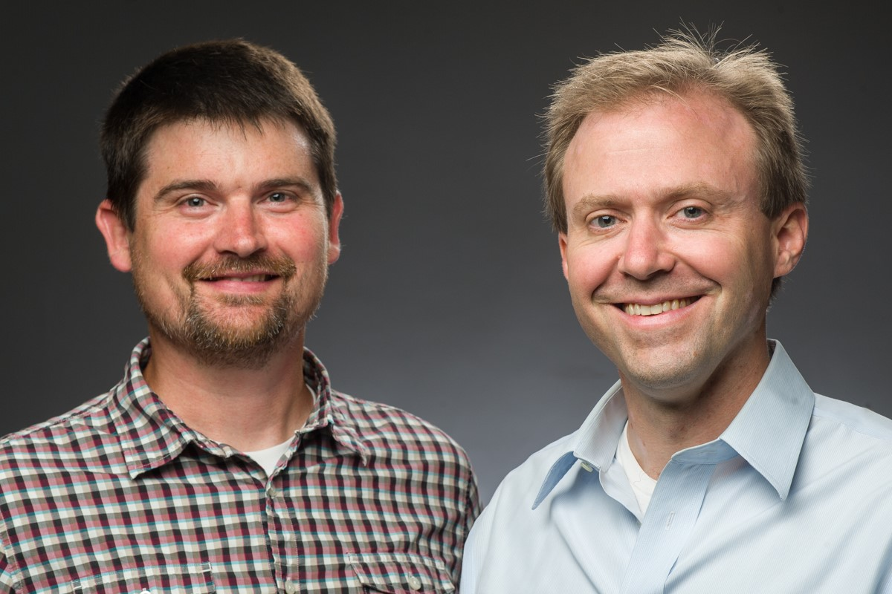
- (left-right) Librarian Jeff Dowdy and project lead Matt Roessing

- In this section, summarize the supporting impact data that you are submitting, including all quantitative and qualitative measures of impact on student success and experience. Include all measures as described in your proposal, along with any measures developed after the proposal submission. Include measures such as:
  - Drop, fail, withdraw (DFW) delta rates
  - Course retention and completion rates
  - Average GPA
  - Pre-and post-transformation DFW comparison
  - Student success in learning objectives
  - Surveys, interviews, and other qualitative measures
- When submitting your final report, as noted above, you will also need to provide the separate file of supporting data on the impact of your Textbook Transformation (surveys, analyzed data collected, etc.)

