Affordable Learning Georgia Textbook Transformation Grants
Final Report
Date: May 30, 2015
Grant Number: 38
Institution Name(s): Albany State University
Team Members:
1. Dr. Arun K Saha, Associate Professor of Physics, Department of Natural & Forensic Sciences, Albany State University. Email – arun.saha@asurams.edu
2. Dr. Liqiu Zheng, Associate Professor of Physics, Department of Natural & Forensic Sciences, Albany State University. Email – liqiu.zheng@asurams.edu
Project Lead: Dr. Arun K Saha
Course Name(s) and Course Numbers: Introductory Physics II/PHYS 1112
Semester Project Began: Fall 2015
Semester of Implementation: Spring 2015
Average Number of Students Per Course Section: 25
Number of Course Sections Affected by Implementation: 2
Total Number of Students Affected by Implementation: 49

1. List of Resources Used in the Textbook Transformation
In the proposed Textbook Transformation the following free resources are used –
https://openstaxcollege.org/textbooks/college-physics and
www.webassignment.net.
Besides, those, the following no cost links are also provided to the students for additional support –
http://highered.mcgraw-hill.com/sites/0073404535/information_center_view0/
http://phet.colorado.edu/en/simulations/category/physics

Several learning modules have been created to enhance student learning and posted to Albany State Open Repository for public access at no cost as given below –
http://hdl.handle.net/10675.1/555832
http://hdl.handle.net/10675.1/555846 and
D2L
2. Narrative
Due to high price of text book, when I saw that students were not buying text books, even after telling them again and again, I did not feel comfortable to teach in class. For poor performance in class, I could not hold them 100 percent responsible either. Now, I do not have any dilemma in my mind, because I can provide text book on first day of semester.
In the proposed transformation, students were given OpenStax free Physics II Textbook on the first day of the semester. No one waited for refund check or pay check from work or support from parents. This was a great thing to me as an Instructor. This free OpenStax Physics II Textbook was adopted through a learning management tool webassign. Webassign was not free. Cost of webassign was $35/one semester and $50 for both semesters. All home works were assigned from OpenStax book and graded by webassign. But all class tests were taken through D2L. In fact, problems in class tests were set from books of various authors including OpenStax Textbook. Of course, problems of the class tests were discussed or worked out in class. Thus, students got exposure to problems of various styles and kinds. Overall, it was a great experience for me.

But one alarming thing is that students are getting more and more averse to reading books day by day. Moreover, costly textbooks would have compounded the situation worse. So, right at this moment, free Textbook has played a great role to mitigate this situation. This is my observation based on chronological student performance data from Fall 2008 to Spring 2015 for same university (Albany State University) and same class (Introductory Physics II).

Now, recognizing this issue, next I want to develop study materials for average students (95% of whole class) where student will learn concepts through problem solving. Students who want to learn more will be referred to the corresponding chapter/section of OpenStax free Textbook. Because, learning from reading Textbook has no alternative.
3. Quotes
Quotes from three students of Spring 2015 Introductory Physics II (PHYS 1112) class
- “This text book is more affordable than the traditional text book. The original text book is also not as accessible as the e book” --- quote from Ms. Janea Brooks

- “I feel as though the book was a great help. The fact that the book was inexpensive is also a plus” --- quote from Ms. Winice Simmons
- “I learned more from the lecture notes than the book. The book was not helpful, especially with the homework questions on webassign. Majority of the homework questions didn't correlate with the books practice problems or the text” --- quote from Ms. Shaquanna Young
4. Quantitative and Qualitative Measures
- Pre and post-transformation passing rate comparison
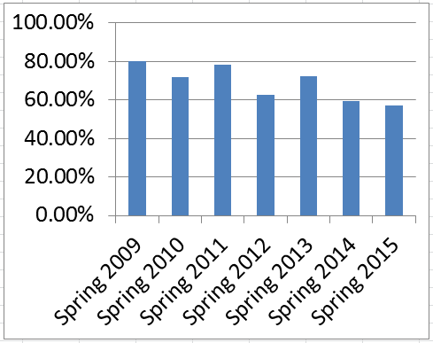
Since Spring 2009 to Spring 2015, passing rate in Introductory Physics II is shown in Fig.1.

Fig.1. Historical passing rate in Introductory Physics II

From the above data, it is clear that by OpenStax free book, the passing rate was maintained as before and situation did not get worse due to decreased reading habits.

- Pre and post-transformation average GPA comparison
The following Figure (Fig.2) displays the historical average GPA of the course Introductory Physics II since Spring 2009.
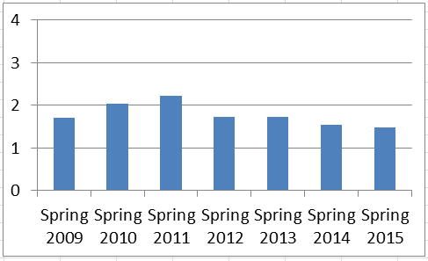

Fig.2. Historical average GPA data of Introductory Physics II

- Pre and post-test score data in Spring 2015
The following Figure (Fig.3) displays pretest and post test scores. In pretest, average score of 43 students is 49.4%. In posttest, average score of 45 students is 64%. The scores show that students learn the subject material to some extent.
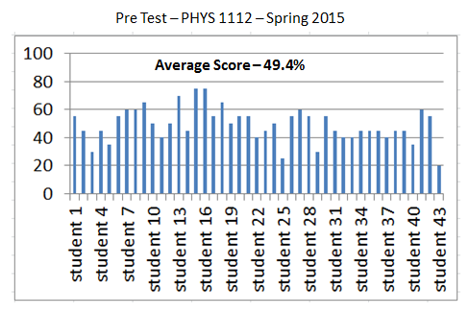

(a)
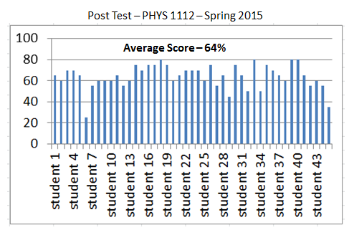

(b)
Fig.3. Pre text data in (a) and post test data in (b)

- Surveys, interviews, and other qualitative measures

Survey Questionnaires & Responses
OpenStax Text Book
Course Name: Introductory Physics II (PHYS 1112)
Spring 2015

- Did you have the text book on First Day of semester?
YES 97.5% (b) NO 2.5%
- For your PHYS 1112 course, did you buy the OpenStax text book with Webassign?
- YES 87.5% (b) NO 12.5%

- When did you buy?
- Beginning of semester 85.0%, (b) After midterm 7.5% (d) Not yet 7.5%

- Did you wait for refund check to buy this Physics text book?
- YES 62.5% (b) NO 37.5%

- Do you think that the cost of your text book for PHYS 1112 was affordable?
- YES 80% (b) NO 20%

- How do you rate your affordability in buying this text book?
- Very much affordable 30% (b) Somewhat affordable 57.5% (c) Not affordable 12.5%

- How do you rate your accessibility to this text book?
- Very much accessible 45% (b) Somewhat accessible 47.5% (c) Not accessible 7.5%

- How did you like the content of the book?
- Liked very much 5% (b) Liked somewhat 47.5% (c) Did not like 47.5%

- How did you like the presentation of the content?
- Liked very much 15% (b) Liked somewhat 52.5% (c) Did not like 32.5%

- Were the interactive video links in the text book helpful for you?
- Very much helpful 10% (b) Somewhat helpful 45% (c) Not helpful 40%

- Do you think that, the low cost of your text book engaged you less amount of time in outside works and you had more time to concentrate in study?
- YES 40% (b) NO 60%

- Next semester, ASU will offer two sections of this course. One section will adopt OpenStax text book (which you are using now) and other section will adopt a hard-cover printed book. Which section you will recommend your friend to get enrolled?
- Section adopting OpenStax text book 42.5% (b) Section adopting hard-cover printed book 55%

Analysis of Survey Results

The survey results show that the primary purpose of this project has been achieved. 97.5% of the students got the book on first day of semester. 87.5% students think that cost of webassign + OpenStax Free Textbook is affordable. But in terms of content, 5% liked very much, 47.5% Liked somewhat and 47.5% did not like.

5. Sustainability Plan
In the proposed project, sustainability plan is one of the important components. The team members of this project have developed a systematic procedure for other faculties who want to teach the course (Introductory Physics II) in future. This document will be preserved in departmental office.
Step 1
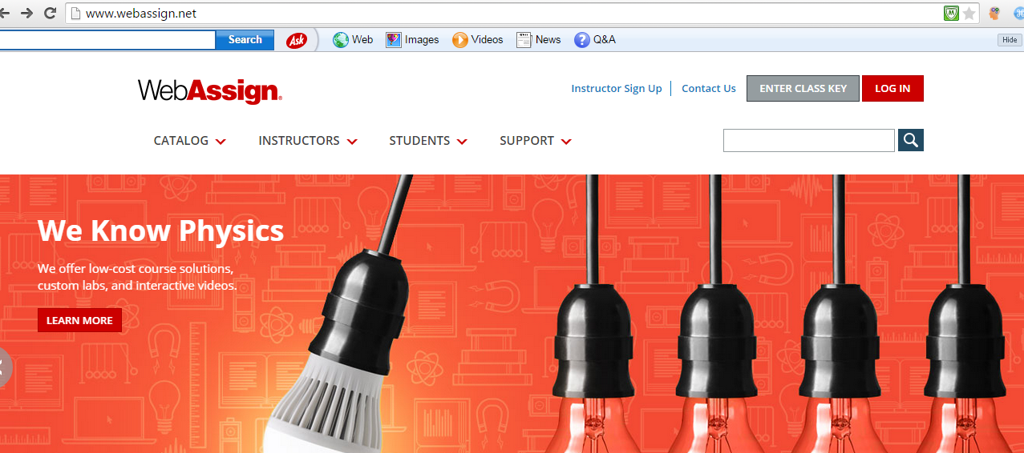

Step 2
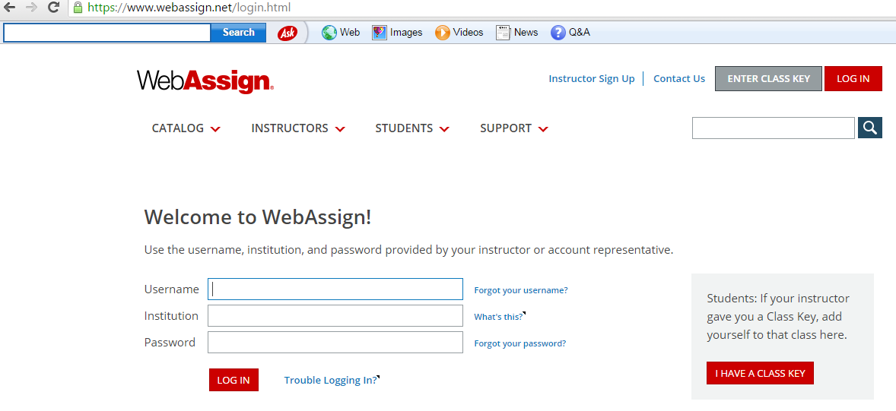

Step 3
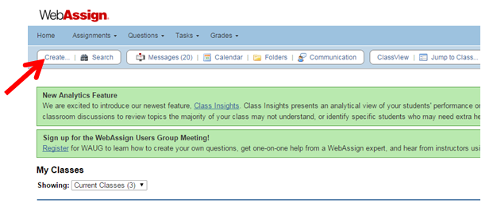

Step 4
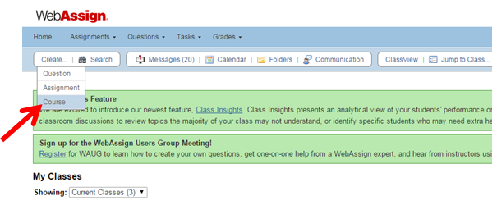

Step 5
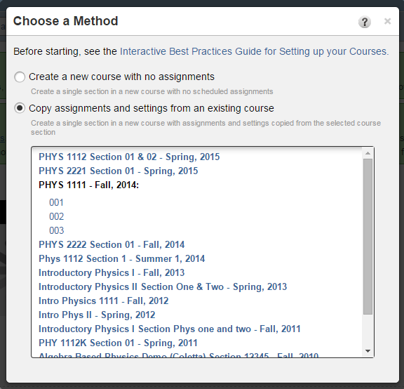

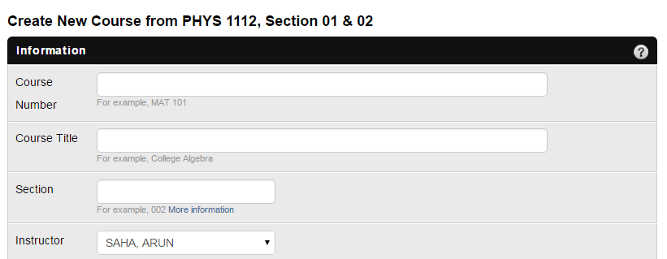
Step 6

Next, the team members created a step – by – step procedure for students to enroll in the course through webassign.
Step 1

Step 2
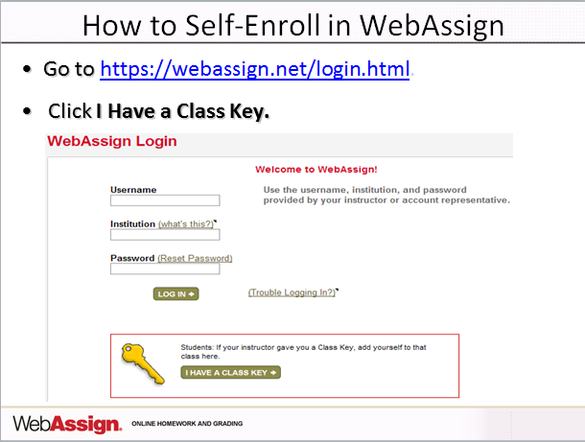

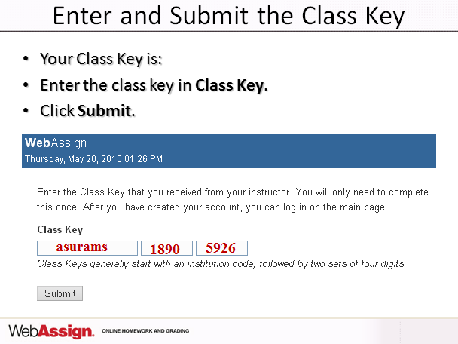
Step 3

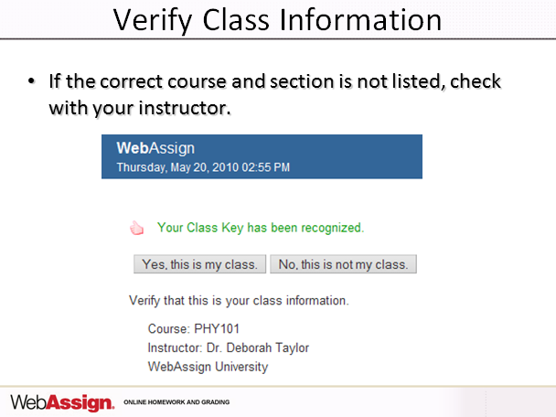
Step 4

Step 5
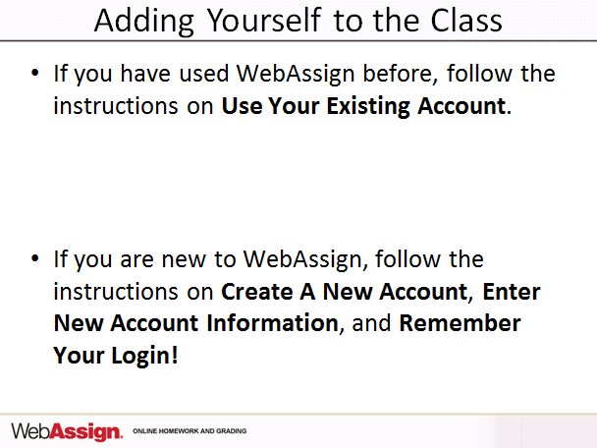

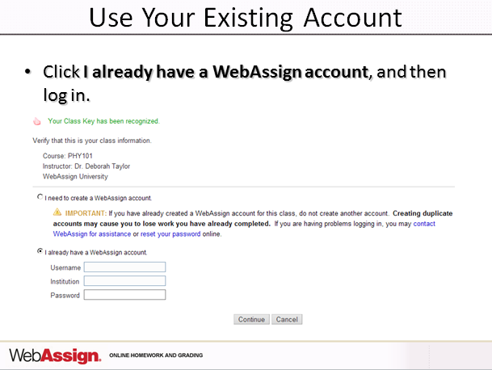
Step 6

Step 7
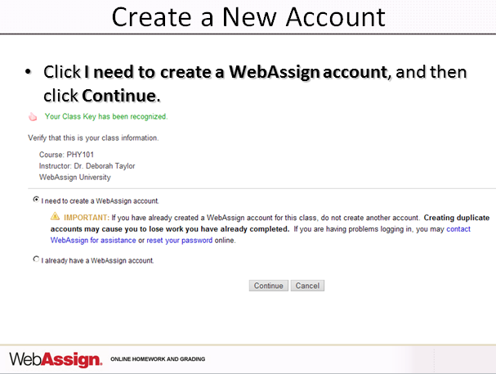

Step 8
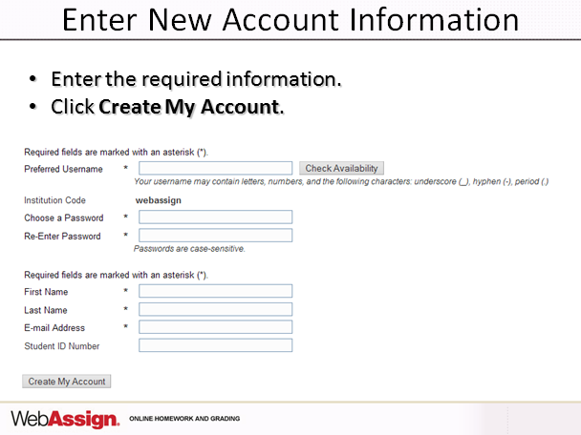

Step 9
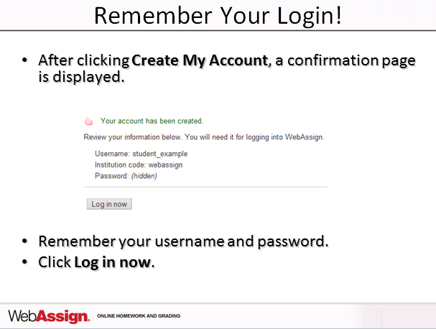

Step 10
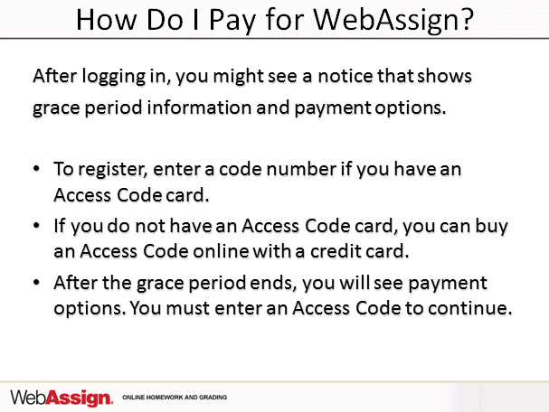

Step 11
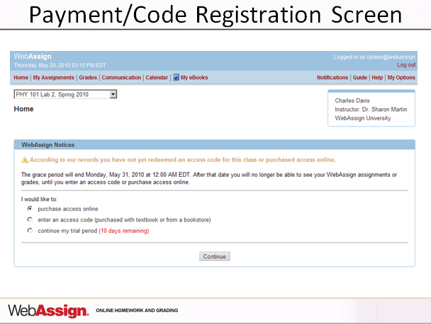

Step 12
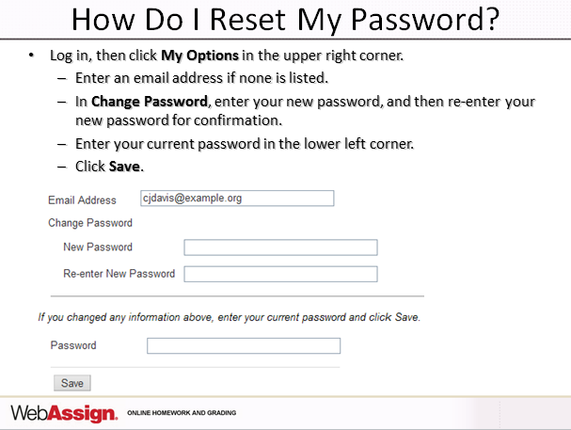

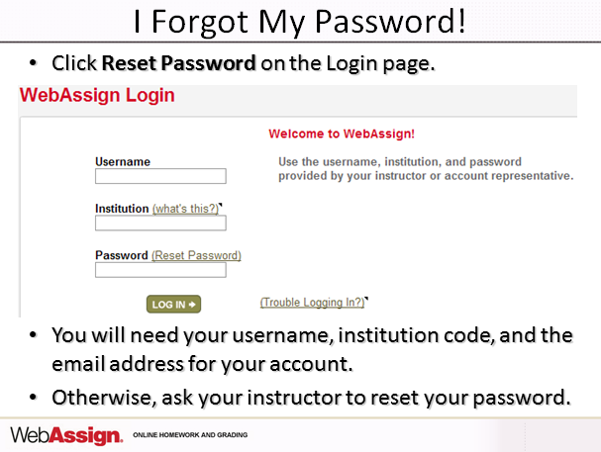
Step 13

Step 14
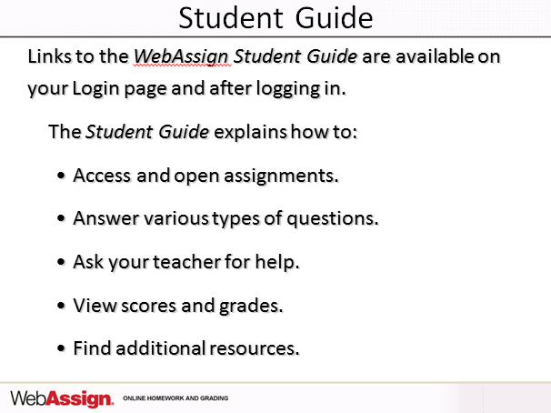

Step 15
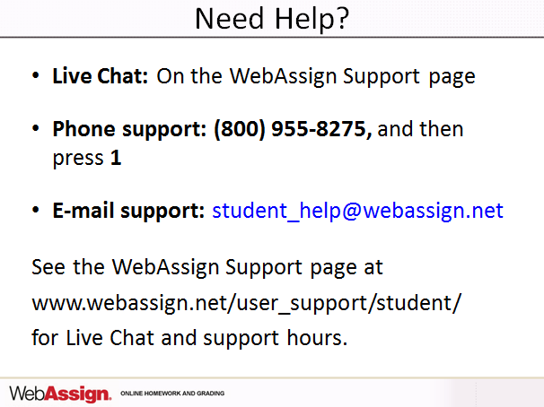

6. Future Plans
With the advent of cheap mobile technology, students are getting busier than before and Textbook reading habit of average students is decreasing day by day. Recognizing this current trend, we want to develop content materials where those students will learn concepts from doing problems. Emphasis will be given on problem solving.

7. Description of Photograph.
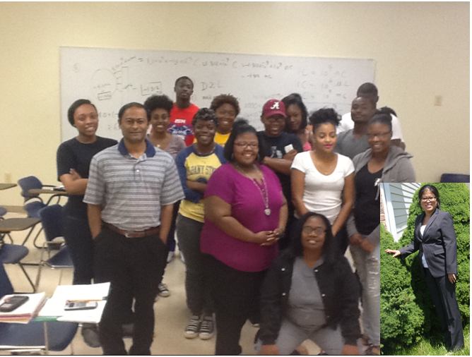

Left-most – Dr. Arun Saha, Project Director, right-most – Dr. Liqiu Zheng, Co-Project Director, in between – students who used free textbook.

