Affordable Learning Georgia Textbook Transformation Grants
Final Report

Date: June 1, 2015

Grant Number: 39

Institution Name: Georgia Highlands College

Team Members : Kimberly Wheeler, Ed.D,
Director of First Year Experience
Assistant Professor of Reading/English,
Division of Humanities
kwheeler@highlands.edu

Sarah Hepler
Faculty Academy Director
eLearning Instructional Designer
shepler@highlands.edu

Project Lead: Kimberly Wheeler, Ed.D,
Director of First Year Experience
Assistant Professor of Reading/English,
Division of Humanities
kwheeler@highlands.edu

Course Name(s) and Course Numbers:
Freshman College Studies, FCST 1010

Semester Project Began:
Fall 2014

Semester of Implementation:
Spring 2015

Average Number of Students Per Course Section:
20

Number of Course Sections Affected by Implementation:
32
Total Number of Students Affected by Implementation:
Approximately 600

List of Resources Used in the Textbook Transformation

All resources may be found here in Modules 1 - 10.·

Narrative

From the first of day of class, I explained to my students that they were to become a part of something very special. I decided to pilot the project in both my face-to-face and online Freshman College Studies (FCST) sections. It wasn’t only for ease of teaching the same curriculum, but it was to compare the outcomes from students being delivered the content from totally different perspectives.

I informed my students that the course would be taught using free, open online resources with no cost to them and no textbook to purchase or carry. I explained that the resources would be housed in a public LibGuide that could be accessed easily anywhere and at any time. From that point forward, my students were 100% supportive. After the first two weeks of the semester, there were two things that became apparent. First, both my online and face-to-face students loved the media, relevant images, articles, and infographics that made up our free, online resources. Second, both groups loved the fact that the LibGuide was formatted in a way that was easy to follow. The semester progressed very smoothly with no snags or problems. Therefore, I was eager to see the final outcome of teaching with free, open online resources.

When I began to average grades from this ten-week course, I found that grades from my face-to-face class were much in line with previous grades while using a textbook. When I received the course evaluation from this face-to-face class, I found that many of the comments were about how much they enjoyed “not” having a book. When I started to average grades from my online course, I found an amazing contrast. Grades were much higher than I previously remembered and there were only two students out of twenty-five who dropped the class. This is a very large difference than with previous semesters using a textbook. The course evaluations for the online course were much about the formatting and resources in the course.

What “I” found from teaching with free, open online resources is the ease of delivering the content through a LibGuide, along with the relevancy of the content. I plan on using the same LibGuide format and using free, open online resources while teaching my Developmental Reading/English course.

Surprisingly enough, I would do nothing differently if I could go back to the beginning of this project. I feel our team worked well together. We divided our duties. We both had experience teaching the course content, so it was easy to find relevant online resources. The student outcome was far above what I expected. My institution plans on implementing the change to using free, open online resources for every section of Freshman College Studies (FCST) starting this fall semester 2015. I will conduct a training for all instructors/professors before the fall semester and all are excited to be making this change. The best thing about this project was the students “and” the professor had fun!

Quotes

- “I also like how she incorporates youtube videos into the modules.”
- “The course was fun.”
- “It is hard to find assignments the way some teachers have things laid out, but the LibGuide made everything easy to find. But in other classes it was very hard and confusing.”
- “I really enjoy not having a book for this class, and I like the fact that all of the information we have learned is in a LibGuide and we can always go back and refer to this information.”

Quantitative Measures

Attitude Assessment
The quantitative portion of our measures consisted of a two-question likert-scale attitude assessment given to students at the conclusion of the semester. This assessment was completed by students in both the face to face and online pilot classes. Nineteen students in the online class and ten students in the face-to-face class completed the survey. All students were informed that the survey was optional, anonymous, confidential, and would not affect their grades.

The assessment was created using the D2L quiz tool and contained the following questions: 1) I prefer to have a printed textbook to take notes in and 2) I prefer to read information from a printed textbook rather than reading online information. Students were given a likert-scale to choose their responses for each question (Strongly Agree, Somewhat Agree, Agree, Somewhat Disagree, Strongly Disagree).

The results differed between the two groups surveyed. For the statement I prefer to have a printed textbook to take notes in, 70% of face-to-face students answered that they either somewhat or strongly disagreed while only 30% of this same group somewhat or strongly agreed. In contrast, 79% of the online students chose somewhat or strongly disagreed and only 21% chose somewhat agree. Thus, although both groups did not prefer to have a printed textbook for note taking, the online students tended to feel more strongly in this direction.

This pattern was repeated for the second statement I prefer to read information from a printed textbook rather than reading online information with face-to-face choosing either somewhat or strongly disagree 60% of the time and strongly or somewhat agree 40% of the time. Online students, on the other hand, chose somewhat or strongly disagree 68% of the time and somewhat agree 32% of the time.

Overall, both groups of students strongly disagreed that the preferred taking notes in a text while a smaller majority of each group disagreed that they preferred reading from printed texts. Face-to-face responses were more evenly distributed while online responses were more extreme.

Grades: Pilot Courses

The face to face pilot had 23 students with the following grade distribution: 11 A’s, 7 B’s, 2 C’s, & 1F. In addition there was one withdrawal. This means that 86% of students in the face to face pilot received a grade of C or better. There were 19 face to face FCST 1010 classes taught in the Spring with an ABC rate of 82%. Thus, overall the students in the face to face Libguide pilot performed better than those in the traditional classes.

The online pilot had 29 students with the following grade distribution: 26 A’s, 2 B’s, and 1 F$. This means that 97% of students in the face to face pilot received a grade of B or better. There were 3 online FCST 1010 classes taught in the Spring with an ABC rate of 77%. Thus, overall the students in the online Libguide pilot performed significantly better than those in the traditional classes. In addition, the students in the online pilot also performed significantly better than the students in the face to face pilot. This is an interesting finding that will need to be further researched.

Qualitative Results

I visited Kim Wheeler’s FCST 1010 class on March 25th to conduct a focus group regarding the implementation of the ALG-funded course redesign. Students were informed ahead of time that I would be coming. The focus group took place after class on the last day of class. When I arrived the class was wrapping up for the semester. I explained my purpose for being there and asked for volunteers. I also assured the students that their responses would be confidential, anonymous, and would not affect their grades. Kim Wheeler left the room so that the students could speak freely about their experiences using the LibGuide.

Seven students volunteered to stay after class and participate in the focus group. The students did not receive any kind of reward for their time. The group consisted of 6 women and one man. The six women were diverse in age and race/ethnicity (white woman in 40’s, white woman in her 20’s, two teenaged Hispanic women, and two teenaged African-American women). The man was white and in his late teens. Thus, although the group was small a variety of demographic groups were represented.

Focus group questions were minimally structured to encourage conversation and student creativity. The following questions were asked: How did you feel when you found out that you didn’t have a textbook? What did you like about using the LibGuide? What did you dislike about using the LibGuide? Although I had originally intended to record the student responses my iPad ran out of power. Thus, I took notes on the first question and created a chart on the whiteboard for the second and third question. I gave the students the option to either 1) write their responses, report their answers to a partner, and then report to the group, 2) write their responses and then report to the group, or 3) report to the group without writing. This choice reflects my commitment to participatory research. The students chose the second option of writing and reporting to the large group.

The first question was: How did you feel when you found out that you didn’t have a textbook? Although all of the students wrote their answers to this question they were reticent to report their answers to the group. Thus, I simply went around the room and asked each student for his or her response. All of the students reported feeling relieved that they wouldn’t need to invest in yet another textbook. One student also reported that she was a bit nervous about using an online textbook. One student also reported that he tends to not buy textbooks when they are required.

The second questions was: What did you like about using the LibGuide? This question had a variety of both expected and novel responses. Once again, the students expressed their delight at not having to pay for a textbook. All students talked extensively about the videos chosen for the LibGuide and some even talked about their favorite video of the semester. One student said that the videos kept him interested. Several students also talked about being able to access the LibGuide from anywhere. These same students enjoyed the fact that the LibGuide was used both in class as a teaching plan/organization tool and as a resource/dropbox outside of class. One student also commented that she could refer to the LibGuide if she missed class. Another student said that the LibGuide forced him to do work - several other students concurred. When I asked the students to elaborate on this response they said that they had no excuse not to do their work since the LibGuide was so accessible.

The third question was: What did you dislike about using the LibGuide? None of the students had any complaints. I pressed the students to think about any issues that they had and they could think of none. I then reformulated the question and asked what types of issues they could envision other students having. The only issue that they could come up with was issues with access since not all students have reliable internet access at home.

Sustainability Plan
·
We will need to take several factors into account in offering these materials to FCST 1010 students and faculty in proceeding semesters. First, all faculty and students will need access to the LibGuide. This access can be granted in one of two ways. The “master course” LibGuide link could be sent to the teaching faculty as is and the faculty member would need to use the guide as is. This means that the faculty member would not have the ability to customize the guide. An alternative approach would be to work with the library to create LibGuide accounts for all FCST 1010 faculty members. In this way faculty could copy over the original guide and edit/add to it as needed. This second approach would also allow the faculty member to stagger release of the different modules. A faculty-driven approach would require training on the LibGuide system. If we decide to use this approach, GHC faculty will provide hands-on LibGuide training to all FCST 1010 faculty during the required training they attend each semester. In either case students will get access to the LibGuide via a link from the syllabus and a widget posted in D2L. Second, updating materials will be a continual process. Before each semester begins the grantees - the Director of FYE and the Director of Faculty Academy - will check for broken links and add/replace new materials as needed. Any new a/v materials will be made 508 compliant via captioning or transcripts. Captioning will be used for videos made in house while transcripts will be used for videos/Prezis/other materials created by third parties or for materials that can not be captioned (for instance, infographics).

Future Plans

As a result of this project, all Freshman College Studies (FCST 1010) courses and our Career Planning Course (FCST 1020) will no longer use a textbook. Instead, both of these courses will be taught using free, open online resources. The impact of the project will allow these courses to maintain a “new” and “relevant” curriculum each semester, as old resources may be changed out with newer ones.

Our hope is to publish the results of the project in a relevant higher education journal. In addition, we would like to report our findings to the entire faculty of Georgia Highlands College with the hope that other college professors may use the same LibGuide format, along with free, open online resources. Personally, my Developmental Reading/English (ENGL 0989) course will be transitioning into a “texbook-free” course using only free, open online resources housed in a LibGuide. ·

Description of Photograph

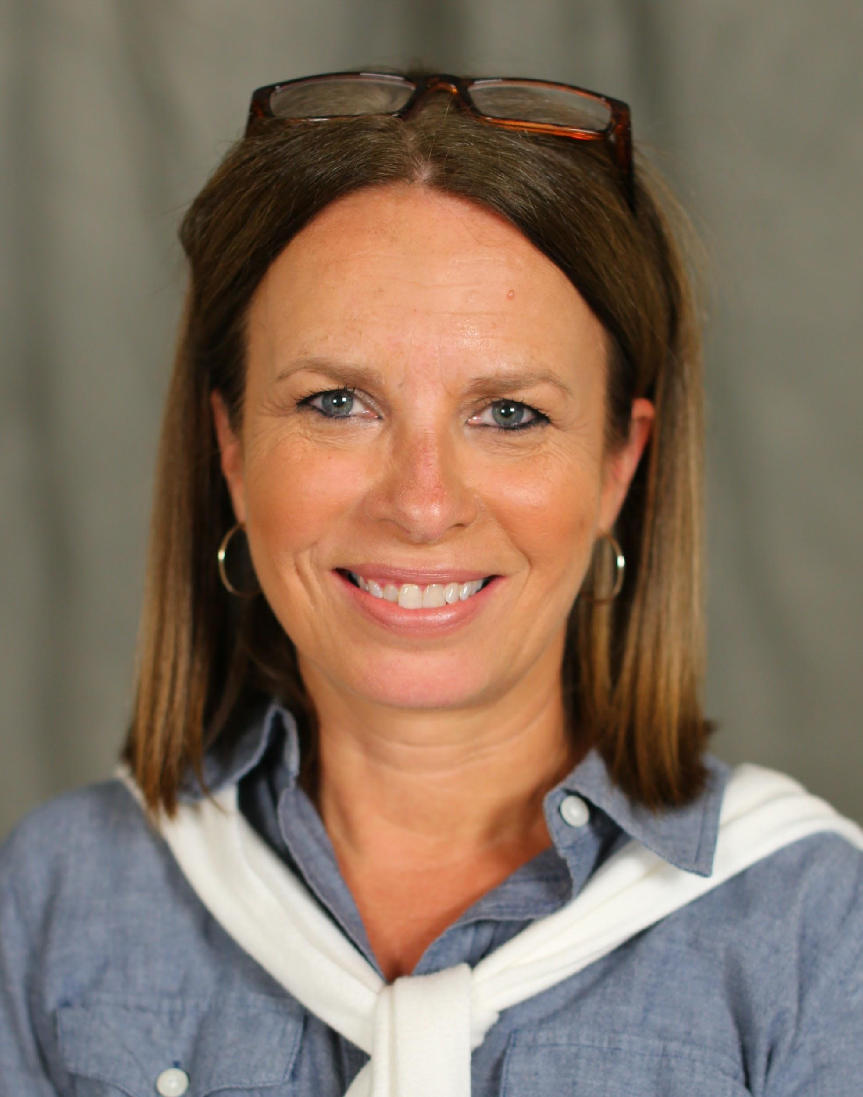
Kim Wheeler, Project Lead
First Year Experience Director
& Assistant Professor of Reading/English

Sarah Hepler, Director of Faculty Academy
& eLearning Instructional Designer

